Title: NHL Salary Cap Tracker

Group Members: Paul Barela, Marco Frescas, Yosep Ha, Jonathan Vu, Nafiz Rahman,

Sanved Paladhi, Diego Djordjevic

GitHub Repository: https://github.com/plb220001/NHL-Salary-Cap-Tracker/tree/master/.idea

Member Tasks:

Introduction, Description, and Background: Marco handled the write-up structure and edited information to ensure the project met specifications.

SQL Database Creation: Nafiz managed the SQL queries for the various operations necessary for the project. Paul designed the database schema and set up the initial tables, ensuring they are structurally based on ER and EER models. Paul, Marco, Sanved worked on the database population and maintaining data accuracy, ensuring each table was populated with the appropriate information. Paul created views for the database based on the specifications in the project.

Front-End Development: Marco and Paul designed and implemented the interface for the front-end portion of the project.

ER and EER Models: Jonathan and Diego managed the ER and EER models. Jonathan created and designed the initial ER and EER models, ensuring the inclusion of various entity types, relationships, and attributes. Diego reviewed and refined the models for accuracy, ensuring compliance with project requirements.

Normalization: Paul outlined the relationships and attribute information to explain the dependencies in each table. Diego created a detailed visual representation of the functional dependencies, ensuring all requirements for 3NF were met.

Relational Model: Nafiz and Yosep managed the relational model. Yosep handled the conversion from EER to the relational model, including the design of schema diagrams and the appropriate primary and/or foreign keys. Nafiz specified integrity constraints and ensured the accuracy of the schema.

Motivation:

The NHL has a history of wanting to obscure salary cap information, and frowns upon third party tracking such as that which used to be available on CapFriendly.com [1]. The result is difficulty for fans, analysts, and even NHL affiliated professionals in finding information on player salaries and team spending. CapFriendly.com, previously the industry standard in stat tracking and salary cap tracking, was purchased and is no longer available to the public. This has created a gap in the market for consumers to access said information, which is currently filled mostly by the websites puckpedia.com and cap-space.com. While together they present the information that used to be available on CapFriendly.com, the organization and readability leaves a lot to be desired.

Our project aims to design and implement a database system that will store and manage the NHL salary cap data, including total cap allowed for teams, player contract details such as contract length and cap hit per player, and core statistics presented in a format more similar to the now defunct CapFriendly.com. By keeping track of the salary cap data and making it easily accessible and understandable, we aim to contribute to the hockey community in a meaningful way. This information is used in real life by fans and enthusiasts for casual purposes as well as by the professional community in order to determine contract values when signing players to teams.

Timeline:

1. Initial Planning and Requirements Gathering:
   1. First we defined the scope and goals of the project from the perspective of building a useful tool. After deciding how we wanted the project to look vaguely, we started fitting the ideas into the requirements of the project as specified in the course.
2. Conceptual Design:
   1. Then we created an ER model to represent the ideas we wanted implemented. We started with a structure of teams and players, and built up from there. We added transactions and contracts to represent relationships between the teams and players as well as teams and themselves. We also added the assets table to serve as a weak entity and identify draft picks held by teams.
   2. After having a basic ER model, we developed changes to build it into an EER model. We added coaches and created a superclass of “persons” for the, now subclass, “player” and “coaches.” Additionally, we adjusted some elements like names and locations to adjust for more complex attribute types existing in the model.
3. Logical Design:
   1. After finishing the EER model, we translated that into a relational schema. We defined the attributes that needed to serve as keys, and ensured the we understood and labelled dependencies correctly before moving to the creation of the database.
4. Physical Design and Implementation:
   1. Then we started creating the database in SQL. We implemented tables based on the relational schema and adjusted the models as necessary to improve the database functionality.
5. Data Population and Testing:
   1. Then we began inserting actual data into the tables and testing query functionality. We also used this time to test integrity constraints between different entities to ensure the database was functioning as planned during the design phase.
6. Normalization
   1. We broke down all of the relations into candidate keys, primary keys, prime attributes, and non-prime attributes. We also described the functionality of each in plain English in order to more easily identify dependencies. Finally, we looked through the dependencies of each relation to ensure we had achieved 1NF, 2NF, and 3NF requirements for every table in the database.
7. View Creation
   1. We determined what views would provide useful information in the context of useful cap information for team planning in the NHL. We then created each view to show information like lists of players that are paid more than a certain amount, or players in specific positions that affect the cap utilization of a team beyond a certain dollar value.
8. Front-End User Interface
   1. We started this step by determining what form we wanted our front-end to take, deciding on a desktop application. We then implemented the application using python with a tkinter GUI.
9. Documentation and Reporting:
   1. Finally, we documented the database and project information in this word document, summarizing the required information and ensuring its accuracy. We created this report and finalized all of the screenshots and other required pieces needed to be submitted.

Introduction:

This project aims to work similarly to CapFriendly.com [3], which used to track salary caps and player stats (i.e., individual salaries) across the National Hockey League (NHL), before being purchased and shut down this year, leaving two separate websites to try and fill the gap left behind. While this information continues to be accessible, the website’s organization and readability leave much to be desired. Our project will unify and prettify the data already seen in the previously mentioned websites.

Background and Related Work:

The National Hockey League (NHL) salary cap system is a crucial aspect of team management, impacting player contracts, team rosters, and overall competitiveness. Over the years, several platforms have emerged to provide detailed salary cap information and player contract data to fans, analysts, and professionals. Below is a chronological list of similar projects in this domain, along with explanations of each and how our project relates to them.

1. CapFriendly.com (2015 - 2024)

CapFriendly.com emerged as a platform offering an extensive database of player contracts, team cap situations, transaction histories, and tools. CapFriendly was widely used by fans, analysts, and NHL personnel for its accuracy and intuitive interface. However, it was acquired in 2024 and is no longer publicly accessible.

Our database and interface design aim to recreate the clarity and intuitively presented data of CapFriendly. We seek to offer a similarly comprehensive resource, focusing on ease of navigation and detailed financial information.

3. PuckPedia.com (2018 - present)

PuckPedia provides NHL salary cap information alongside general hockey statistics. While it offers extensive data, users have criticized its organization and cluttered design, making it less intuitive to navigate compared to predecessors like CapFriendly.

We aim to enhance user experience by ensuring that our database presents information in a more intuitive and organized manner than PuckPedia. Our project focuses on streamlined data presentation and user-friendly search functionality.

4. Cap-Space.com (2020 - present)

Cap-Space.com offers insights into NHL team salary caps, including data on team cap hits, player salaries, and contract details. Similar to PuckPedia, issues have been raised about its navigability and presentation format, which can be less user-friendly for those seeking specific information quickly.

Our project borrows from Cap-Space.com's data but distinguishes itself by focusing on superior data presentation and ease of use. We aim to provide more flexible search capabilities and a cleaner interface.

How Our Project Differs:

One of the main differences our project offers compared to the competition is the flexibility it allows in searching the database. While other projects, such as Cap-Space.com and PuckPedia, are limited to viewing one team or player at a time, our database grants the capability to search for specific criteria across the entire league. For example, users can:

1. Return a list of all teams currently exceeding the salary cap, facilitating league-wide financial analysis.
2. Find all players with salaries less than or greater than a certain amount, aiding in assessing player value and potential trades.
3. Analyze and compare the overall value or cap hit of different teams, supporting more comprehensive evaluations of team strategies.
4. View historical data on trades, contracts, and transactions, which is essential for analysts and enthusiasts tracking team developments.

Having coaching information directly available in the same platform is an invaluable feature of our implementation, as a primary concern in hockey is the quality of coaching. This implementation allows one to consider the value added to a team by coaches, not just players.

Using the transactions table allows for users to view recent transactions between any teams in the NHL, which is useful context when considering the needs and wants of players and teams. This functionality is not present in the competitors, and is instead more commonly found through other providers without the same context.

Our project distinguishes itself by offering enhanced search capabilities, user-friendly design, comprehensive data analysis tools, and a commitment to data accuracy. By addressing the limitations of current platforms and building upon the strengths of past resources like CapFriendly, we look to deliver a superior NHL salary cap database. This resource is designed to meet the needs of the hockey community, providing valuable insights to fans, analysts, and professionals.

Conclusion:

In conclusion, the NHL Salary Cap Tracker project addresses the need for accessible and organized information on NHL contracts that is not readily and easily available from the NHL itself. It works to fill in the void left by the shutdown of CapFriendly.com through comprehensive database design and structuring. This new database exists as a tool for fans, analysts, and professionals to access player contracts, team salary caps, and relevant statistics easily and efficiently.

Future Work:

Future expansion ideas to make this product more useful and appealing include enhancing the user interface, integrating real time updates using the NHL API, and integrating advanced analytics to broaden the base it serves. Providing a graphical interface for the project would allow for easier navigation and data visualization of the information that the database currently provides. Adding analytical tools could increase the depth of information and provide deeper insights for hockey enthusiasts or professionals. These advanced tools are a feature of CapFriendly.com that has yet to be implemented to the same level by competitors, despite CapFriendly’s exit. Finally, using API to incorporate real time updates would create a level of engagement for users of the tool that would make the project more appealing to use. These enhancements would improve the project’s validity as a competitor to the similar tools on the market, and ensure its feasibility as a hockey resource in the future.

3.1 – Normalization of EER Conceptual Data Model

1NF: All attributes are atomic. This condition is met for all tables, as no table uses attributes that have relations as elements.

2NF: Every non-prime attribute of R is fully functionally dependent on the primary key.

3NF: No non-prime attribute of R is transitively dependent on the primary key.

1. Locations: A location can be uniquely identified by either its id itself, or by the combination of city, state, and nation, which together are unique to a single location, but separately are not.
   1. Candidate Keys: location_id, {city, state, nation}
   2. Primary Key: location_id
   3. Prime Attributes: location_id, city, state, nation
   4. Non-Prime Attributes: None
   5. 2NF Justification
      1. No non-prime attributes are in the table -> all are functionally dependent on prime attributes.
   6. 3NF Justification
      1. No non-prime attributes are in the table -> none are transitively dependent on the primary key.
2. Teams: A team can be identified uniquely by either its team name or its team id. All of the non-prime attributes can only be derived from either of these candidate keys.
   1. Candidate Keys: team_id, team_name
   2. Primary Key: team_id
   3. Prime Attributes: team_id, team_name
   4. Non-Prime Attributes: location, division, cap_space, cap_hit, roster_size
   5. 2NF Justification
      1. All non-prime attributes depend fully on team_id.
   6. 3NF Justification
      1. While team_id -> all of the non-prime attributes and team_name -> all of the non-prime attributes, neither team_id -> team_name nor vice versa, so there are no transitive dependencies.
3. Person: The person_id is a unique numerical identifier assigned to each of the people added to the person table. The unique identifier is the only way to identify a person, and as such the only way to determine the non-prime attributes. Even if it is very unlikely, there could technically be multiple people with all of the non-prime attributes matching, so person_id acts as the only candidate key.
   1. Primary Key: person_id
   2. Prime Attributes: person_id
   3. Non-Prime Attributes: first_name, middle_name, last_name, birthdate, nationality
   4. 2NF Justification
      1. All non-prime attributes depend fully on person_id.
   5. 3NF Justification
      1. There are no intermediary attributes between person_id and the non-prime attributes, so no transitive dependencies exist.
4. Players: Player_id is derived from person_id, and once again serves as the only unique identifier for the player. Position, number, height, and weight are derived from player_id and are fully dependent on it.
   1. Primary Key: player_id
   2. Prime Attributes: player_id
   3. Non-Prime Attributes: position, number, height, weight
   4. 2NF Justification
      1. All non-prime attributes depend fully on player_id.
   5. 3NF Justification
      1. Attributes (first_name, middle_name, last_name, birthdate, nationality) depend solely on person_id. Each piece of personal information is directly tied to player_id without involving other attributes.
5. Coaches: Coach_id is derived from person_id, and once again serves as the only unique identifier for the coach. Each coach is assigned to a team and a role, but those traits do not uniquely identify a specific coach because a team can have multiple coaches.
   1. Primary Key: coach_id
   2. Prime Attributes: coach_id
   3. Non-Prime Attributes: team_id, role
   4. 2NF Justification
      1. All non-prime attributes depend fully on coach_id.
   5. 3NF Justification
      1. There’s no dependency between team_id and role that bypasses coach_id, so there are no transitive dependencies.
6. Contracts: A contract is uniquely identified through the combination of {player_id, team_id}, because only a single contract will exist between a player and a team. The cap_hit attribute is dependent on the identification of the specific contract through the primary key.
   1. Primary Key: {player_id, team_id}
   2. Prime Attributes: player_id, team_id
   3. Non-Prime Attributes: cap_hit
   4. 2NF Justification
      1. The only non-prime attribute depends on the entire composite primary key, {player_id, team_id}.
   5. 3NF Justification
      1. The attribute cap_hit depends directly on the composite key (player_id, team_id). There’s no intermediary attribute affecting these relationships, so there are no transitive dependencies.
7. Assets: An asset requires all three pieces of information to be uniquely identified, {round, year, original_team_id}. This is because each team gets exactly one asset per round per year, so the assets are defined by their original team. However, since they can be traded, some teams can hold multiple assets for the same round/year. This table structure allows the current owner of an asset to be found through identifying the origin of the asset through the primary key.
   1. Primary Key: {round, year, original_team_id}
   2. Prime Attributes: round, year, original_team_id
   3. Non-Prime Attributes: current_team_id
   4. 2NF Justification
      1. The only non-prime attribute depends on the entire composite primary key, {round, year, original_team_id}.
   5. 3NF Justification
      1. Current_team_id relies directly on the entire composite primary key, and there aren’t any other prime attributes or keys for it to rely upon, so there are no transitive dependencies.
8. Transactions: Transactions require the information in the primary key, {player_id, origin_team_id, transaction_date}, as players can technically be traded multiple times with the same origin team if they happen to be traded back to that team at some point. The transaction_date attribute combined with the player and team information will always uniquely identify a specific transaction. The non-prime attributes depend on that unique trade being identified to be determined.
   1. Primary Key: {player_id, origin_team_id, transaction_date}
   2. Prime Attributes: player_id, origin_team_id, transaction_date
   3. Non-Prime Attributes: destination_team_id, transaction_type
   4. 2NF Justification
      1. Both of the non-prime attributes are fully functionally dependent on the entire primary key.
   5. 3NF Justification

The non-prime attributes (destination_team_id, transaction_type) are directly tied to the composite primary key without involving other attributes. Therefore, there are no transitive dependencies.

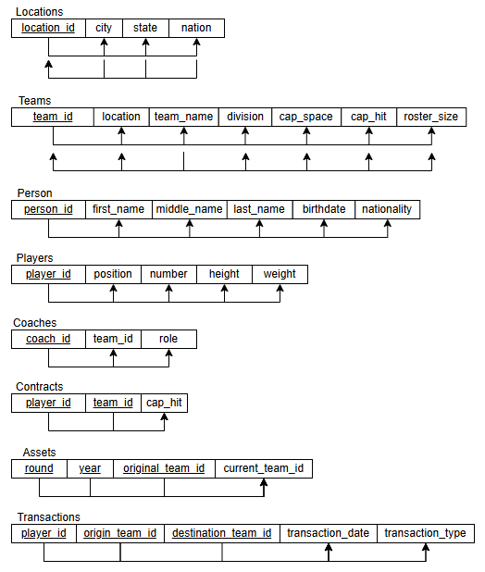

3.1 - EER Model:

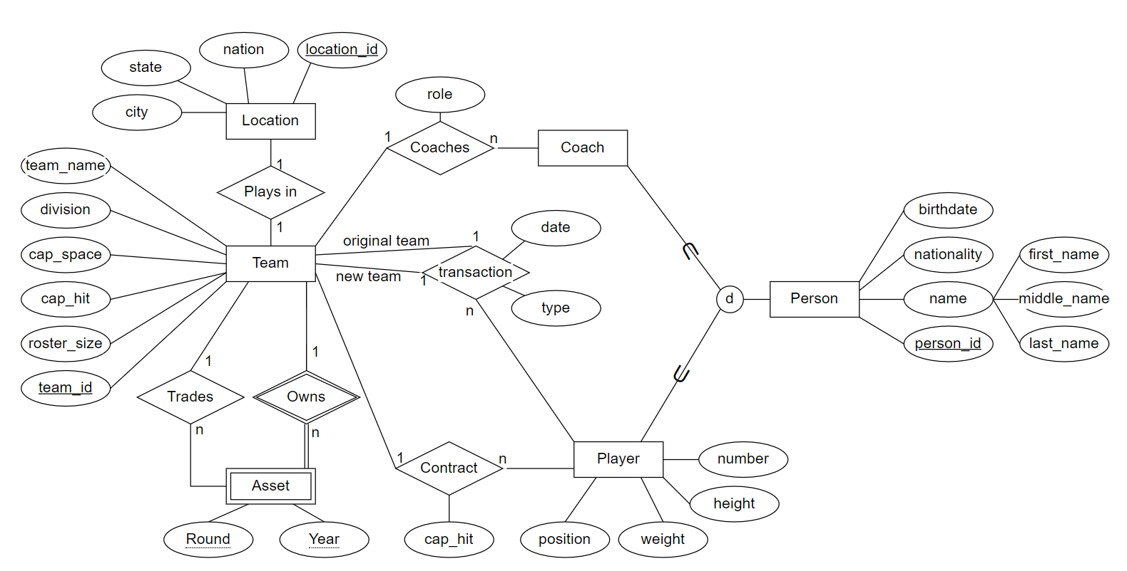

* One component in your design that makes it an Enhanced ER (EER) diagram: Person as a superclass of players and coaches
* Composite Attribute: Name
* 1:1 Cardinality: Plays In
* 1:M Cardinality: Team:Players, Team:Coaches (one team can have multiple players and/or coaches)
* M:N Cardinality: Players:Transactions (players may be involved in multiple transactions with different teams)
* Unary: Teams:Teams
* Binary: Contracts:Teams:Players
* Ternary: Transactions:Teams:Players
* Weak entity: Assets

3.2 - Relational Model:

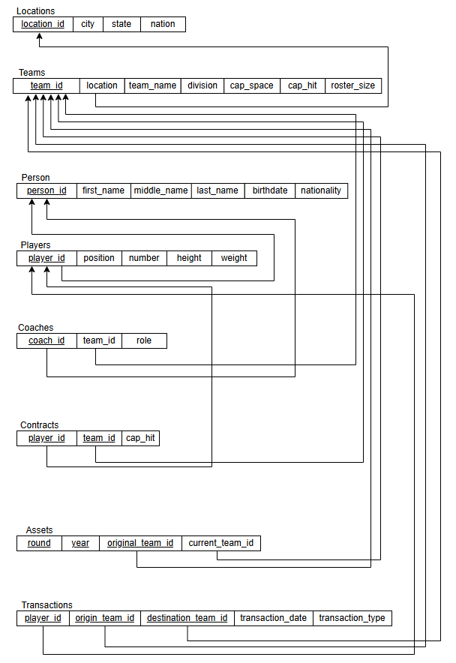

3.3 - Database Creation Statement Screenshot:

- Note: due to the sheer number of players in the NHL, some of the database insertion statements are very, very, very long. I have provided the actual files in the .zip for your ease, but am also including screenshots as the instructions have required. For my screenshots of some of the larger tables, I included only portions of the tables because of the massive size of the tables.

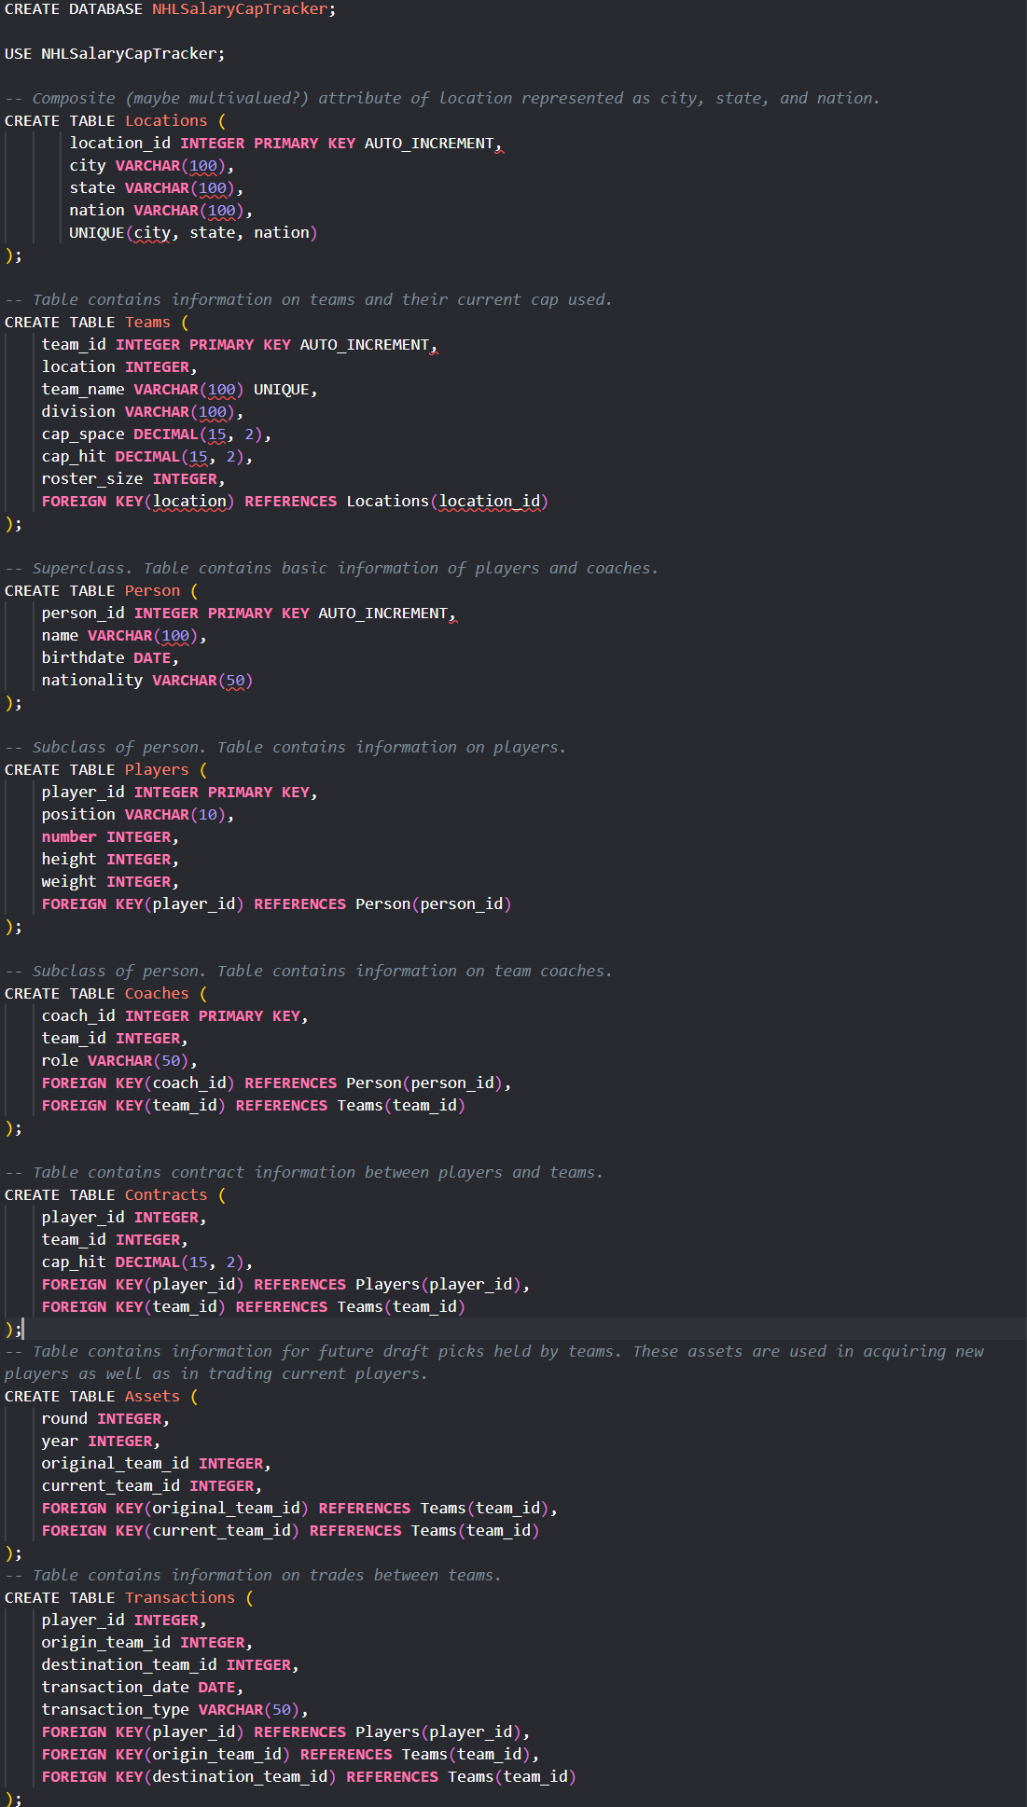

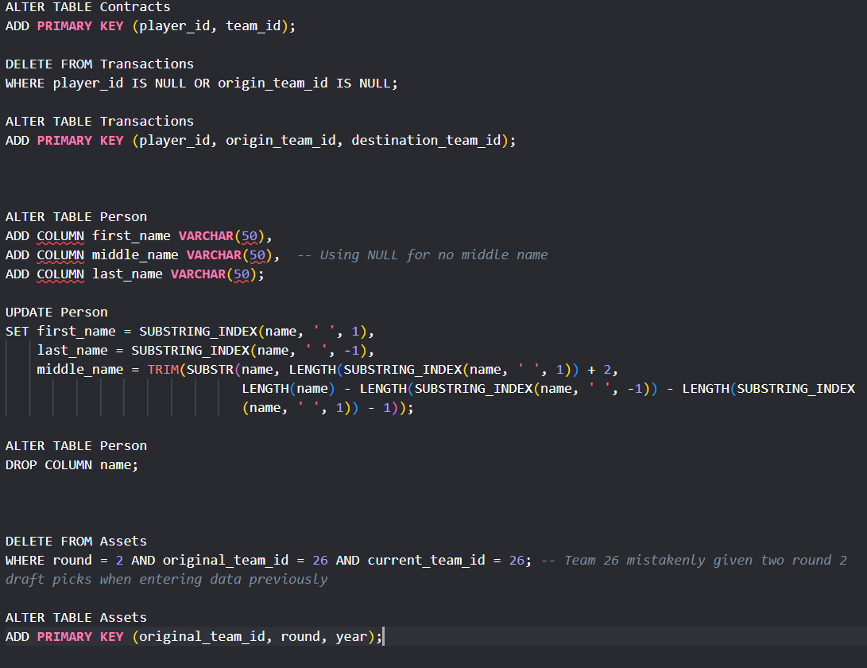

3.3 - Table Population Statement Screenshots:

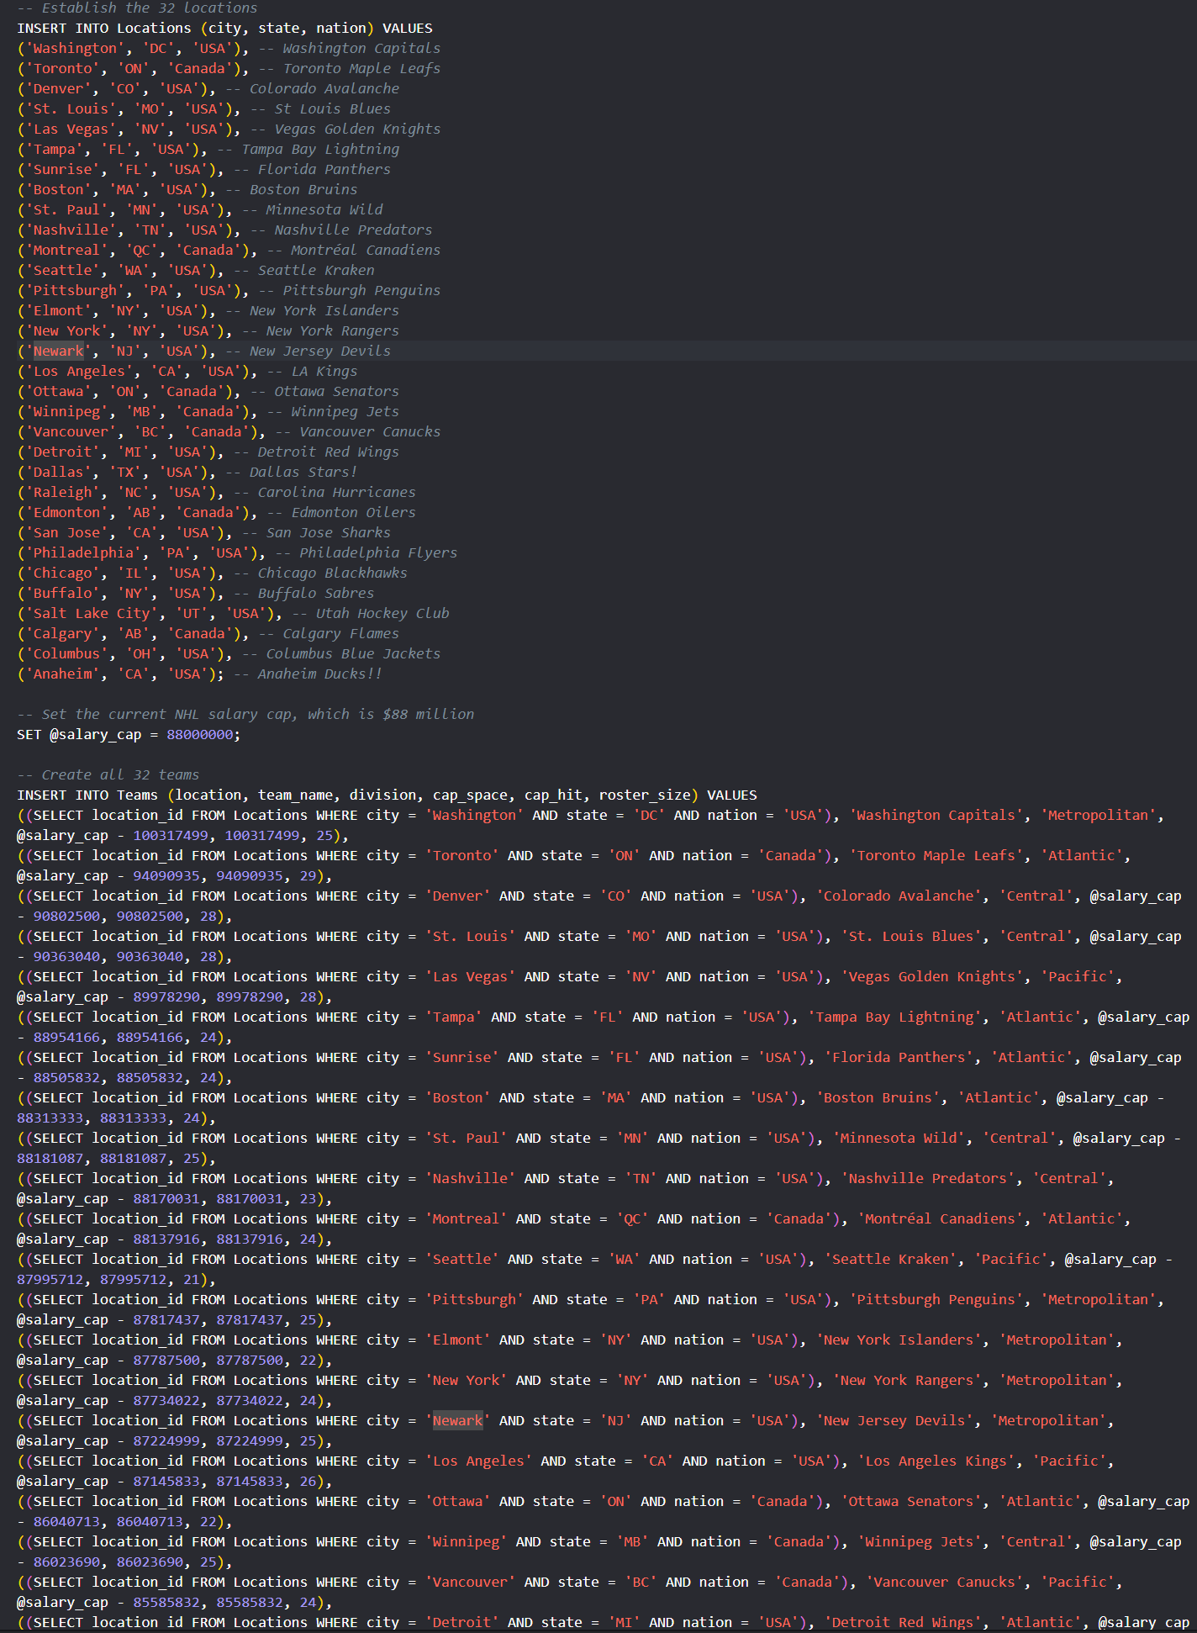

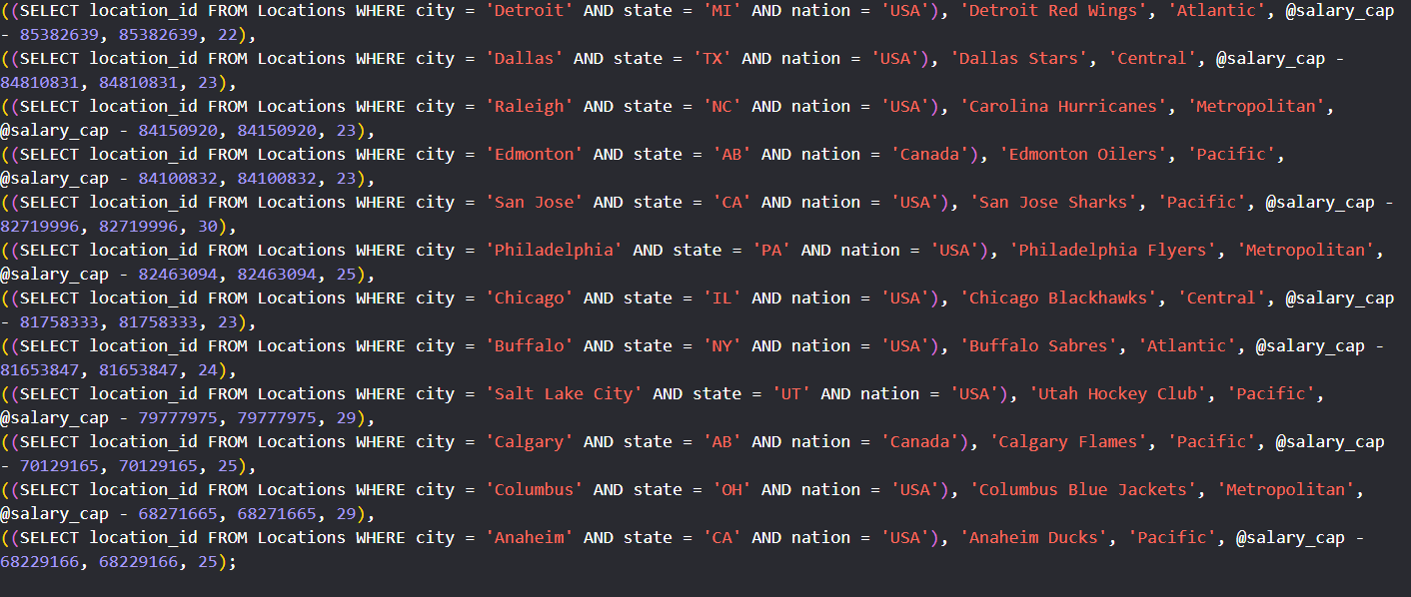

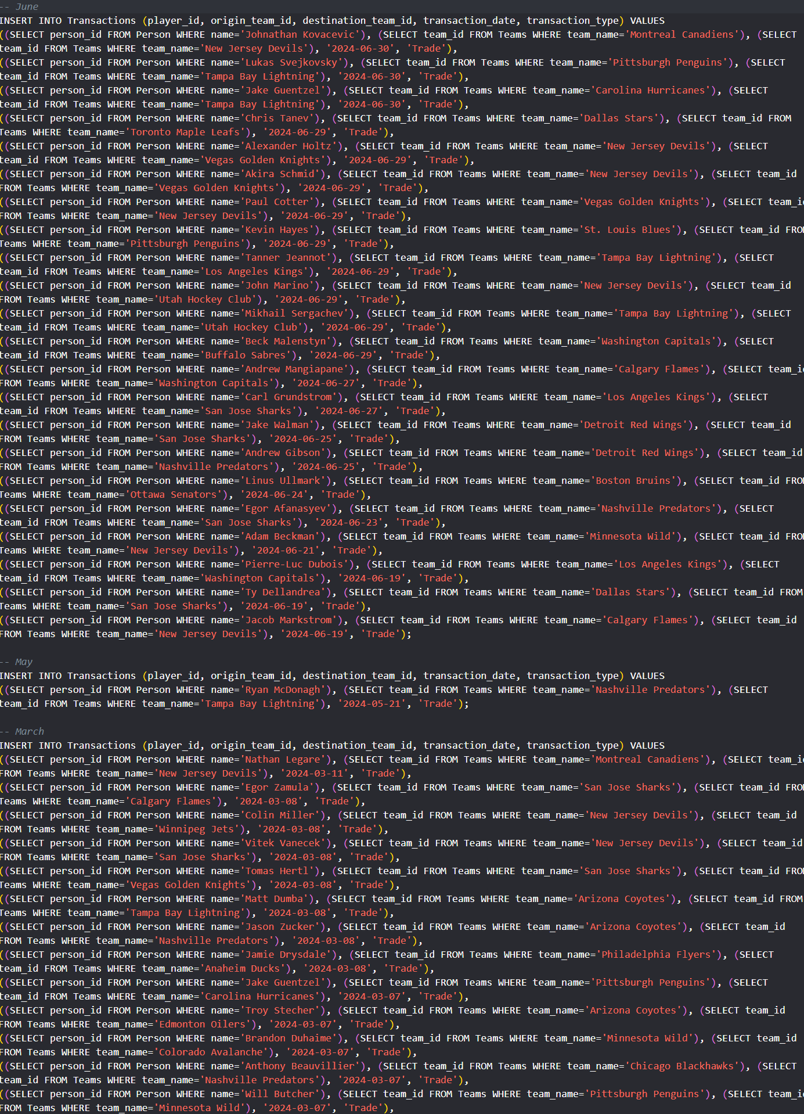

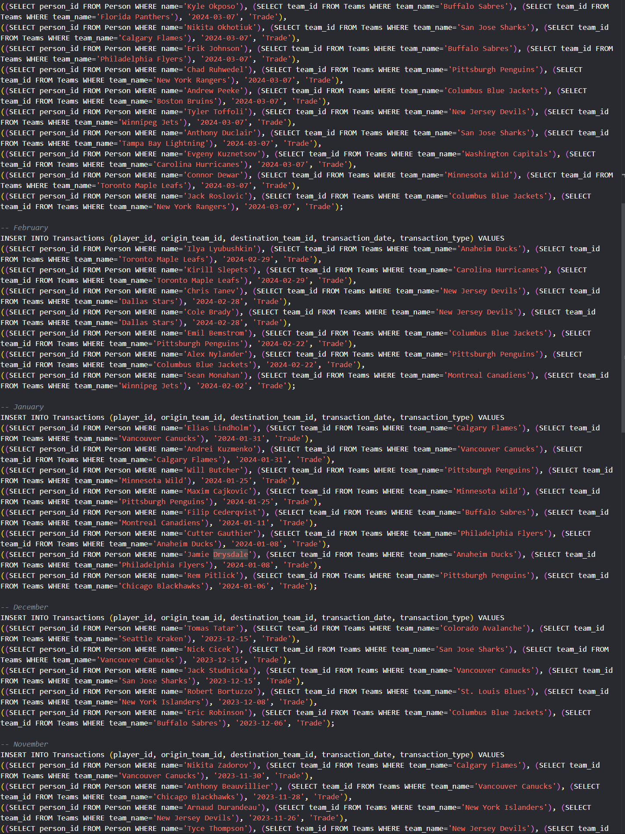

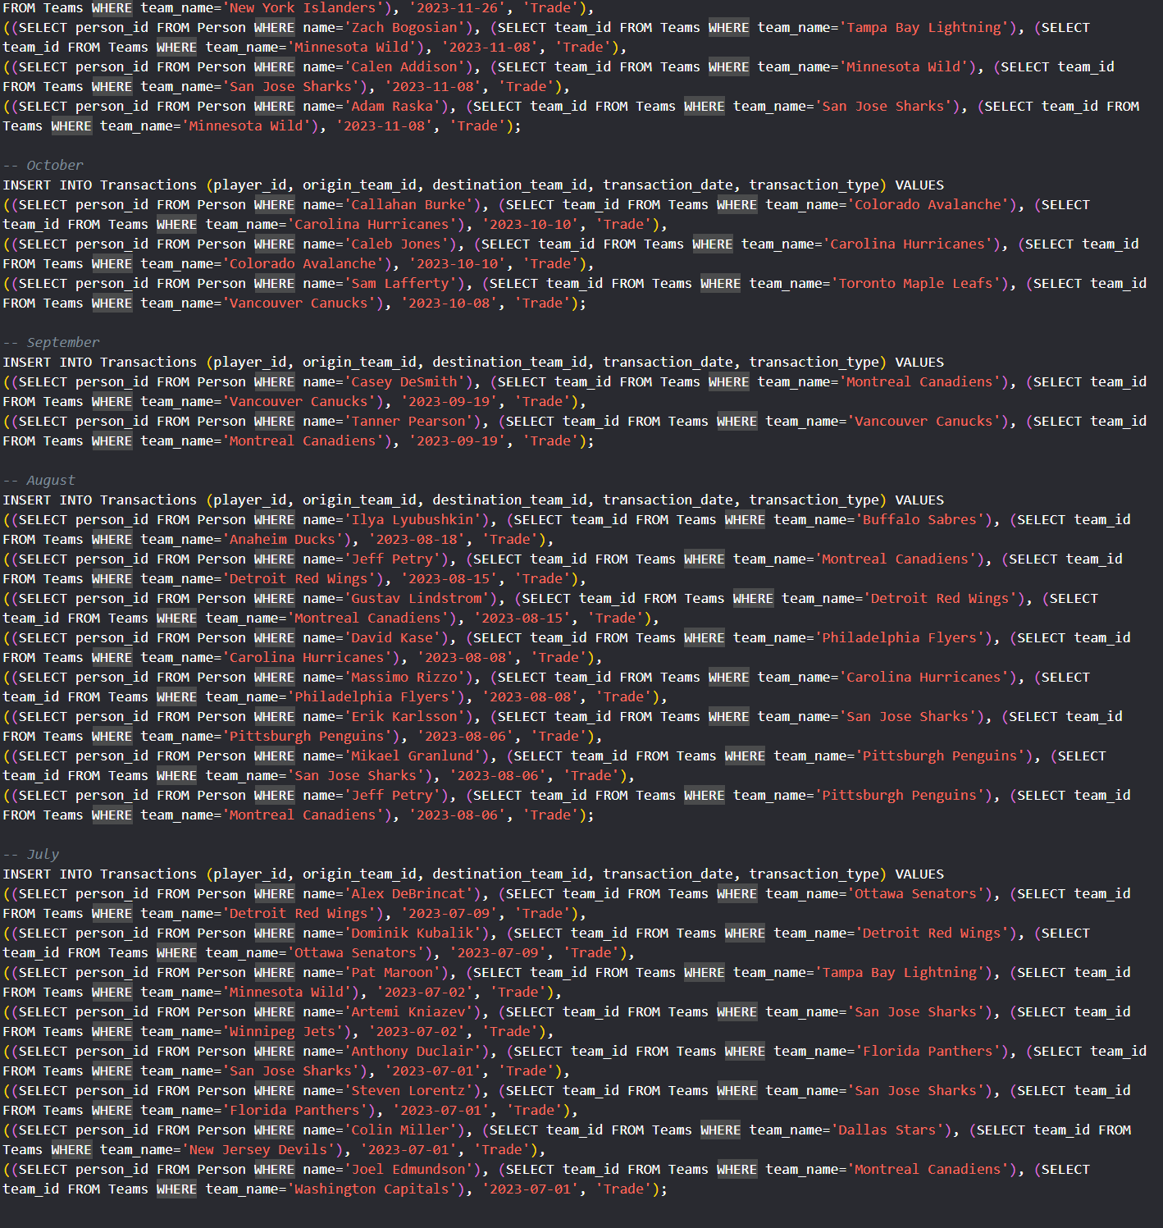

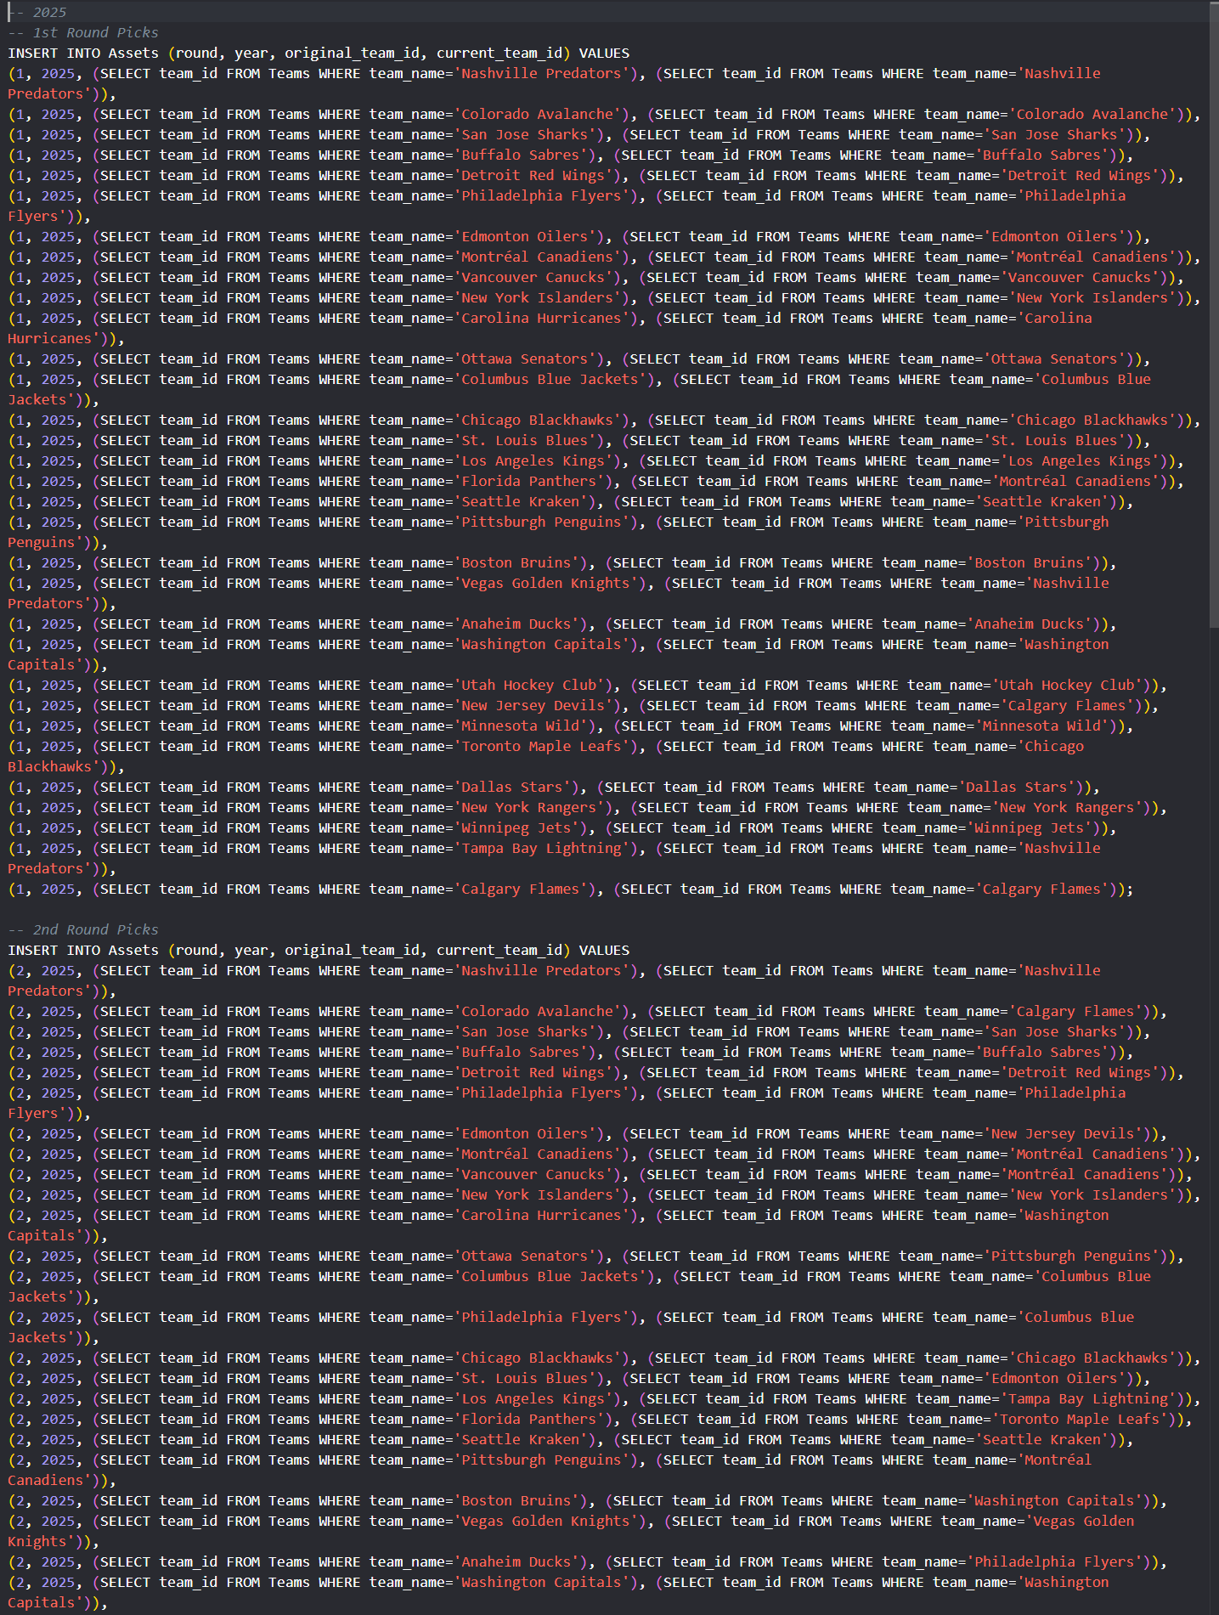

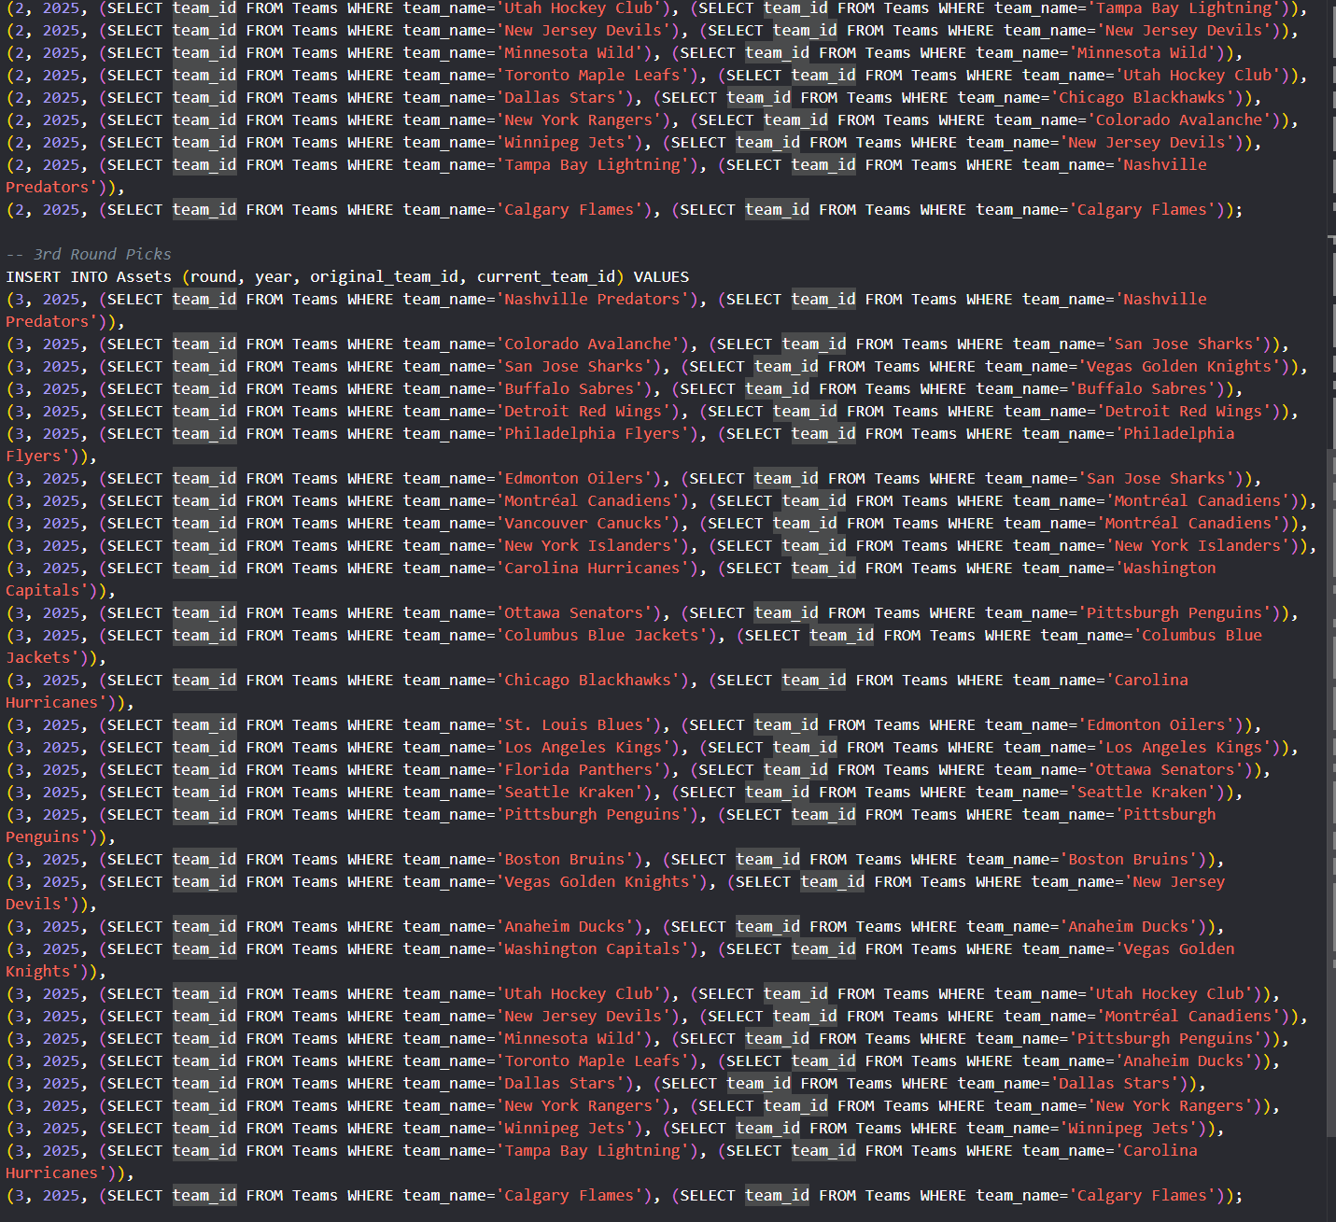

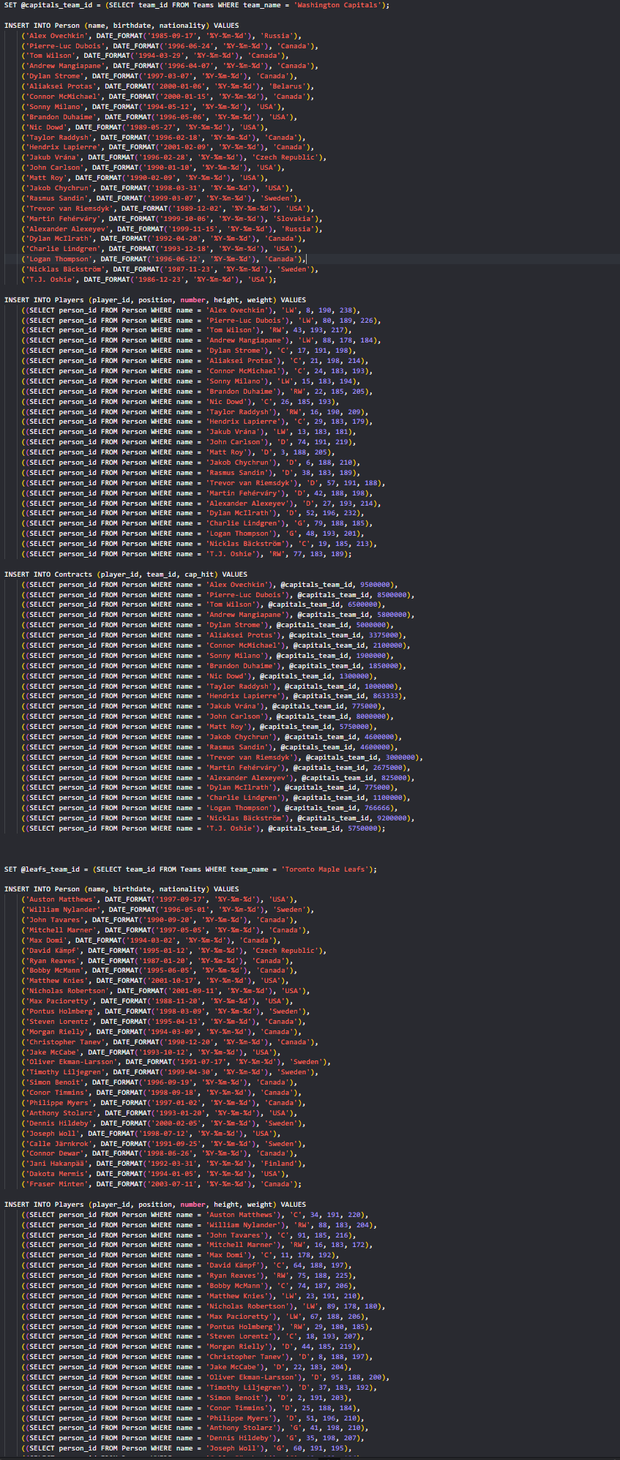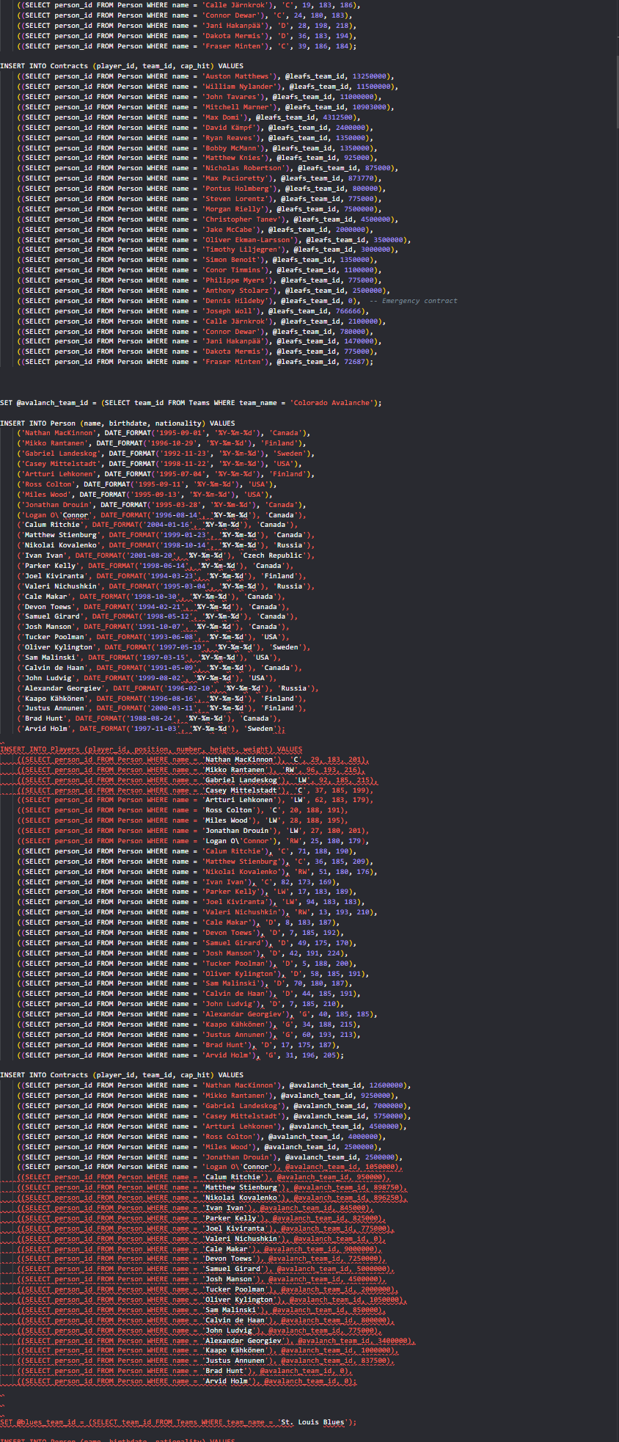 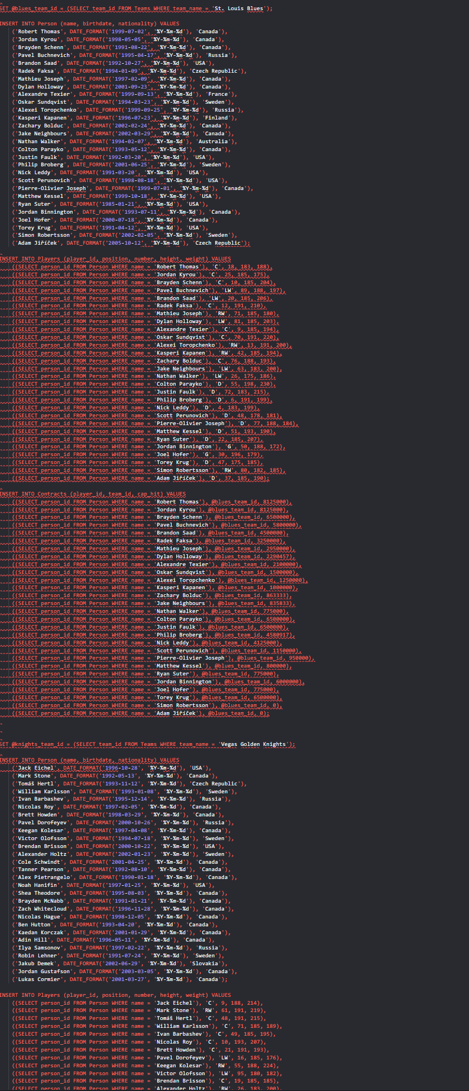 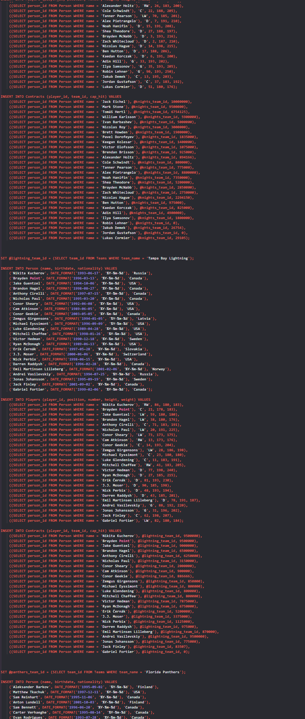 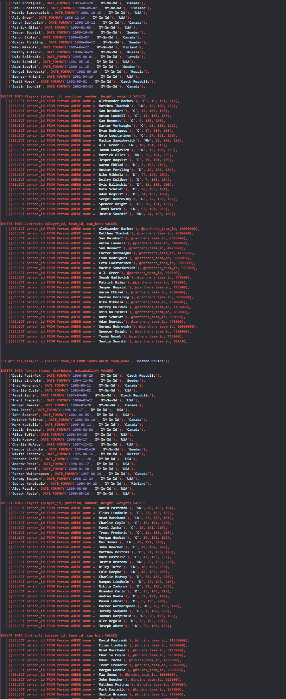 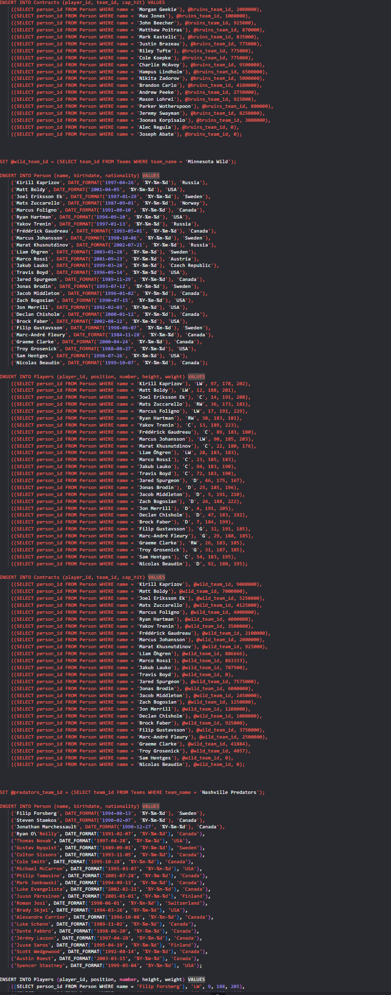 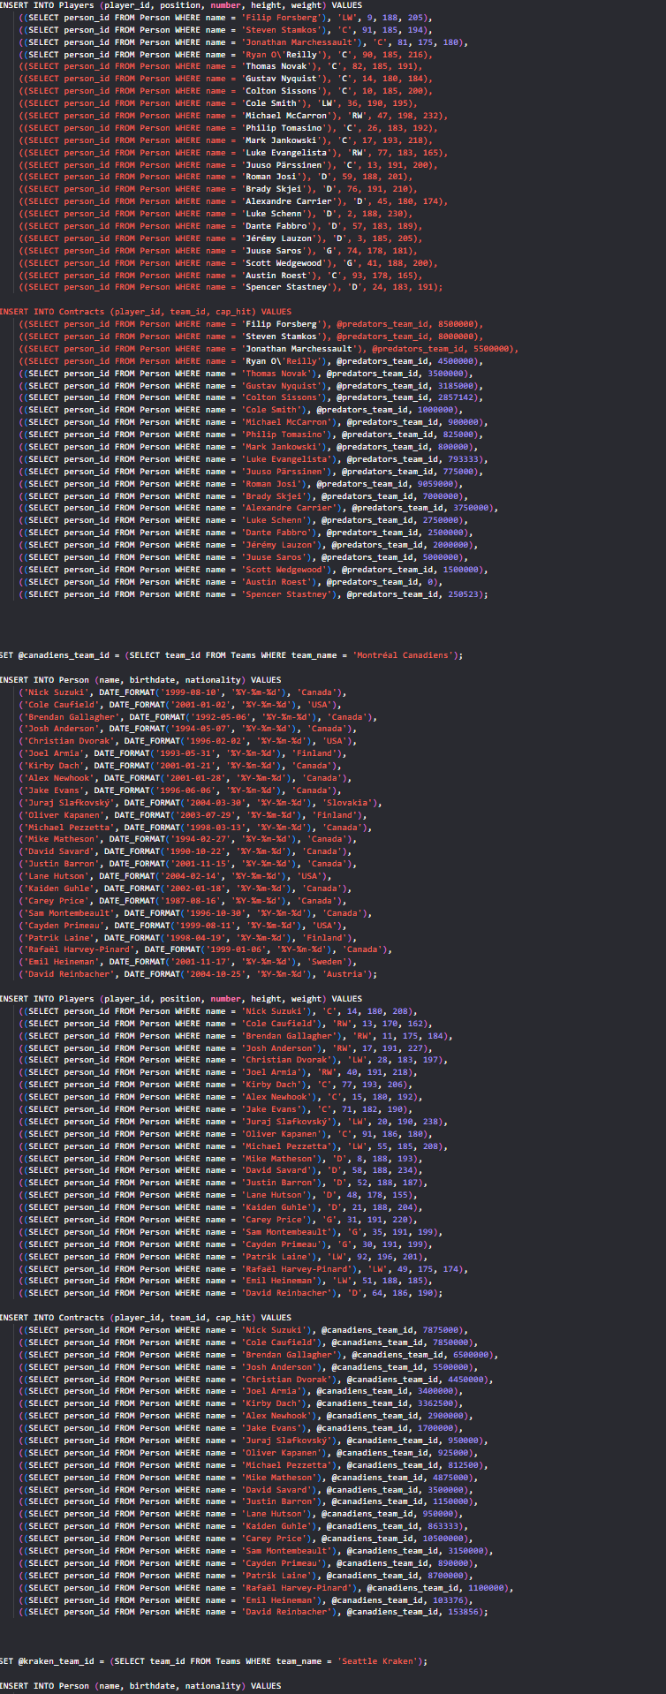 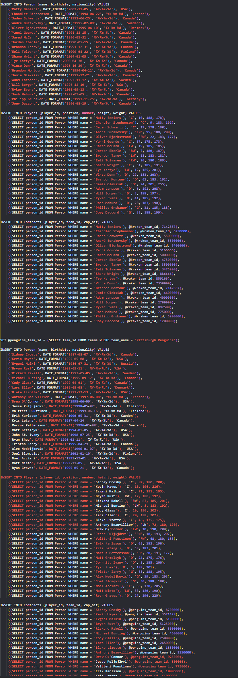 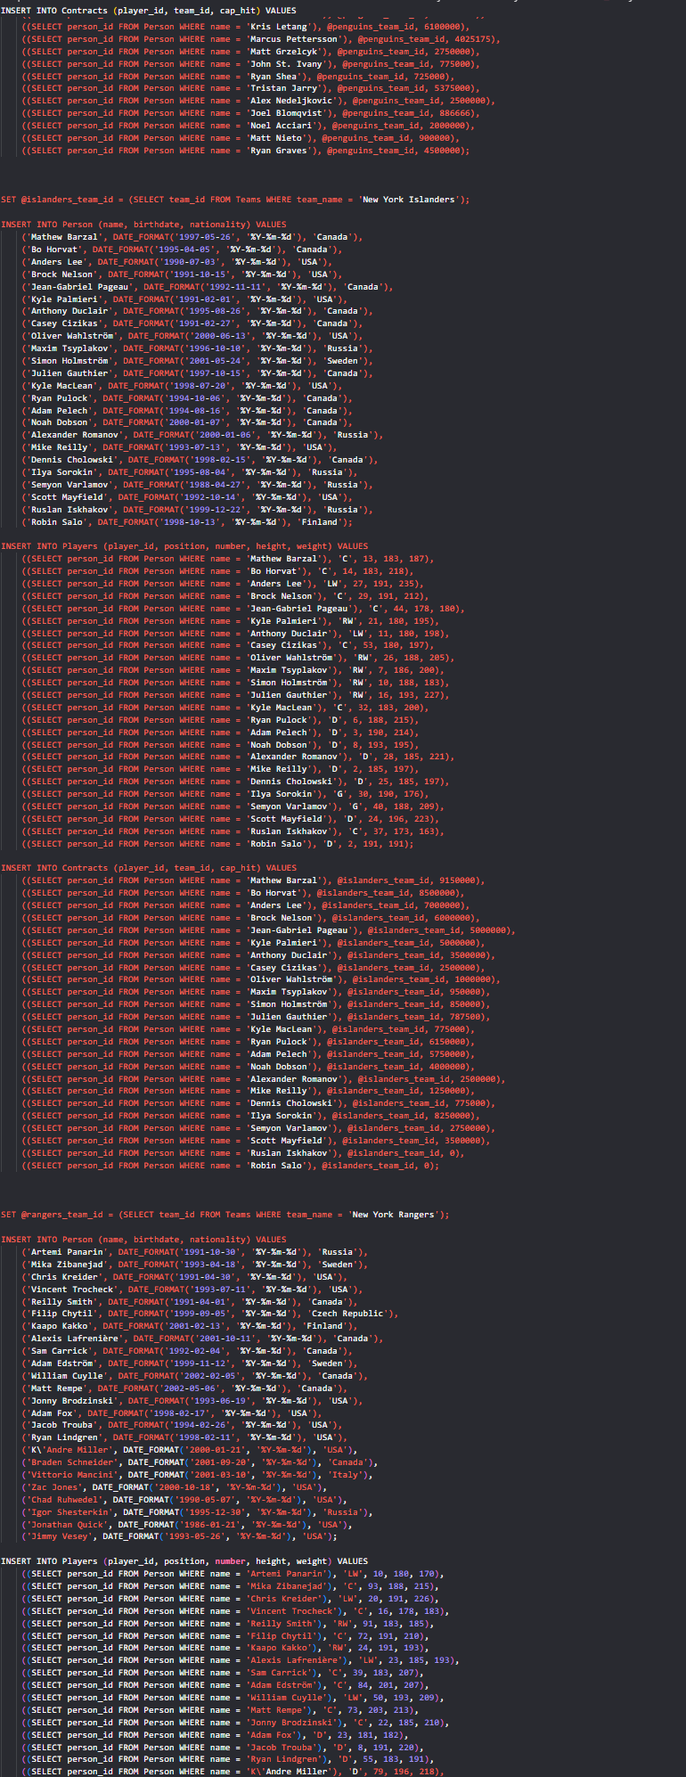 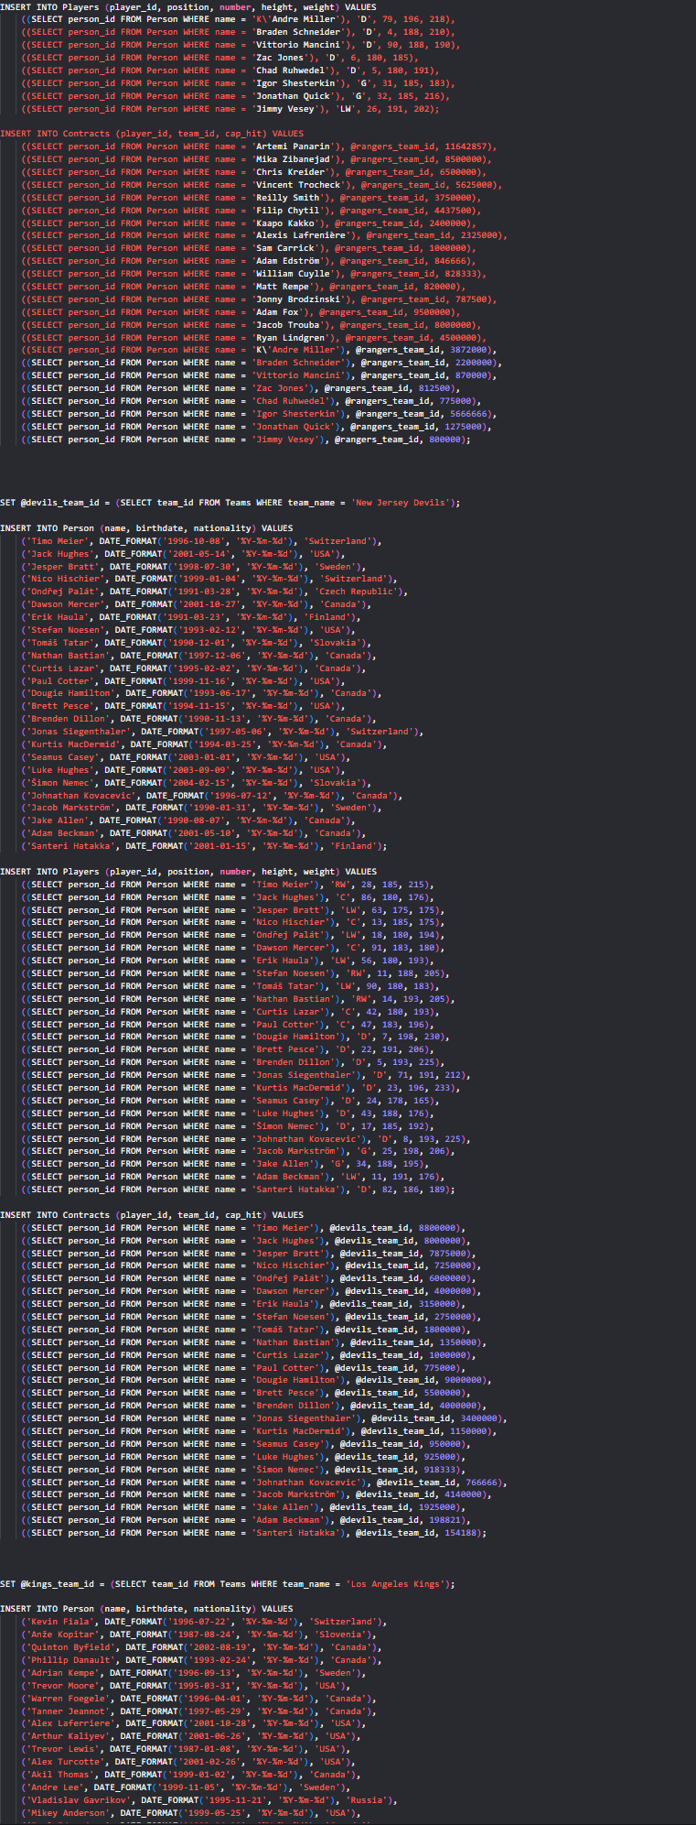 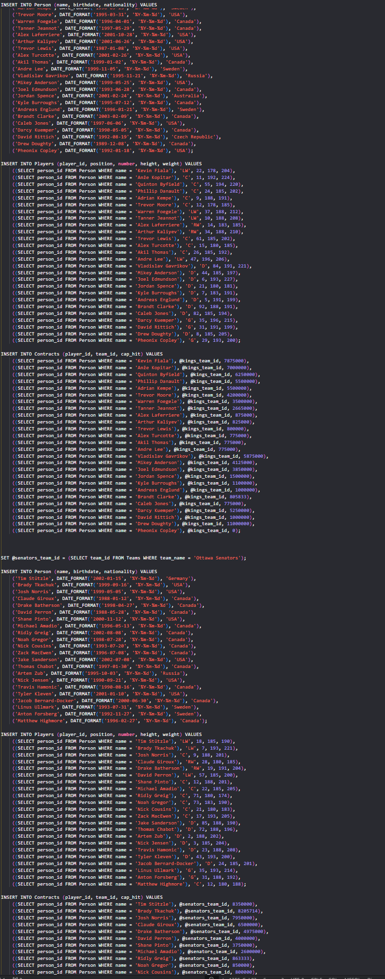 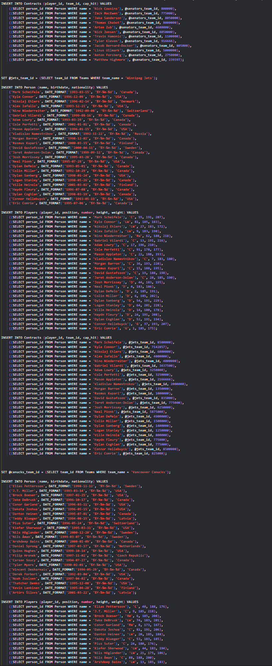 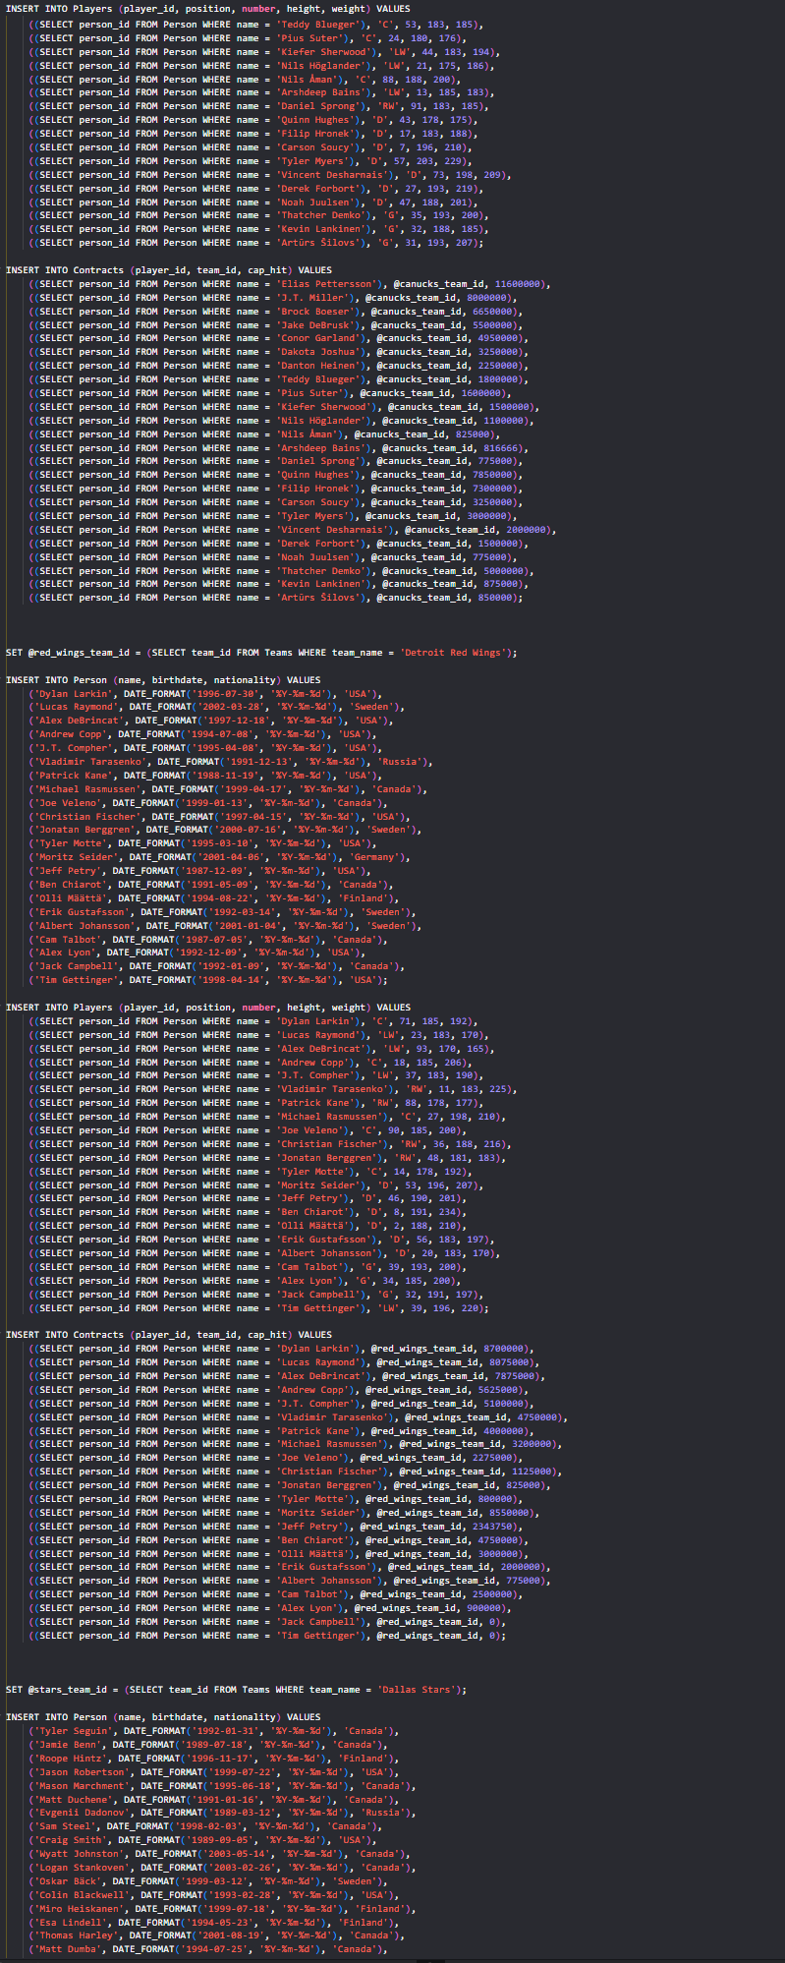 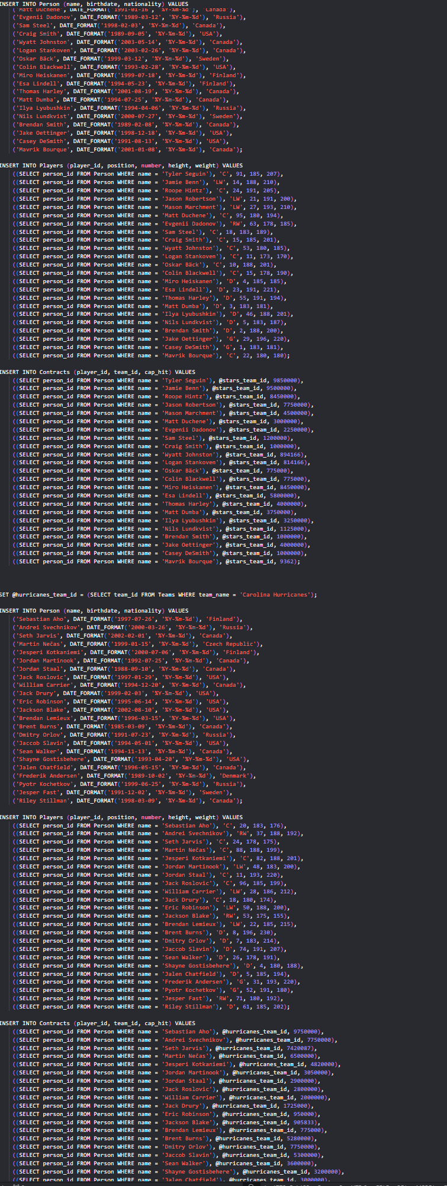 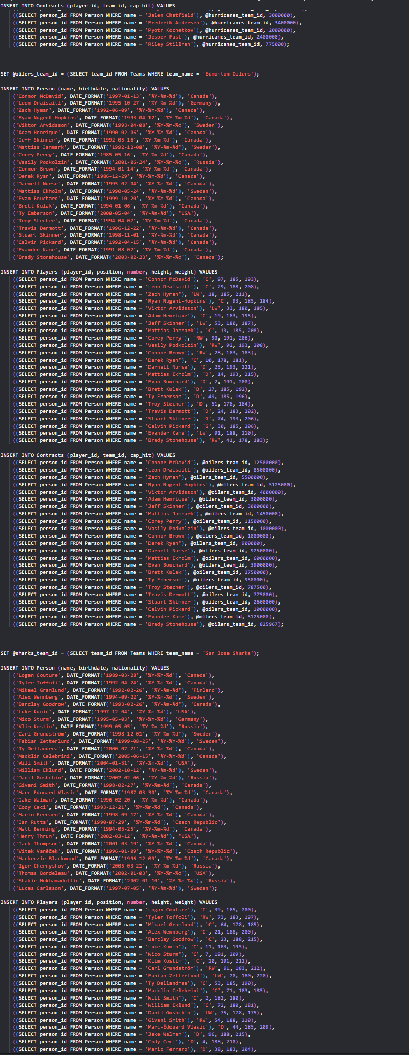 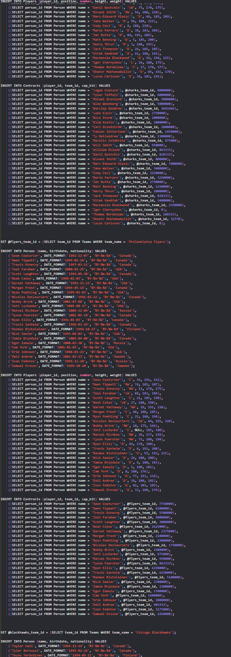 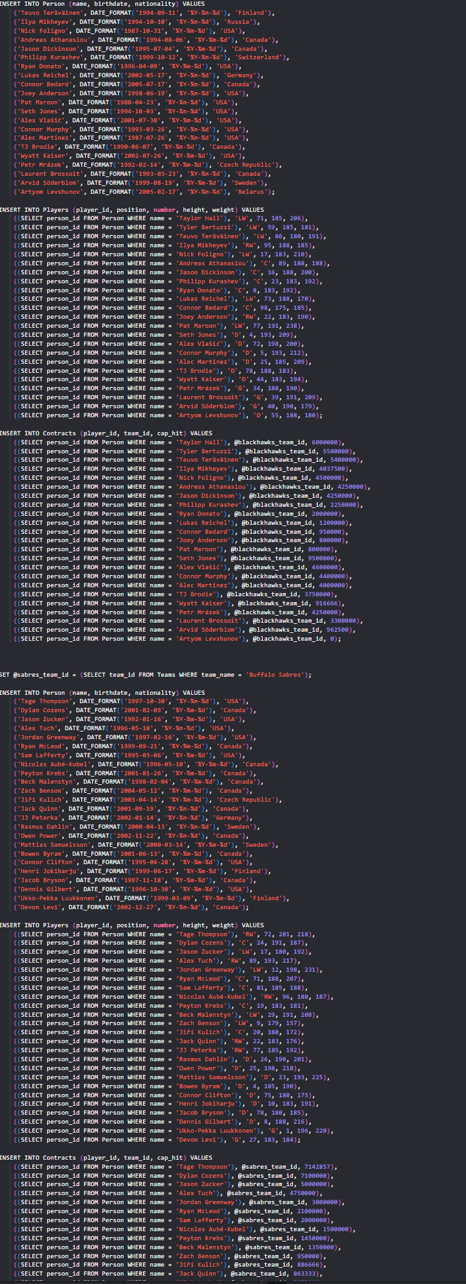

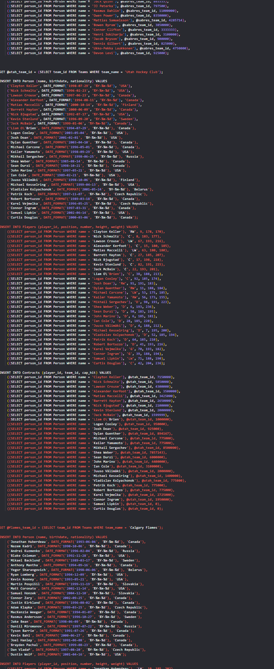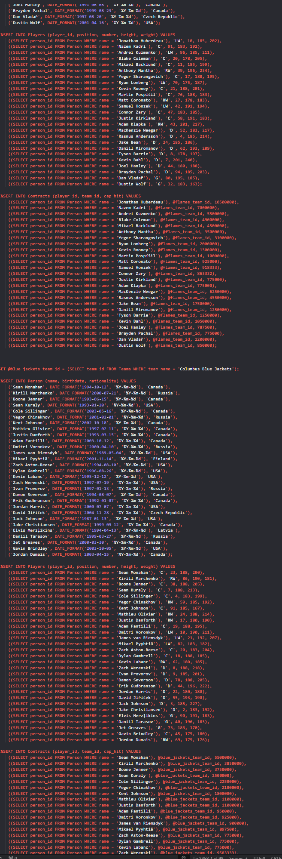 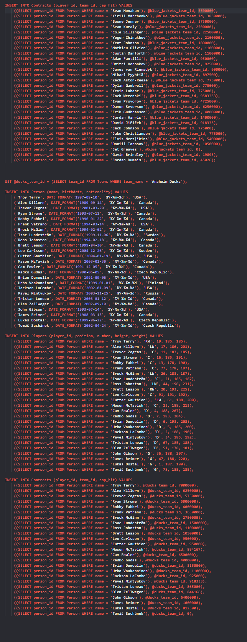

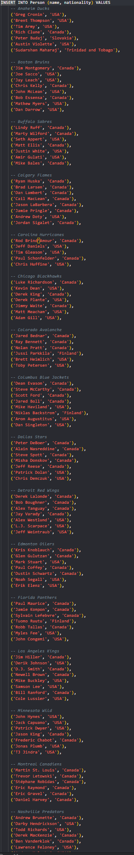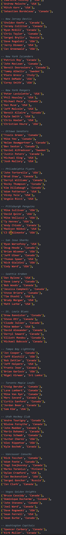 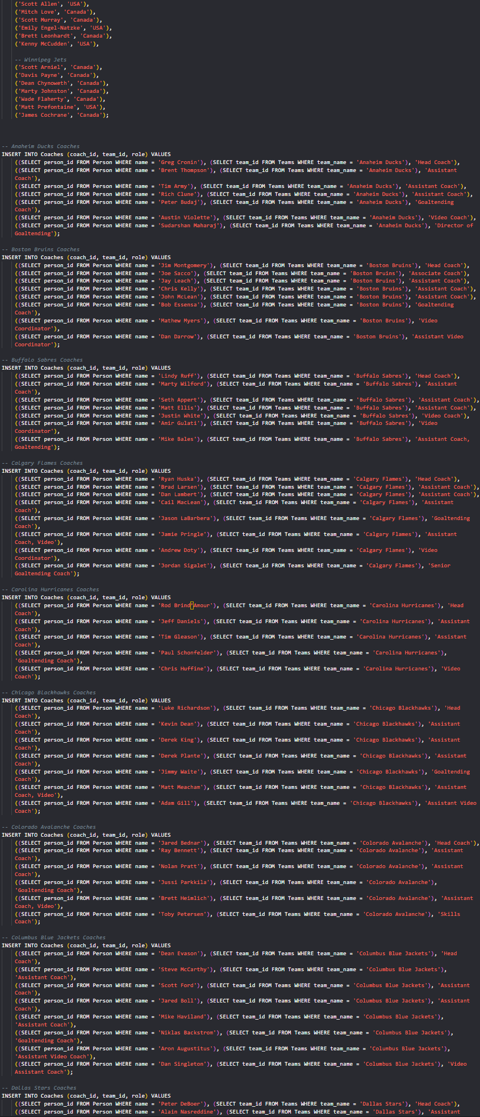 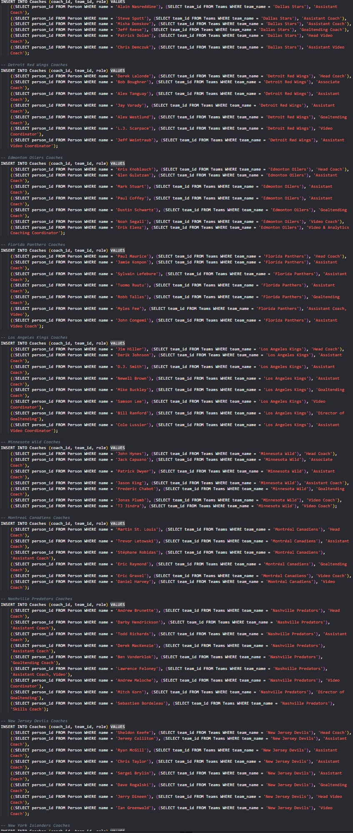 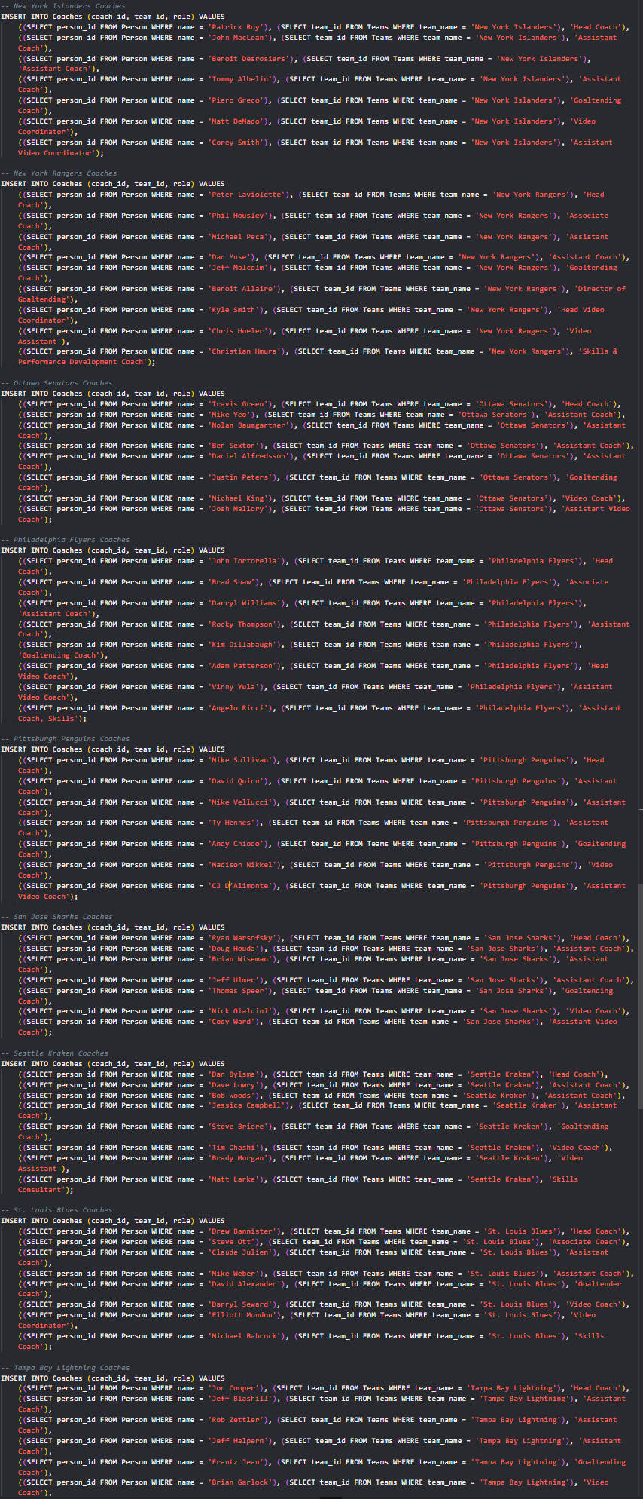 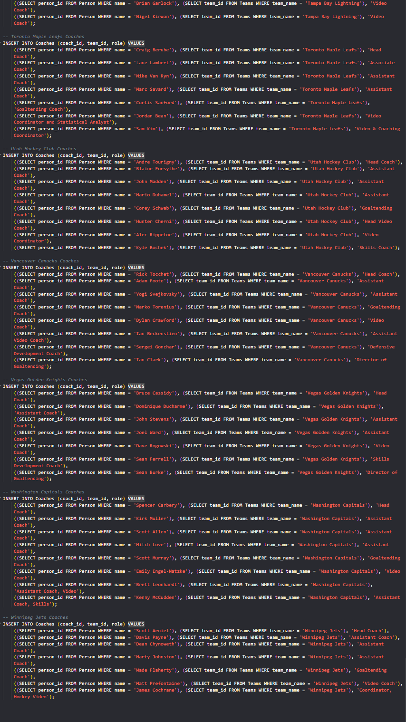

3.3 - Screenshots of Tables:

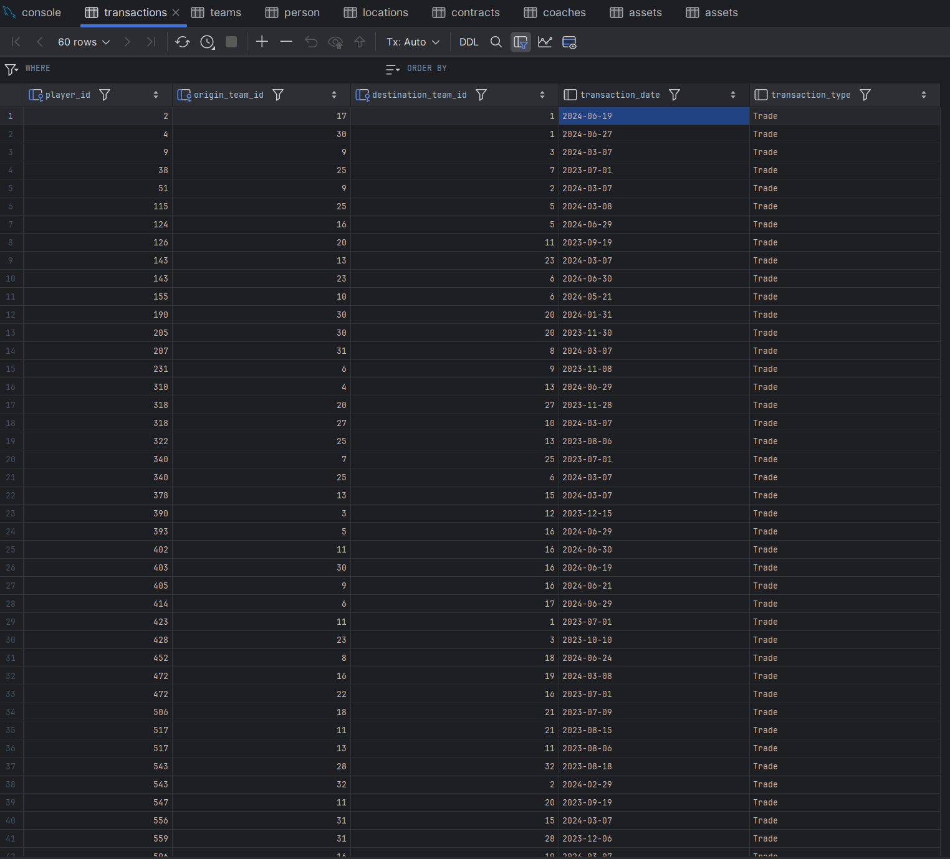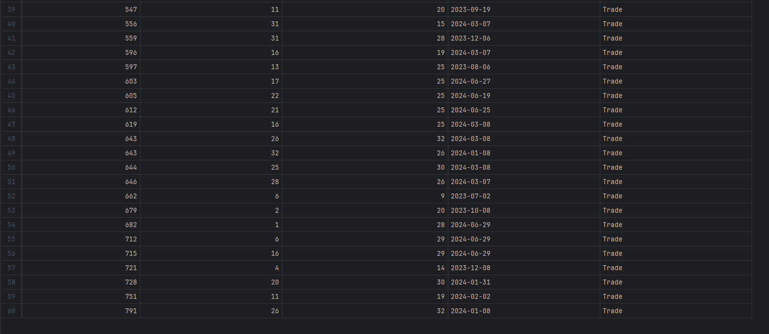

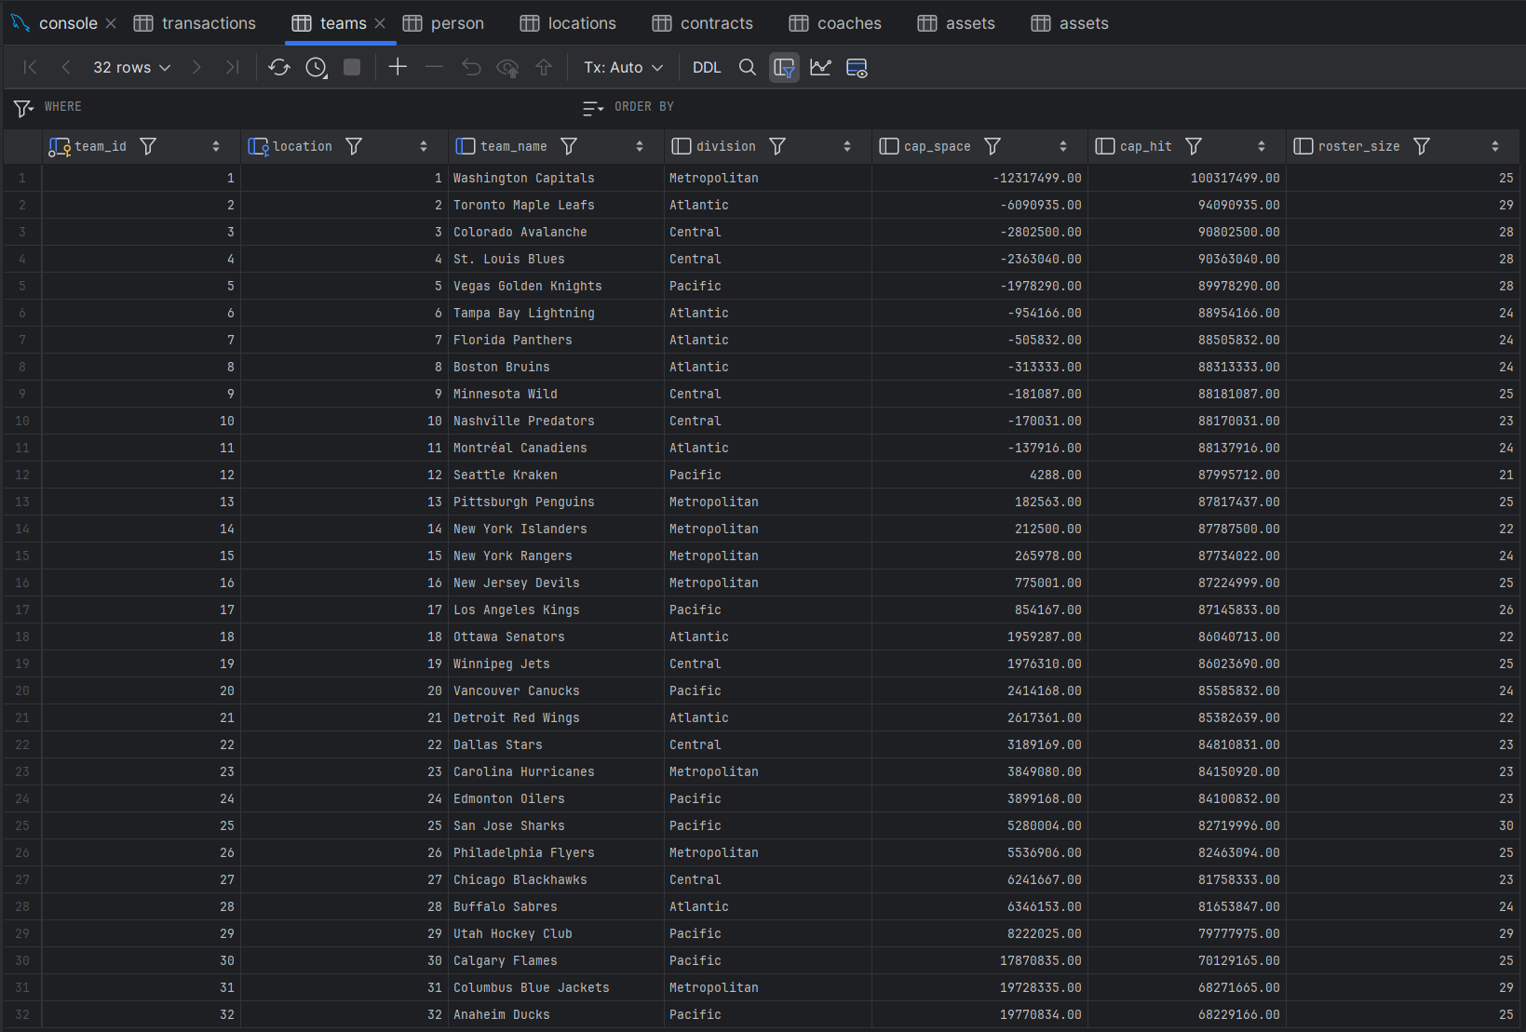

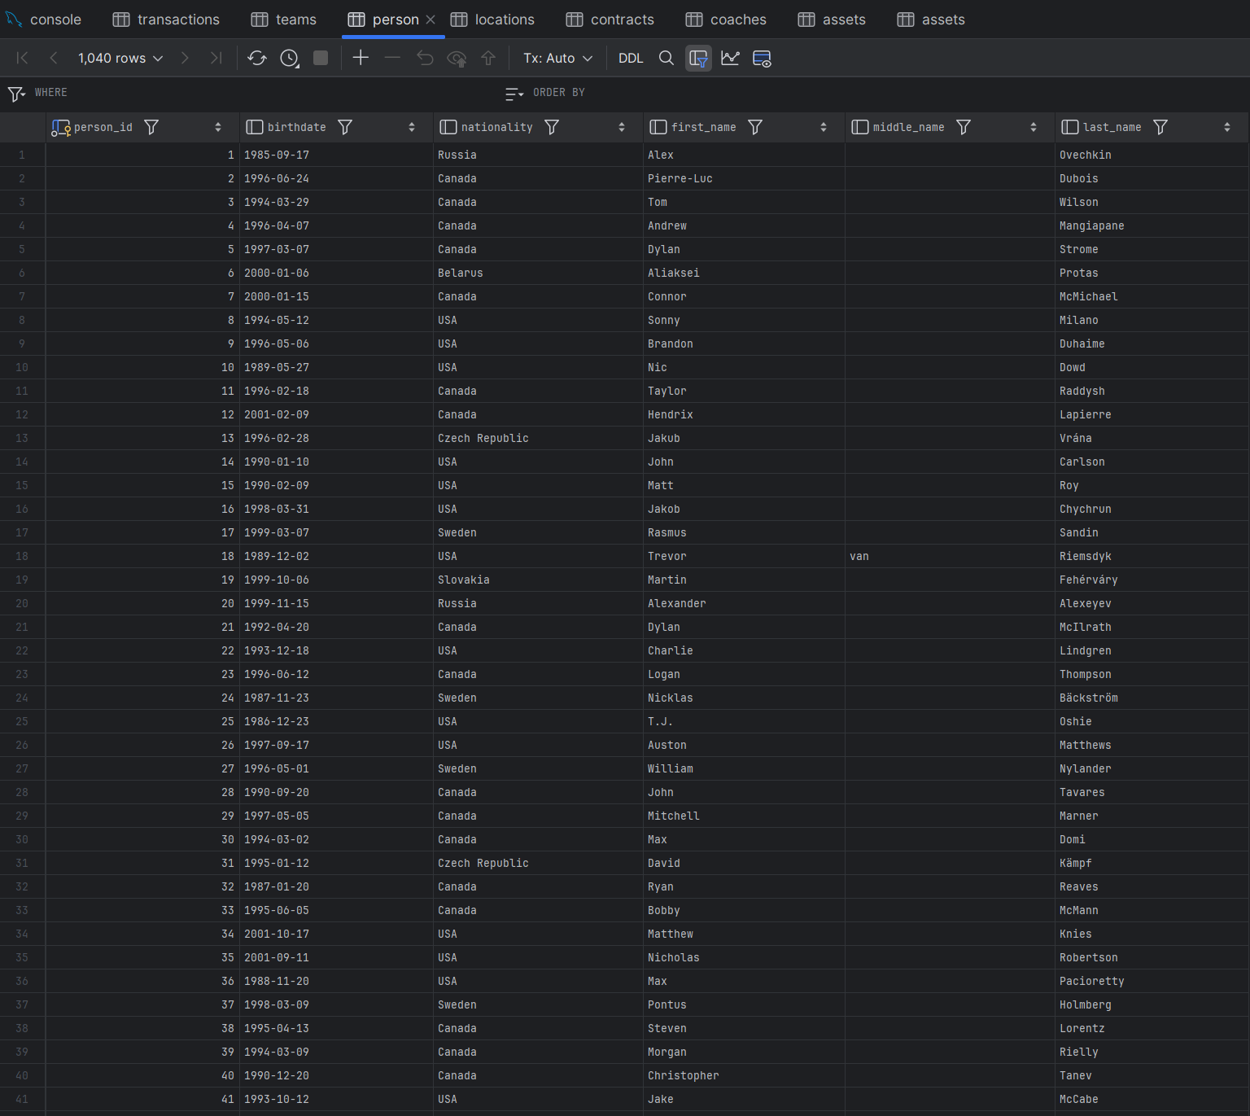

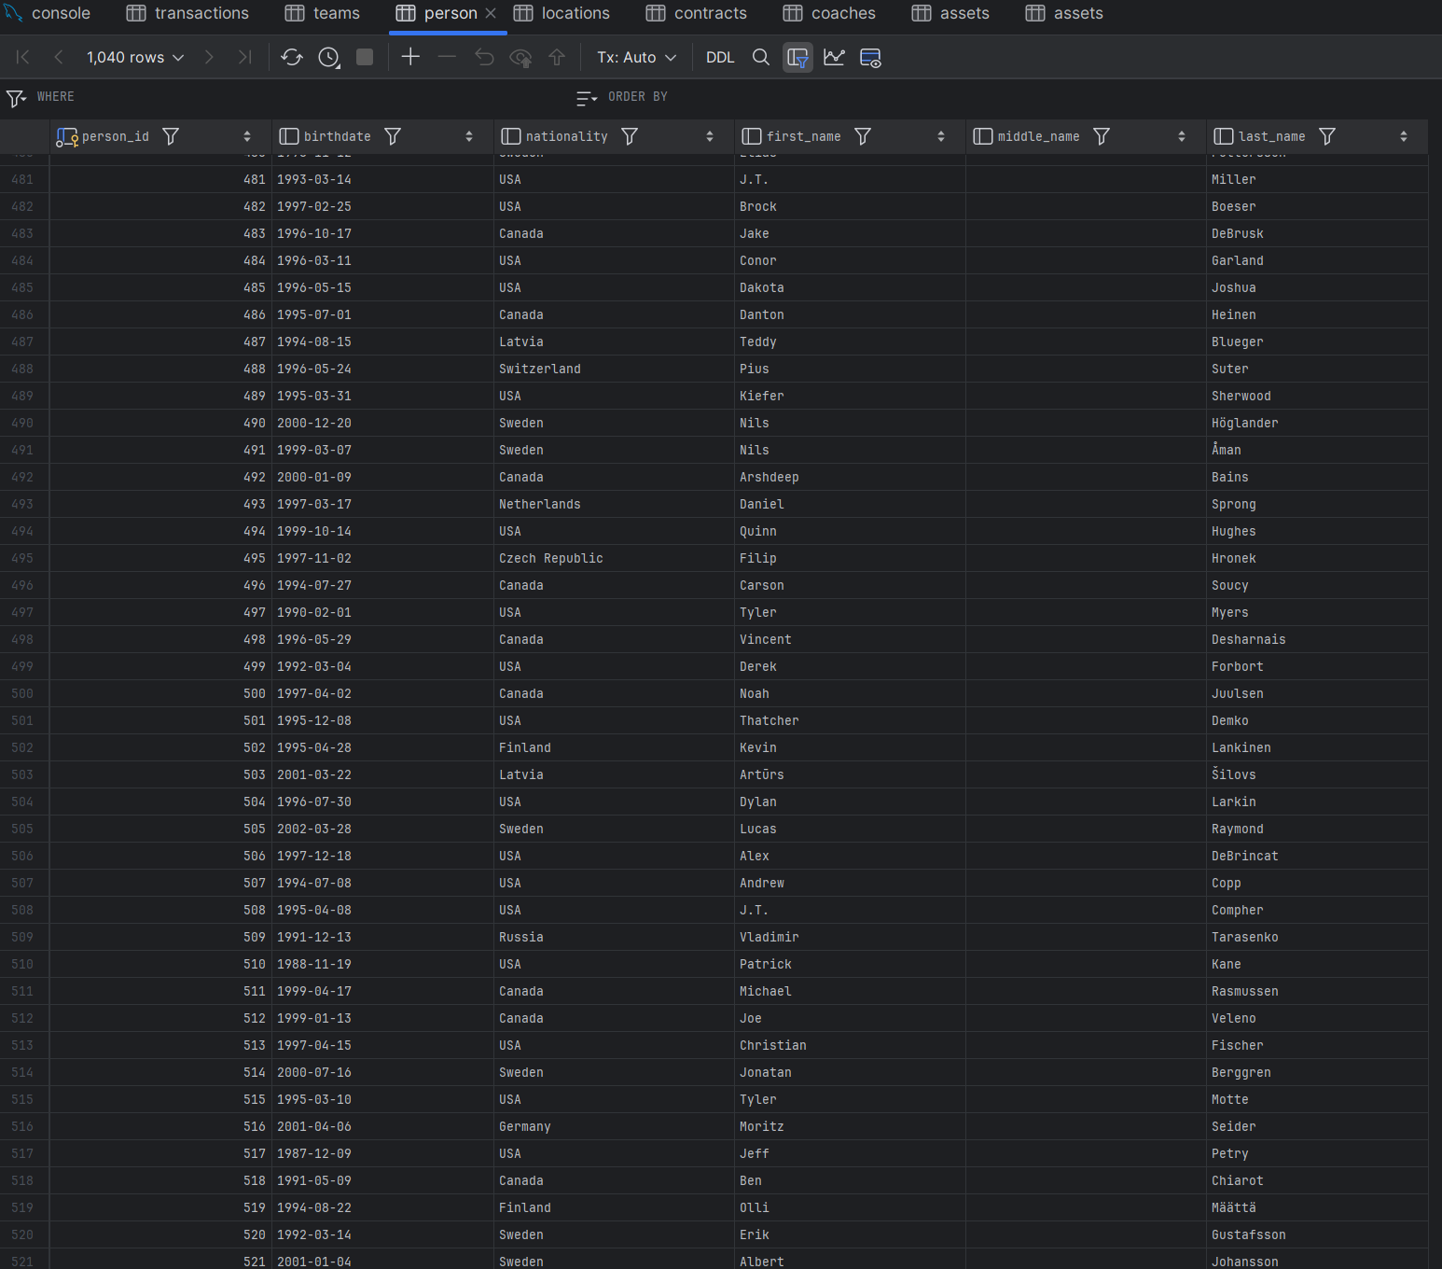

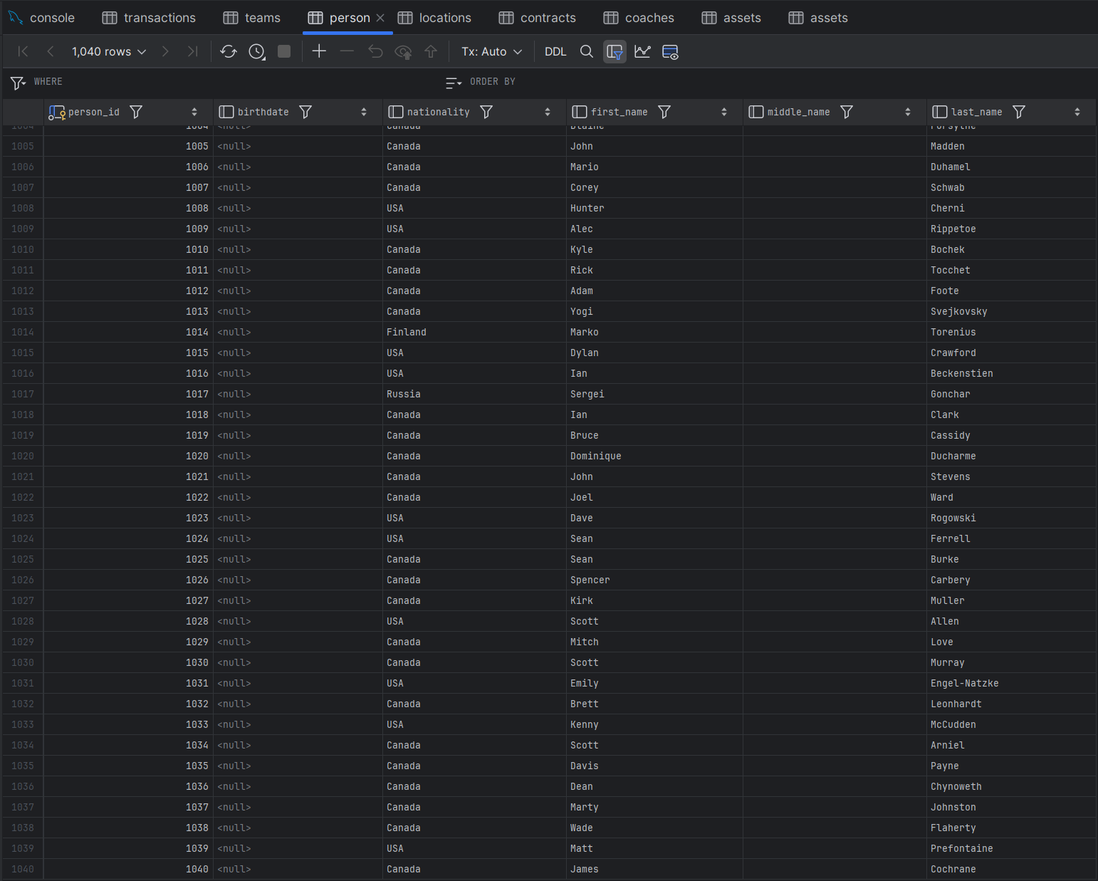

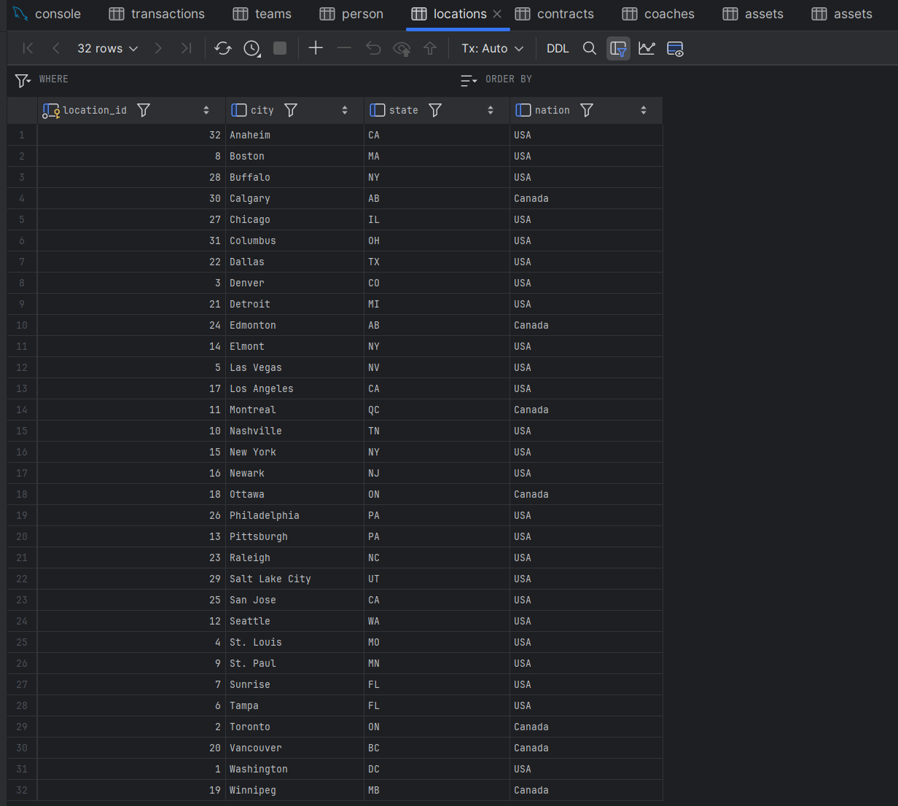

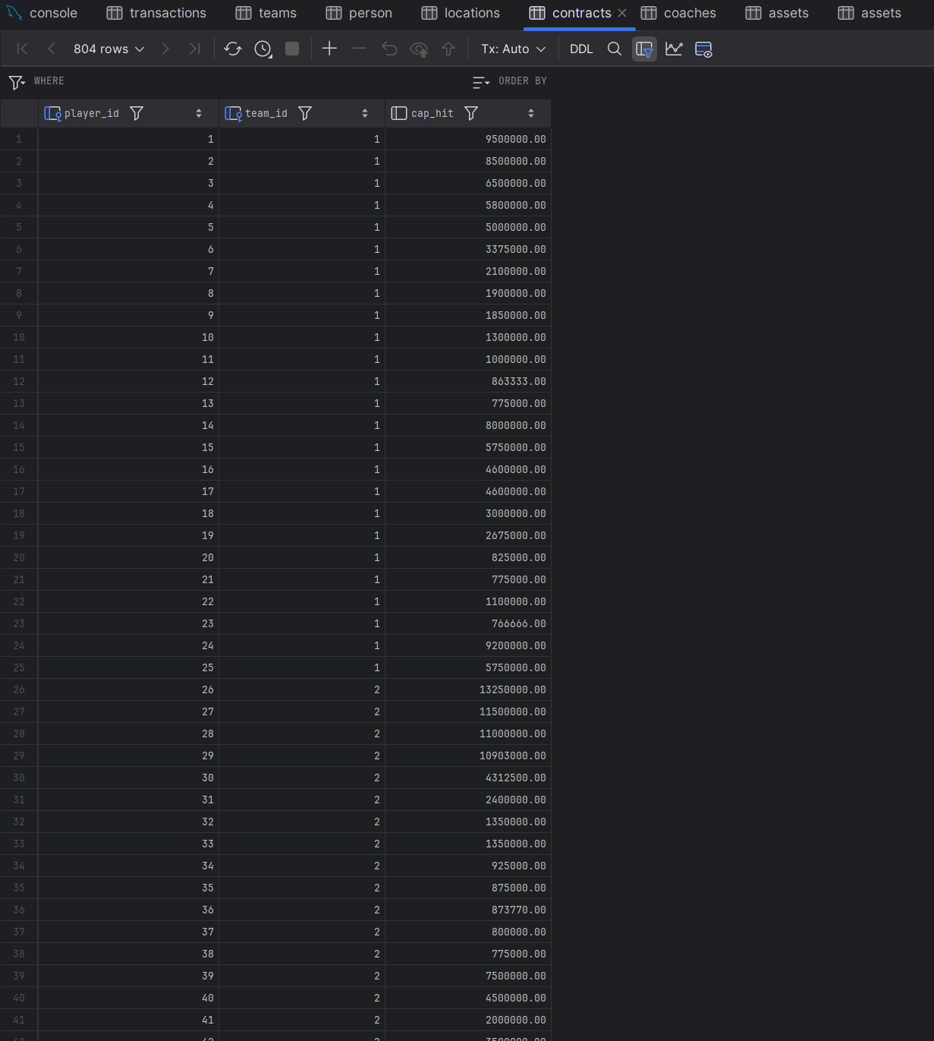

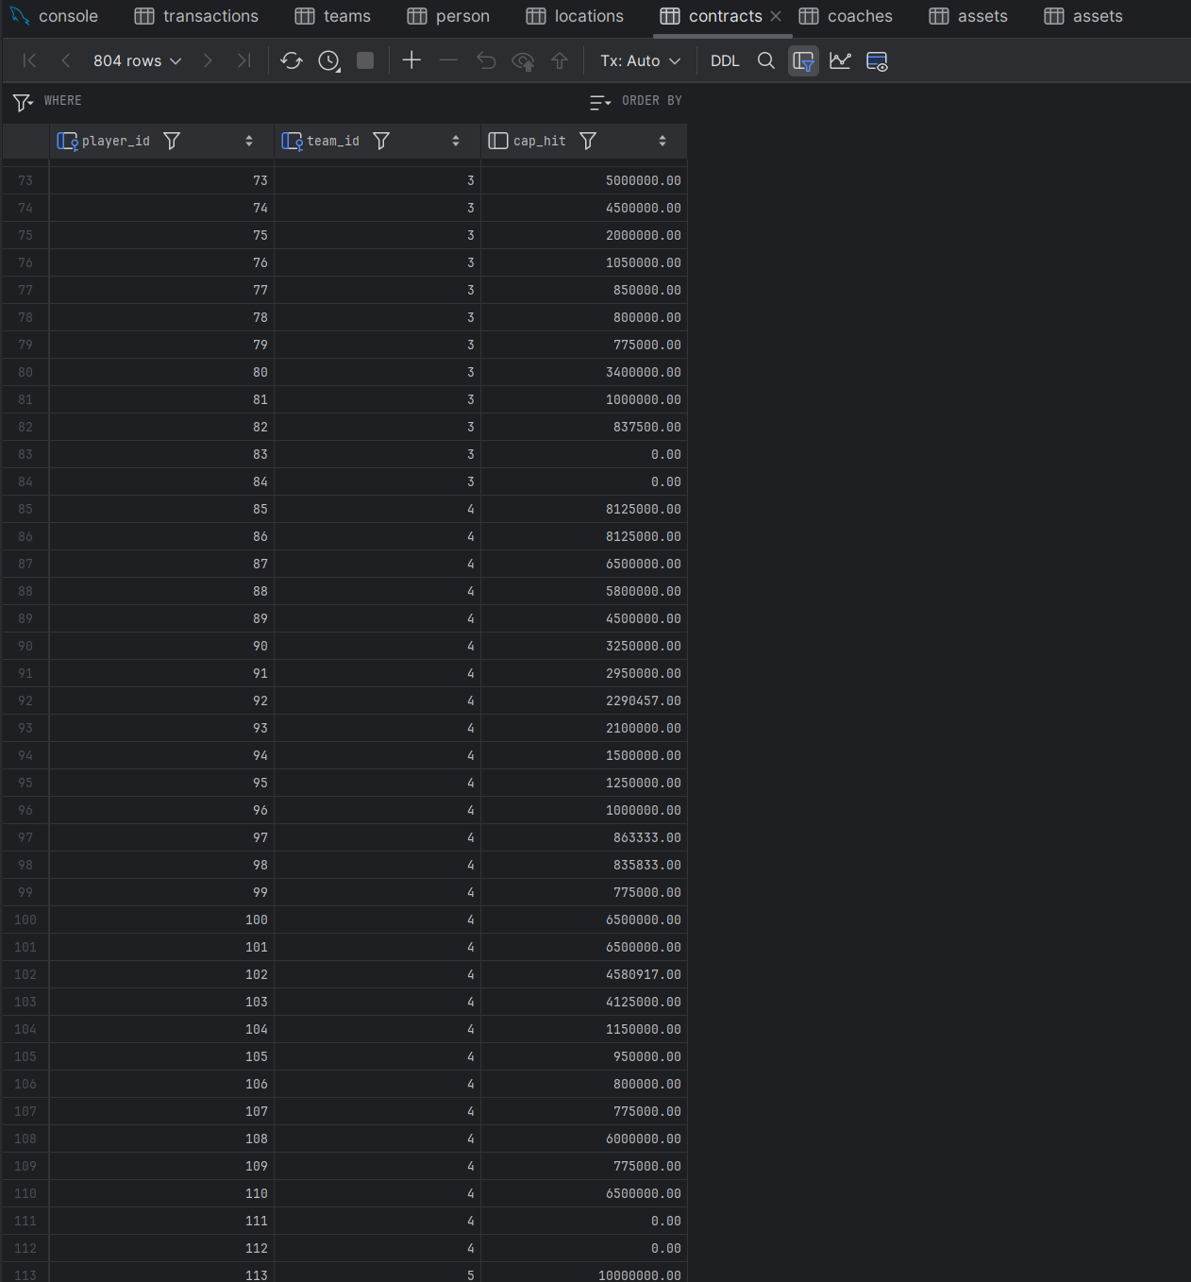

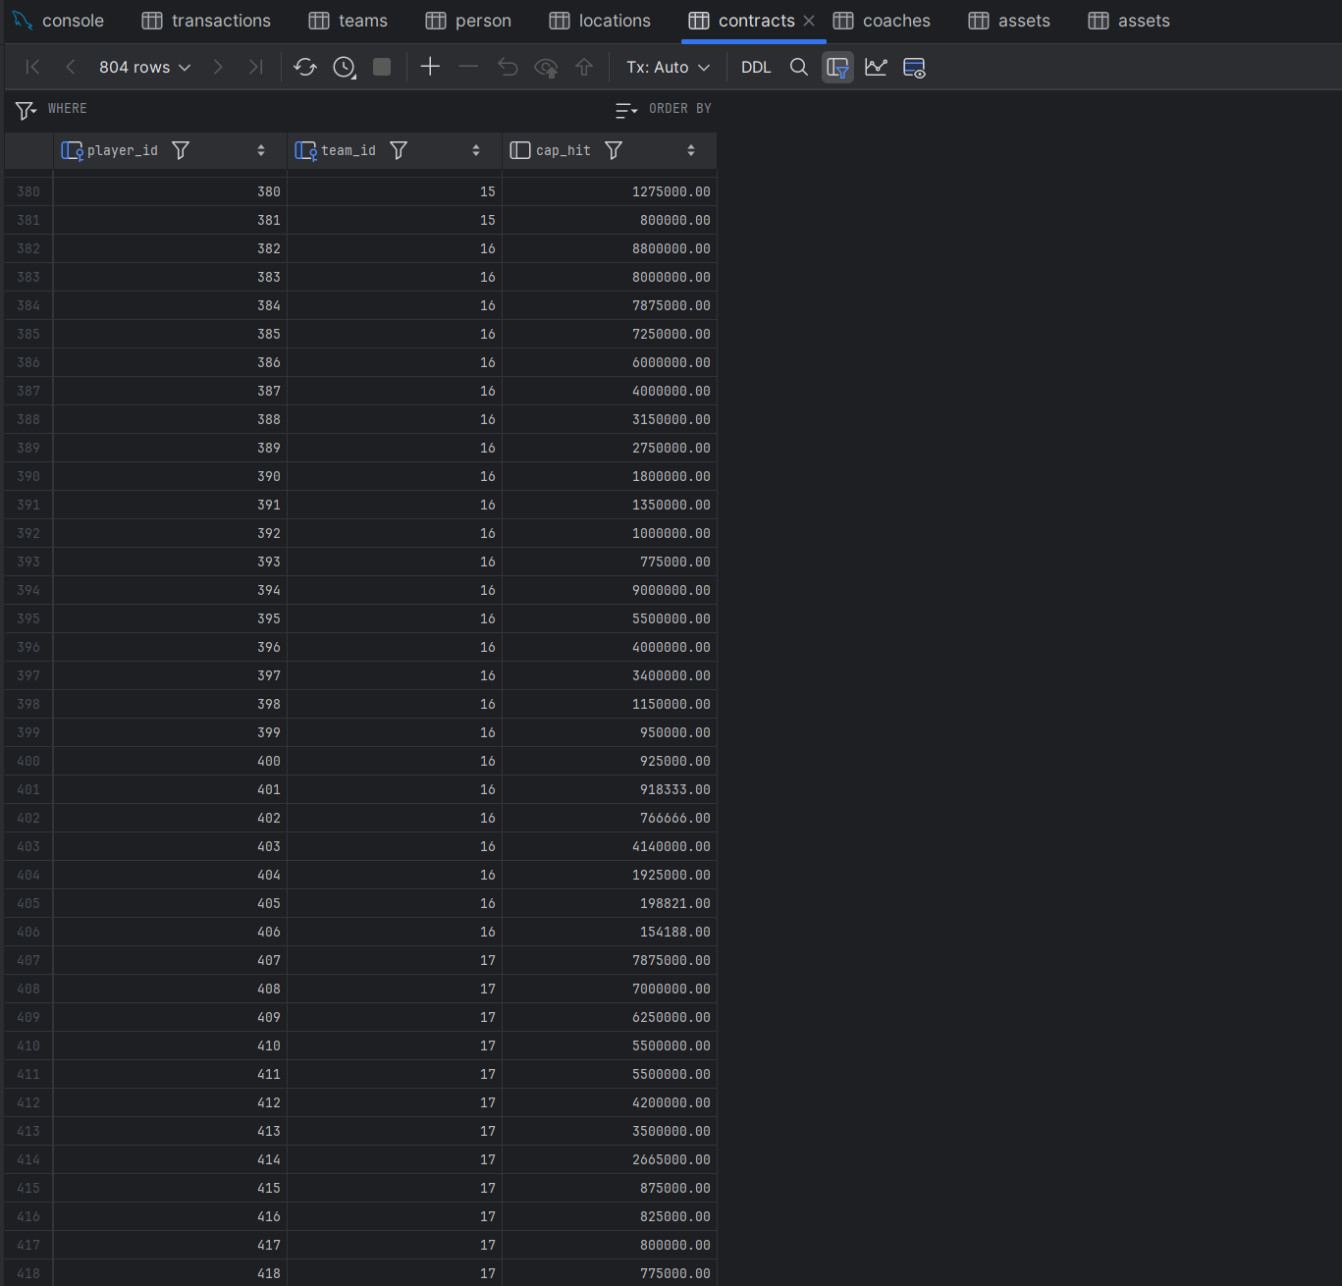

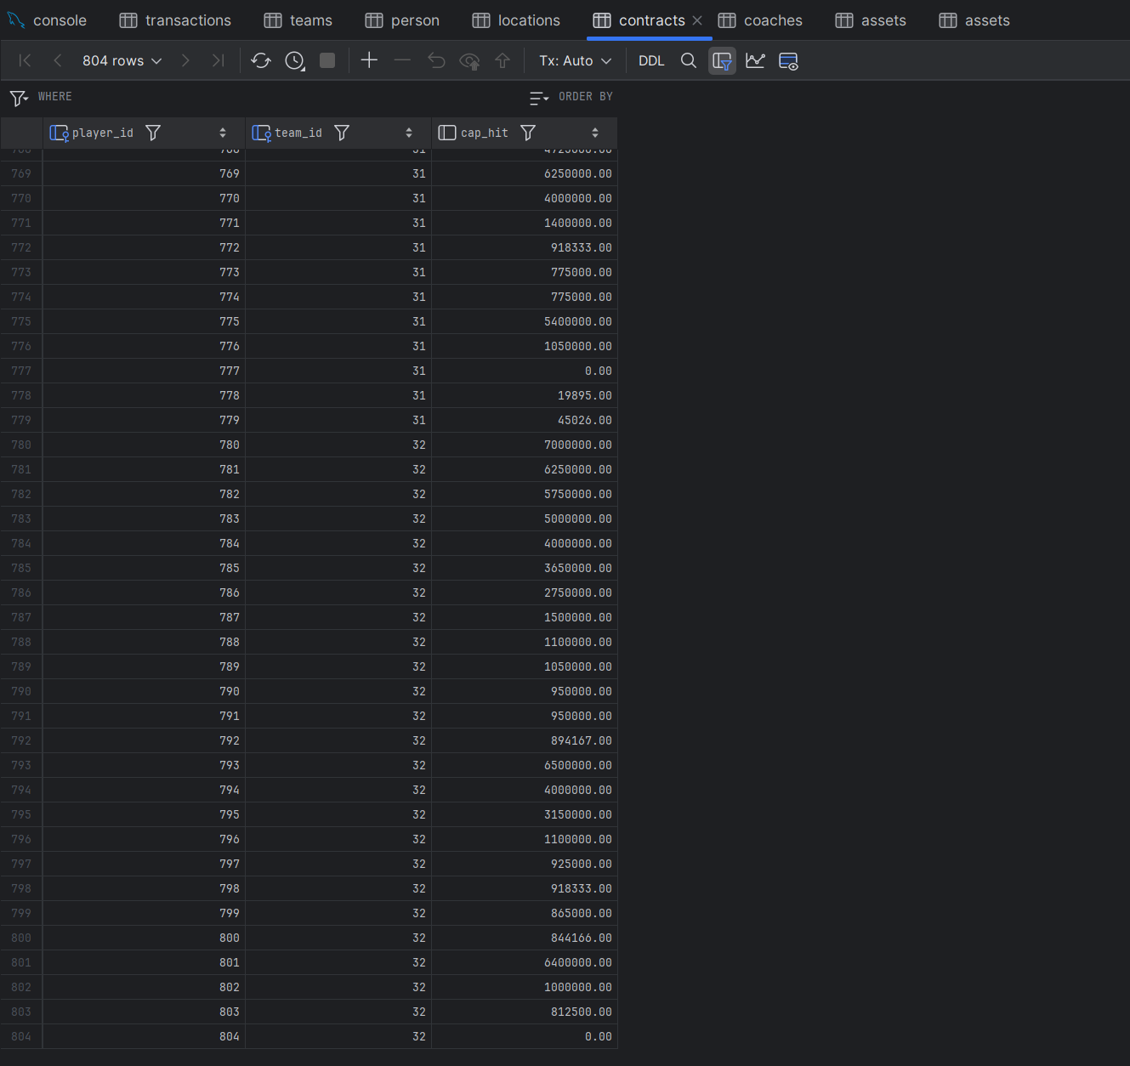

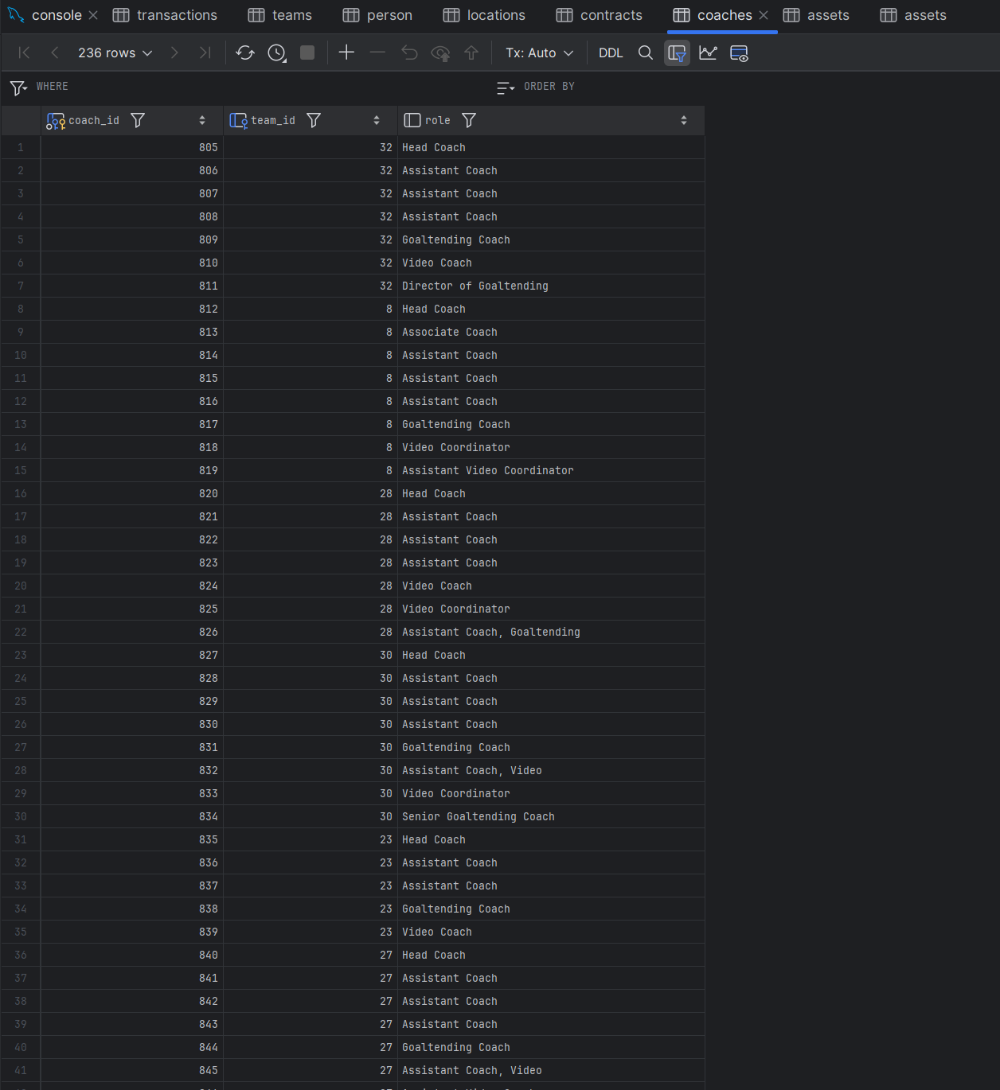

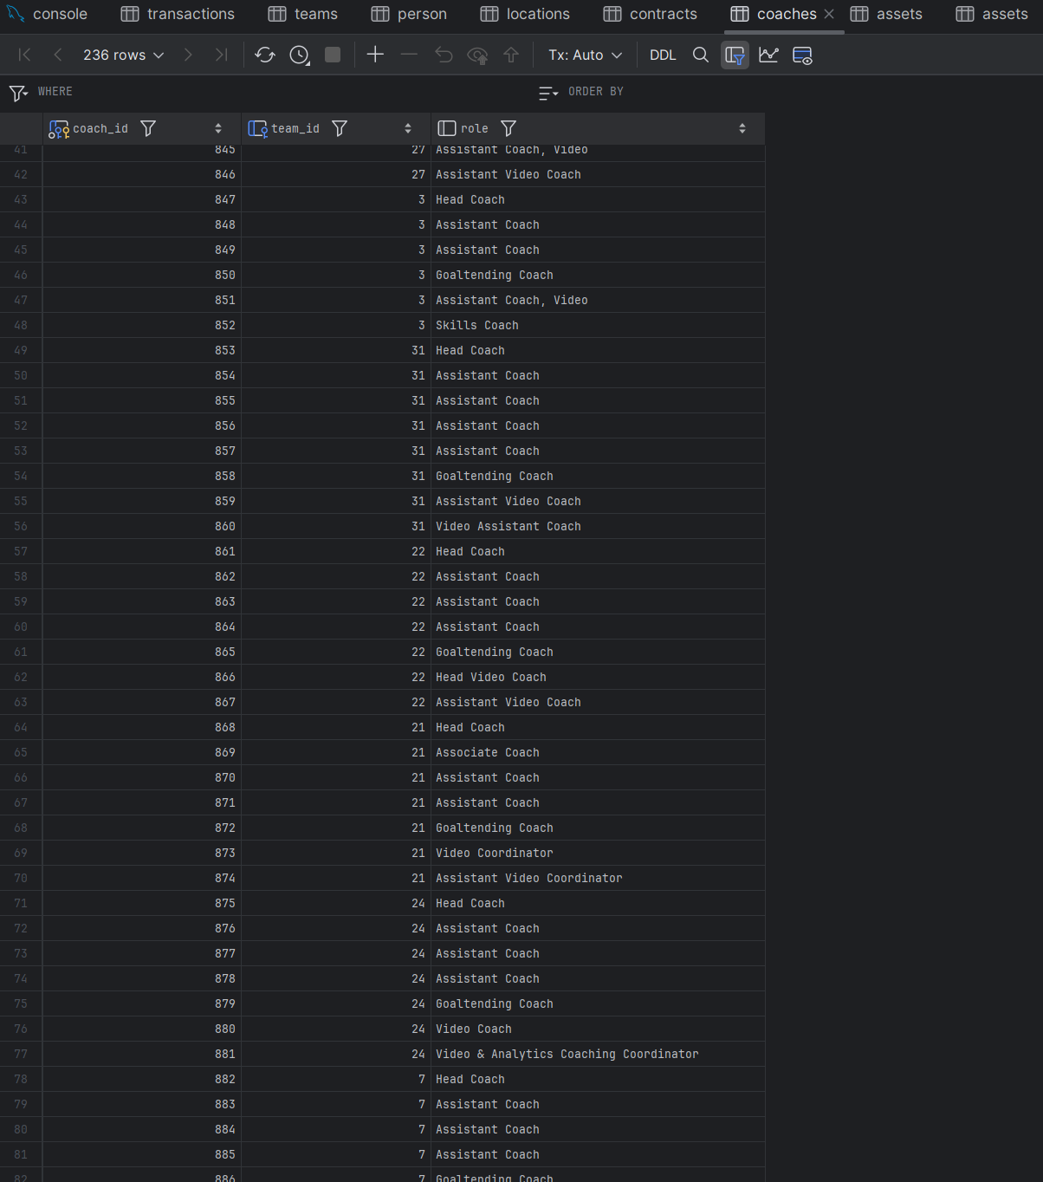

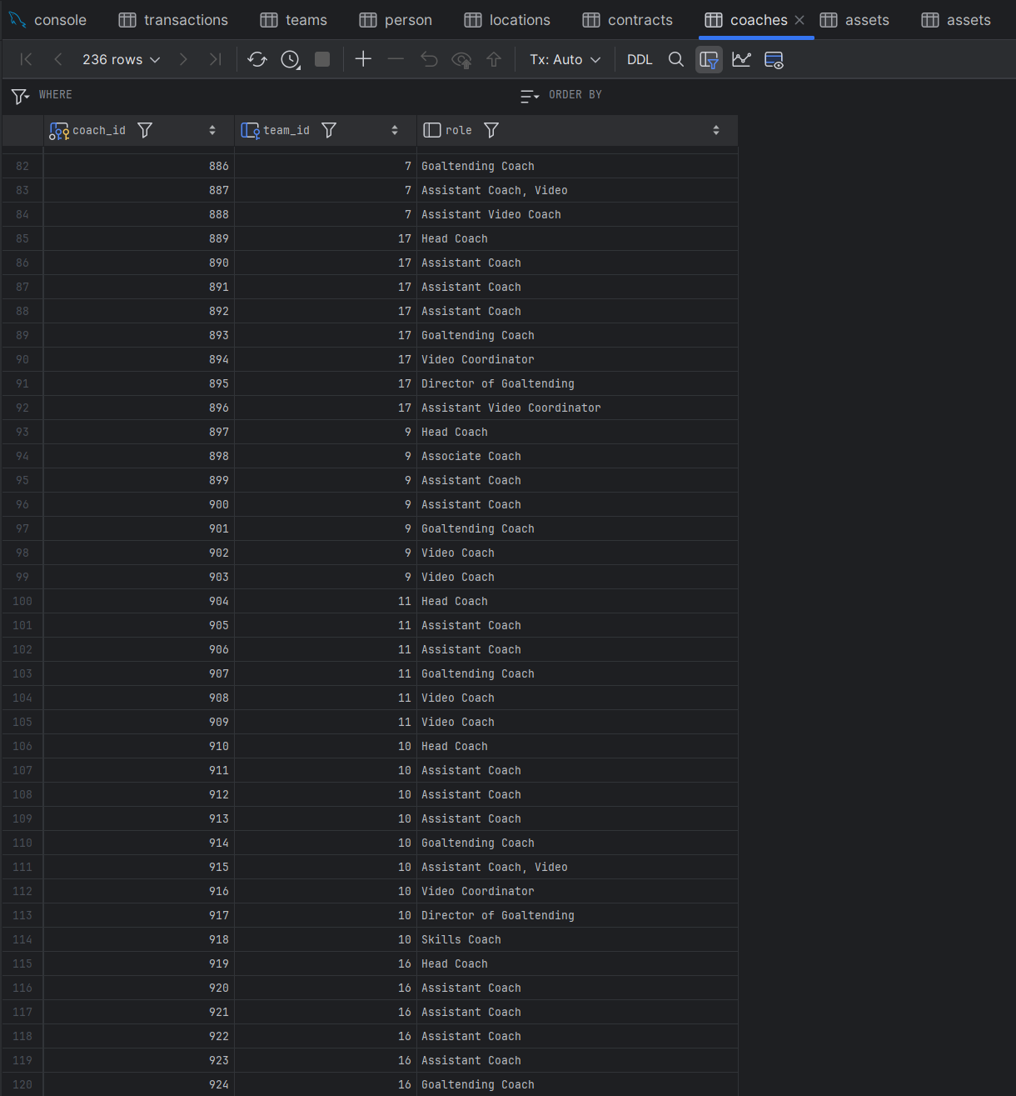

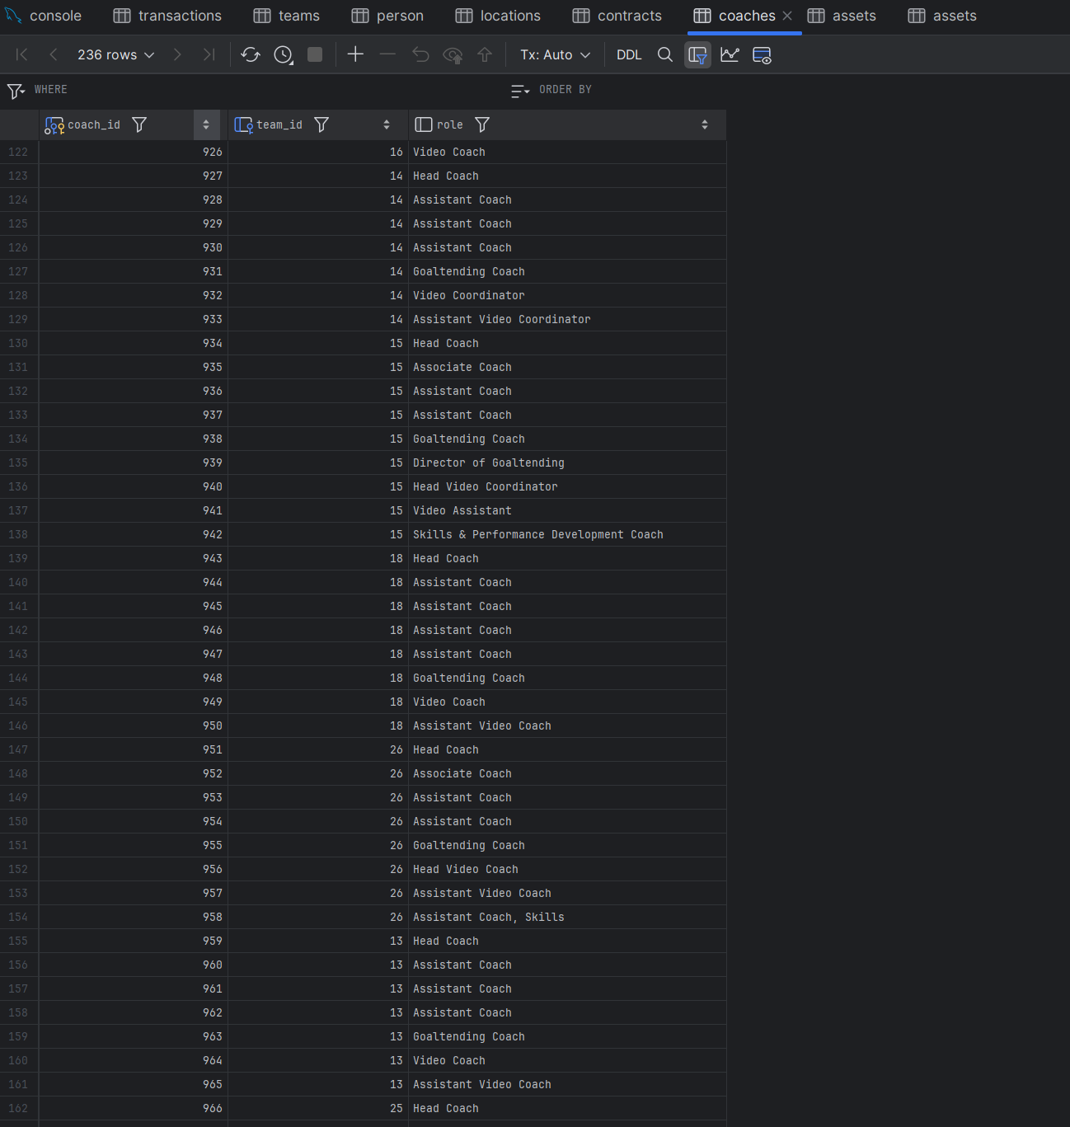

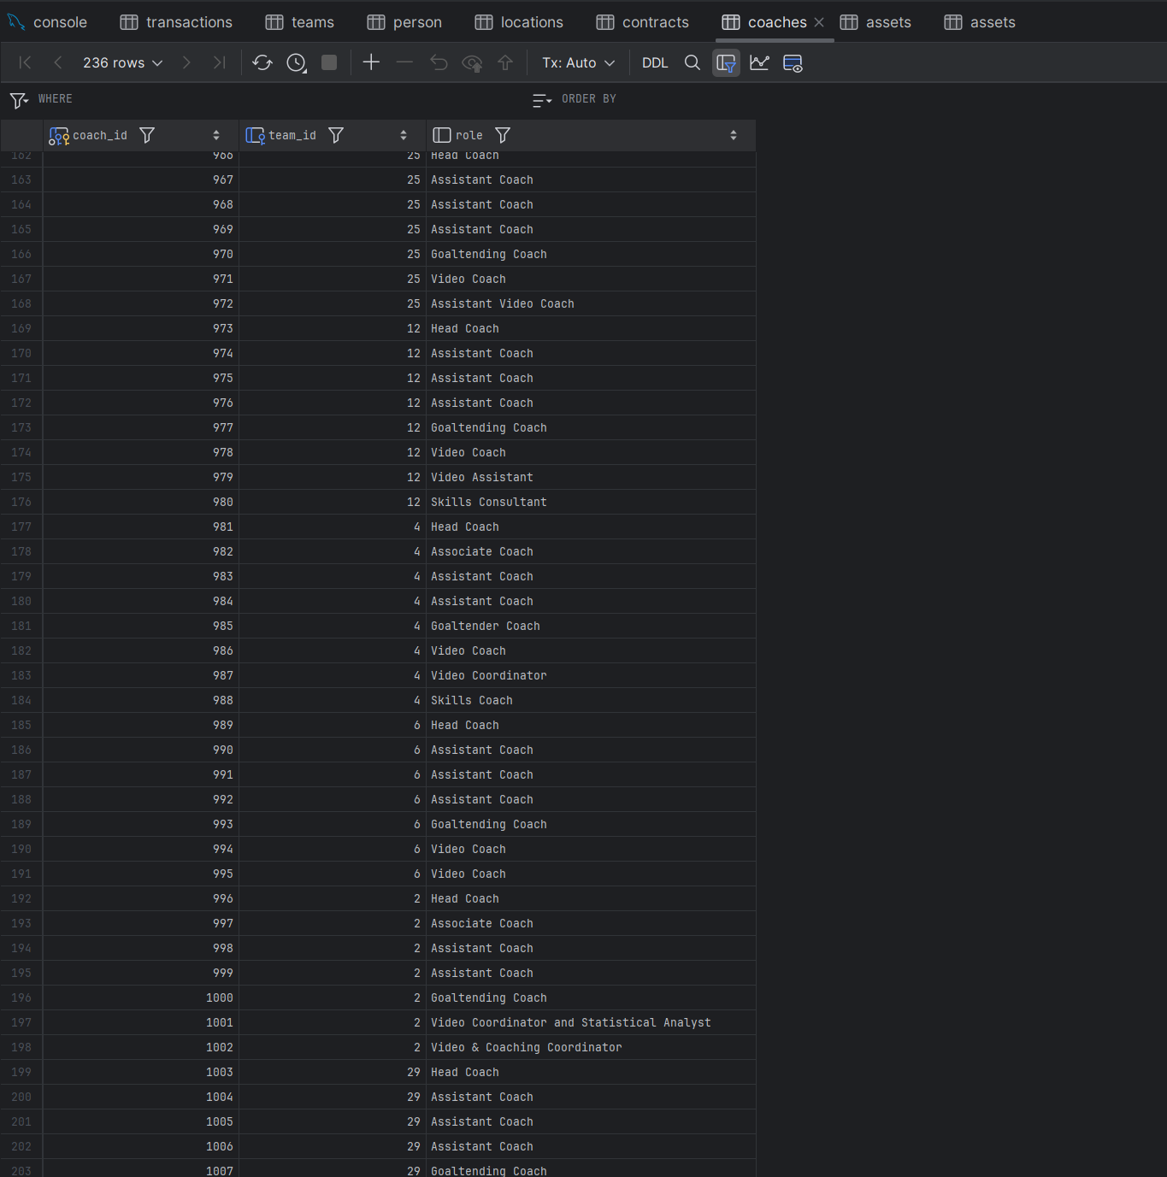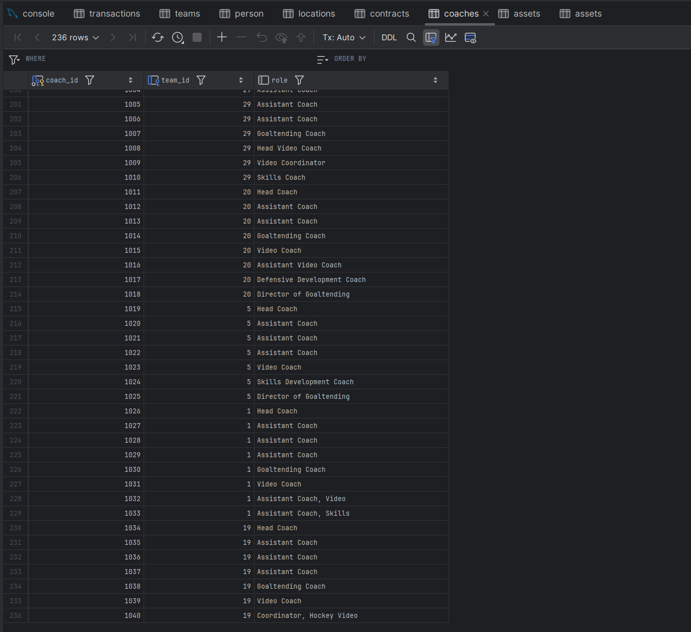

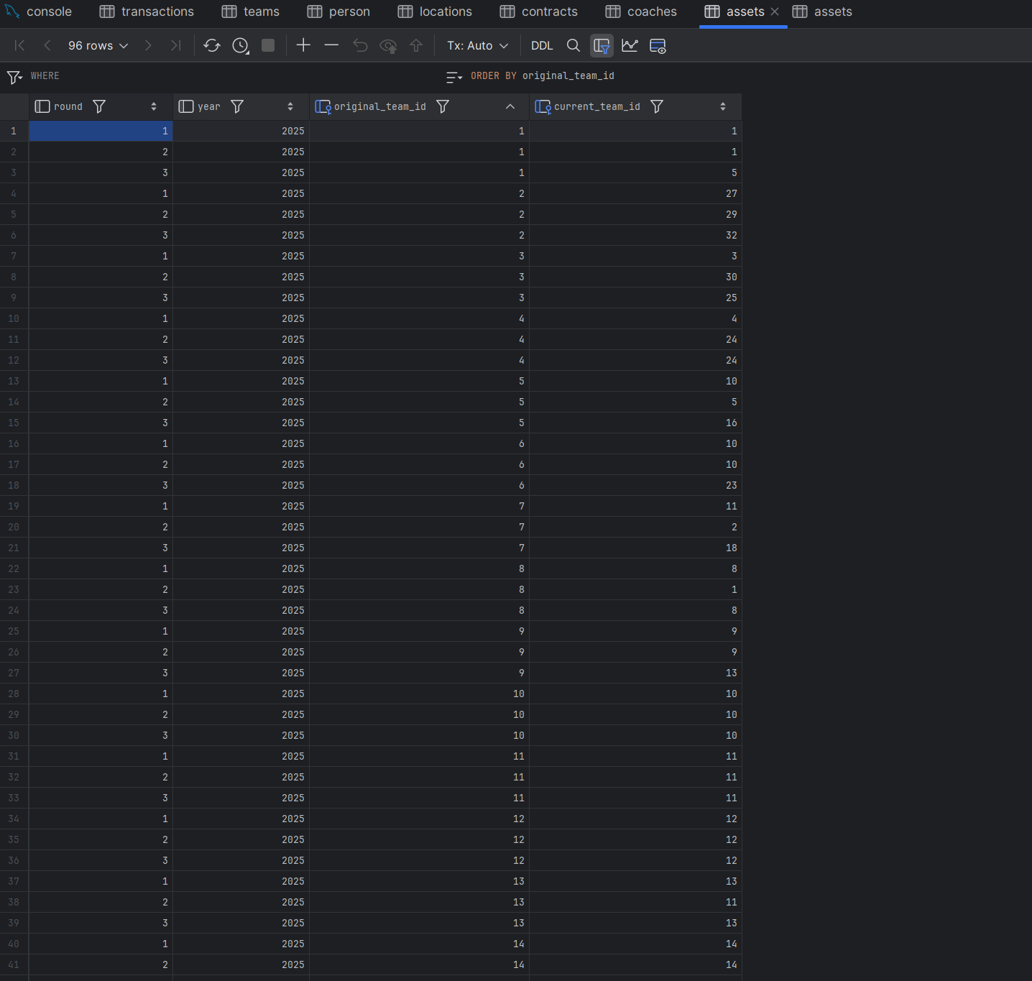

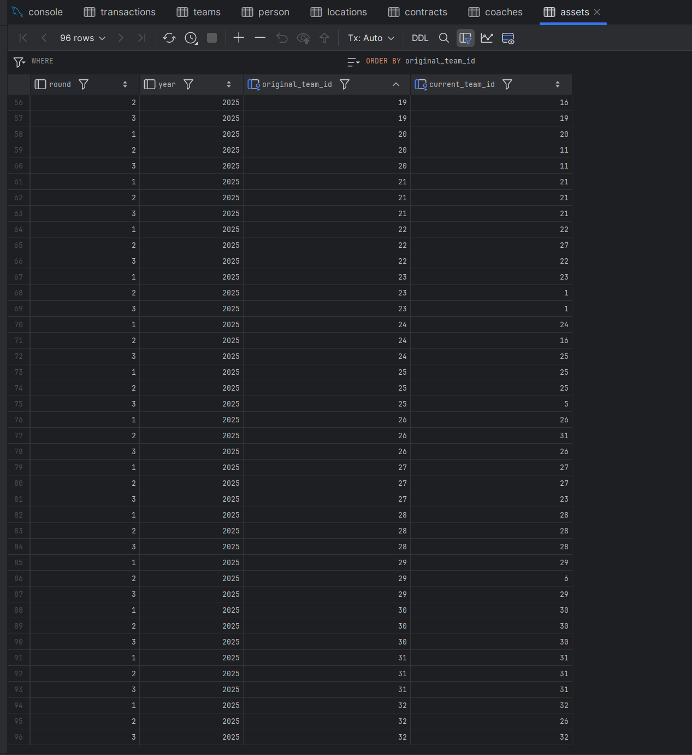

3.4 – Database Query Execution Screenshots:

Queries:

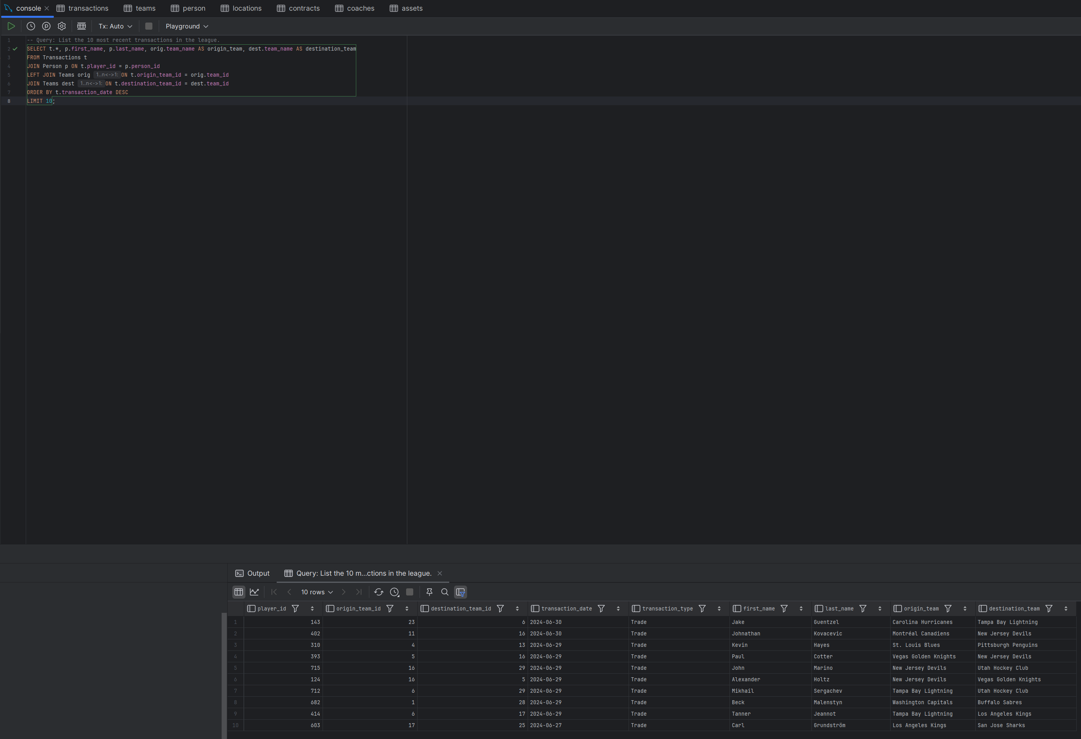

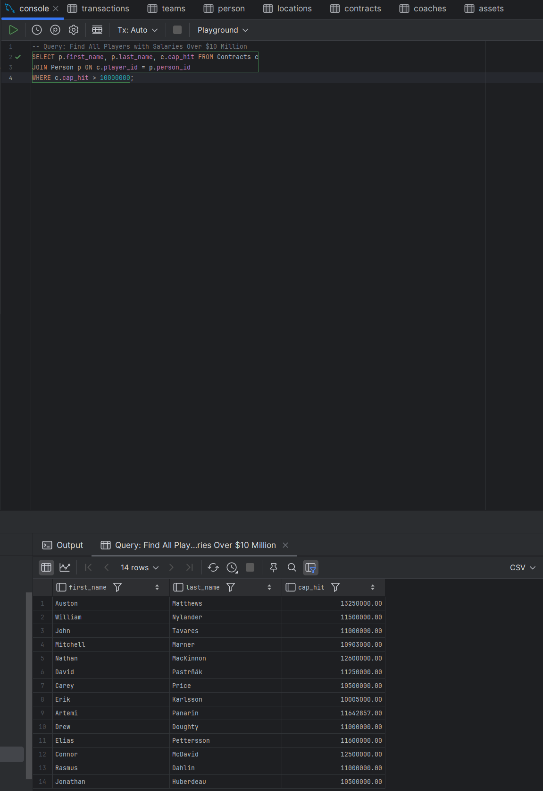

Insert:

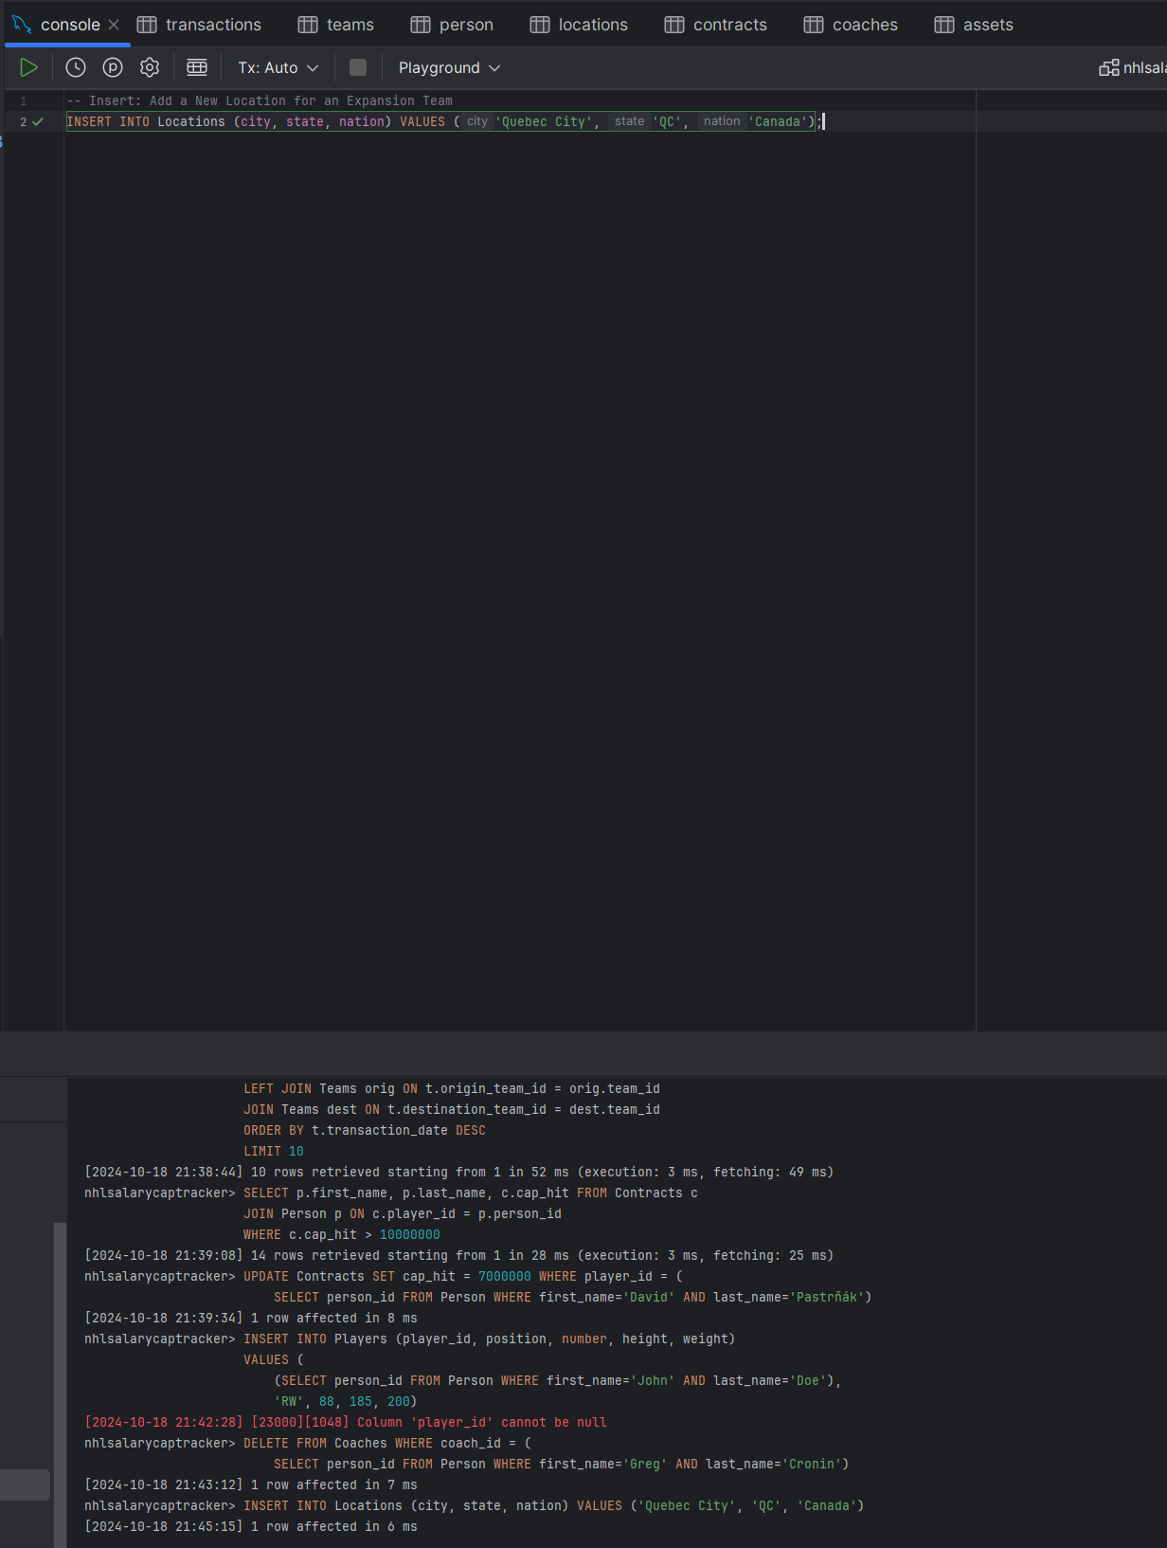A

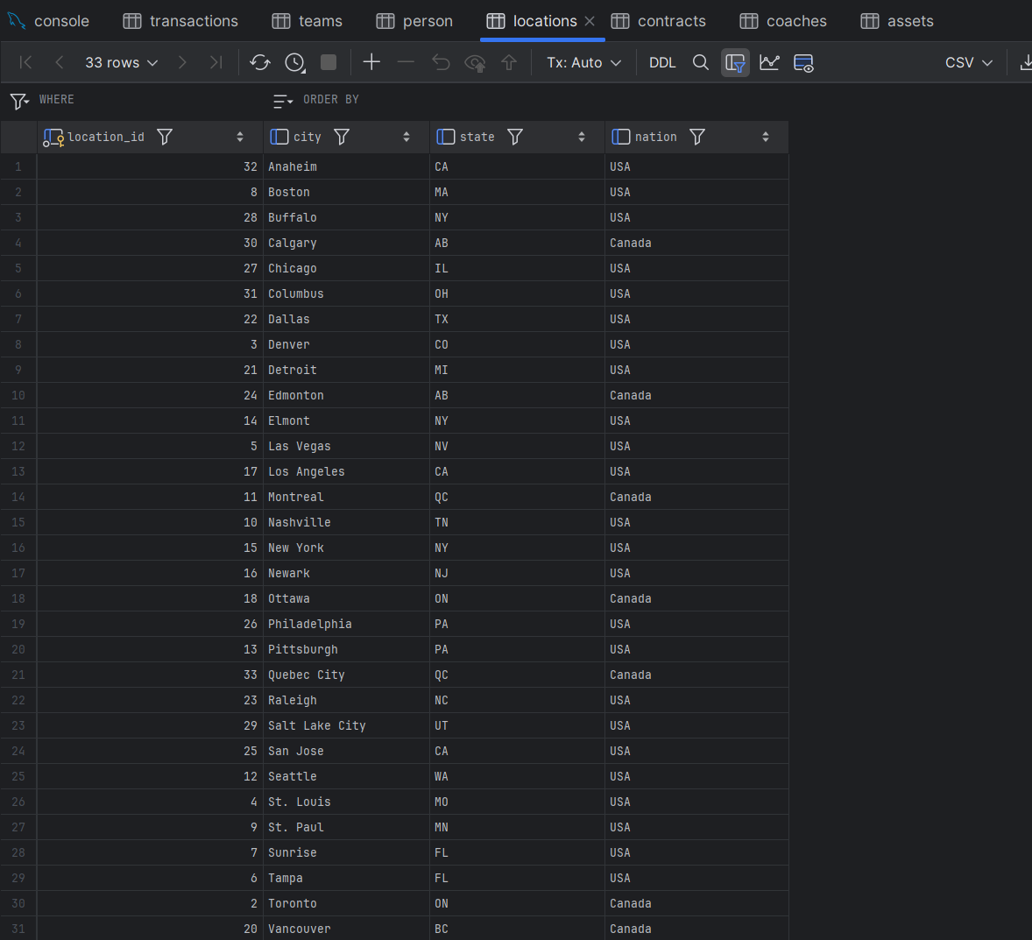

Delete:

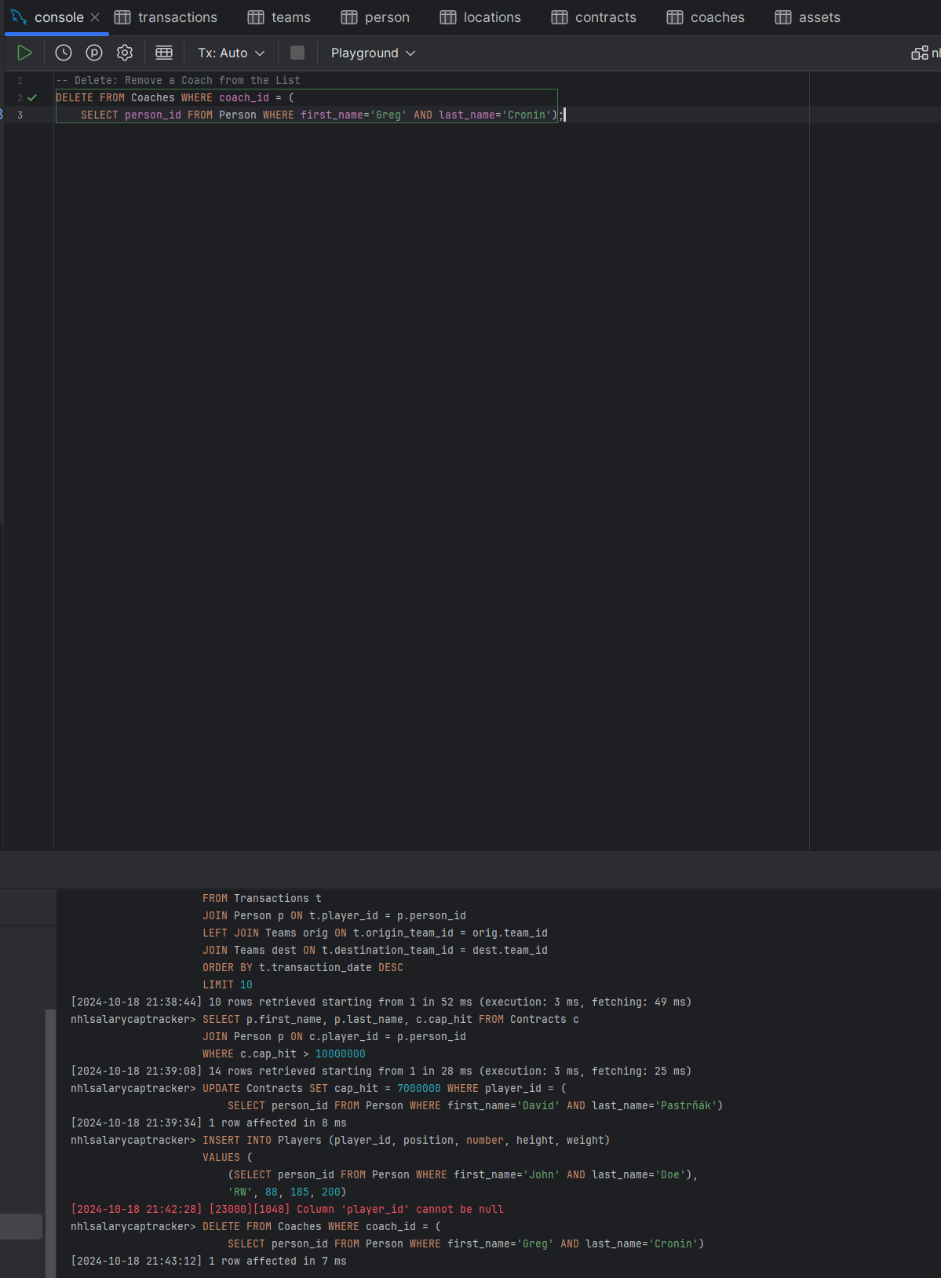

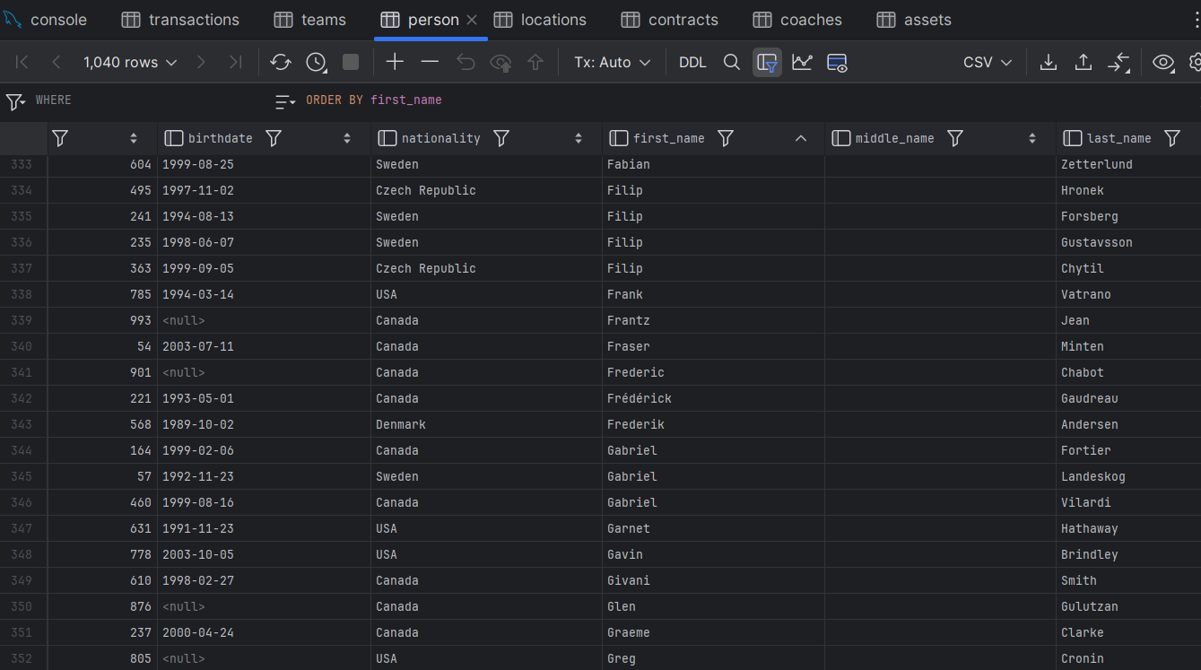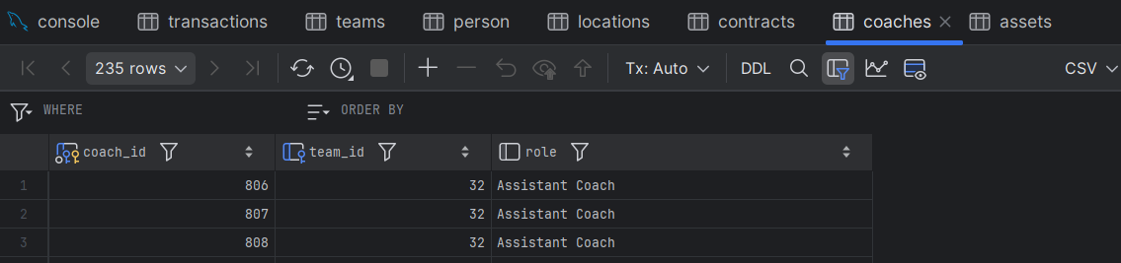

coach_id 805 (Greg Cronin) no longer in coaches table.

Update:

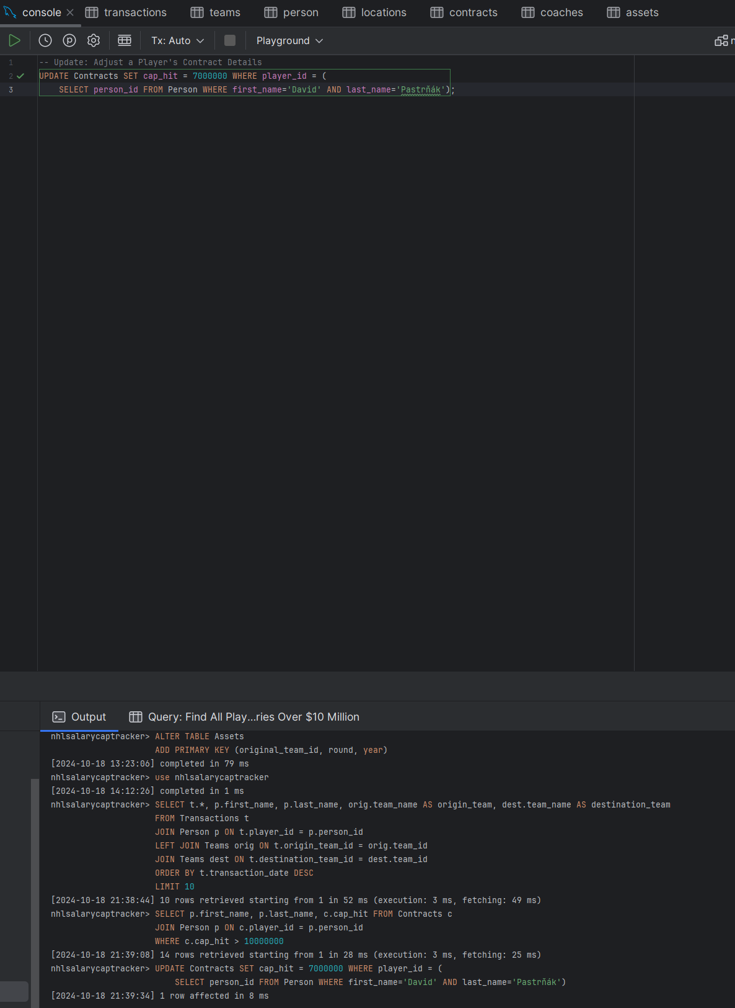

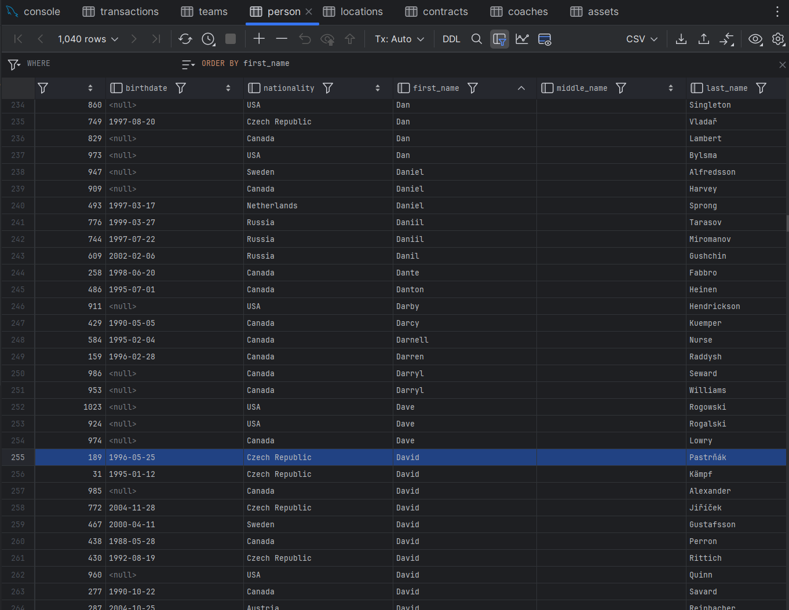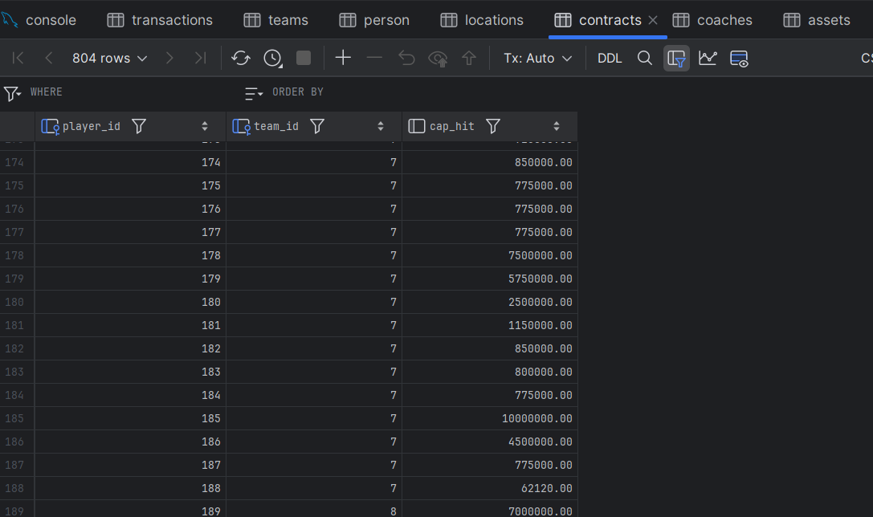

3.5 – Create View

View #1 – High Salary Goalies

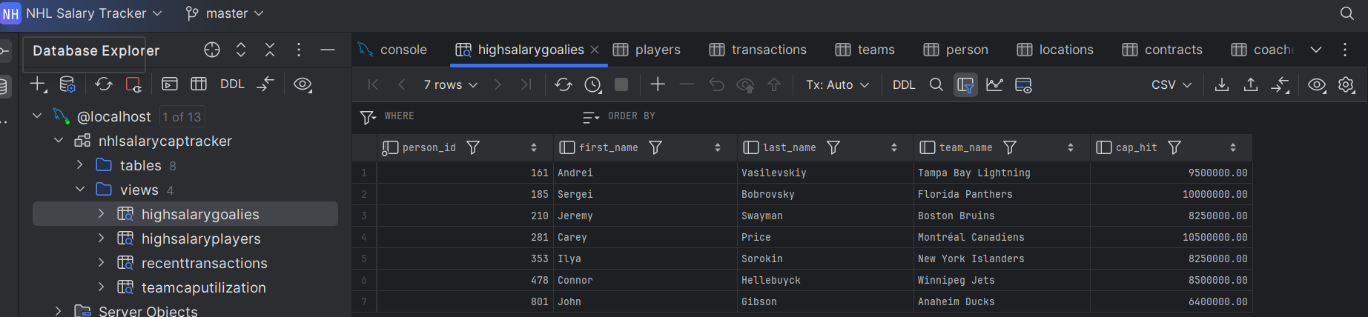

View #2 – High Salary Players

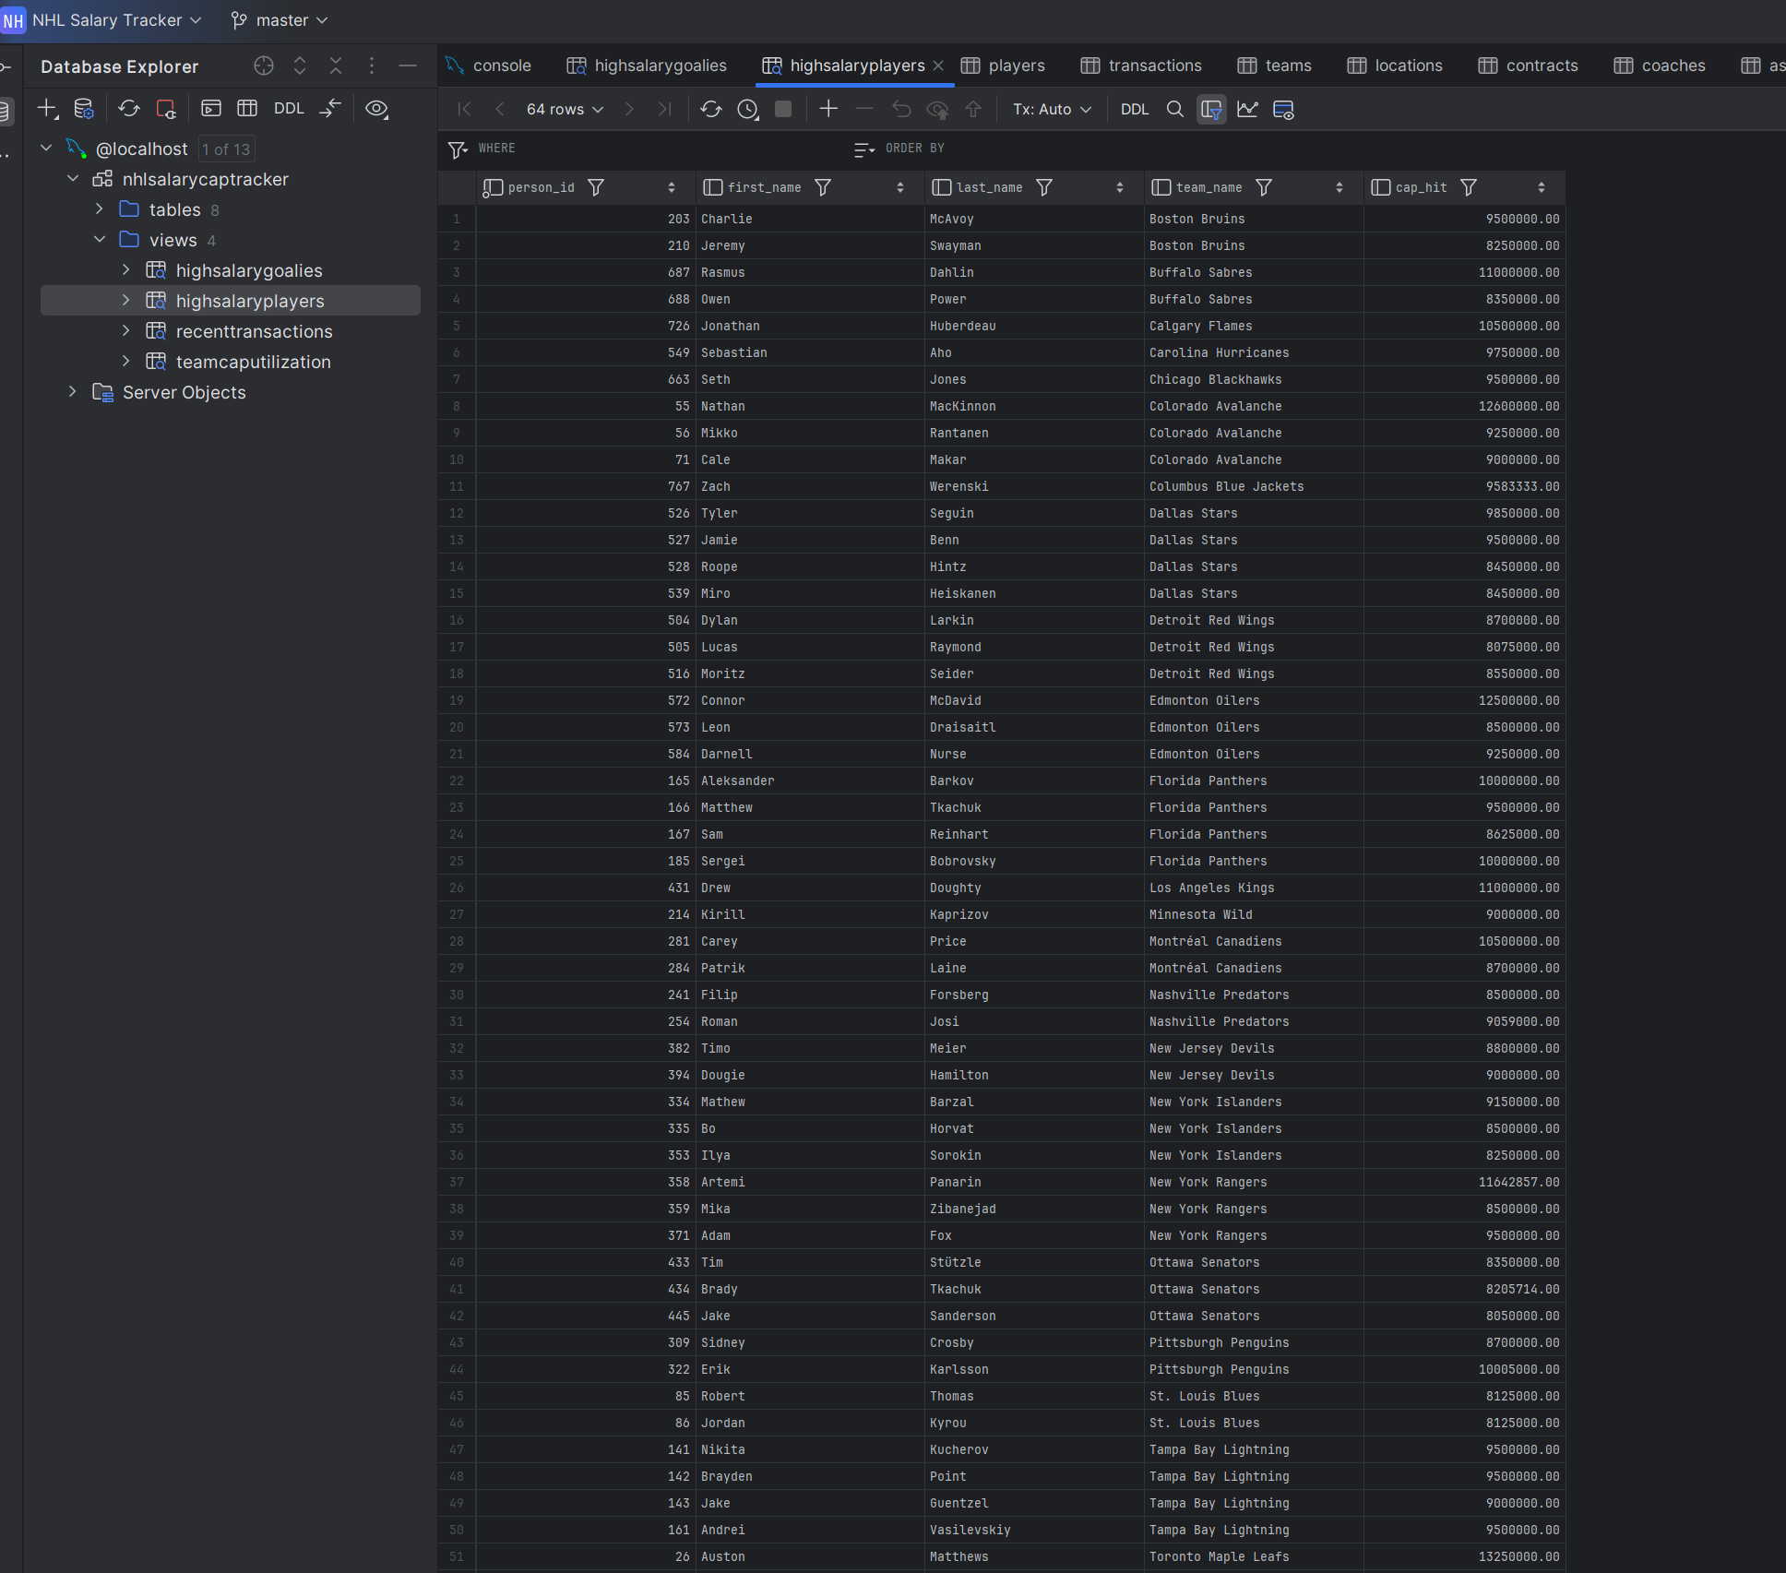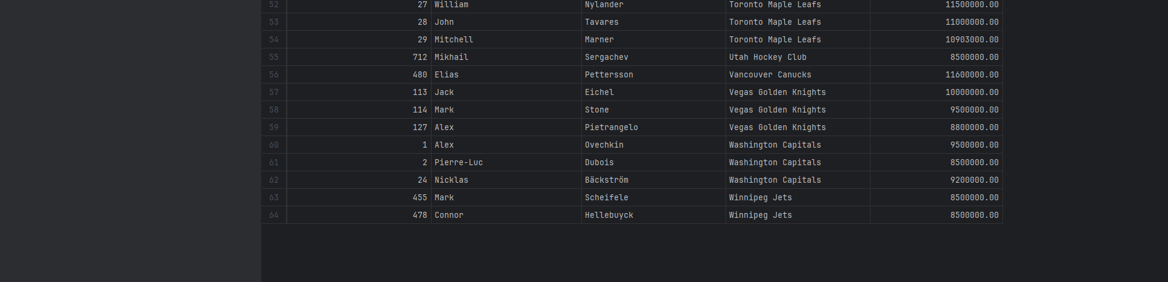

View #3 – Recent Transactions

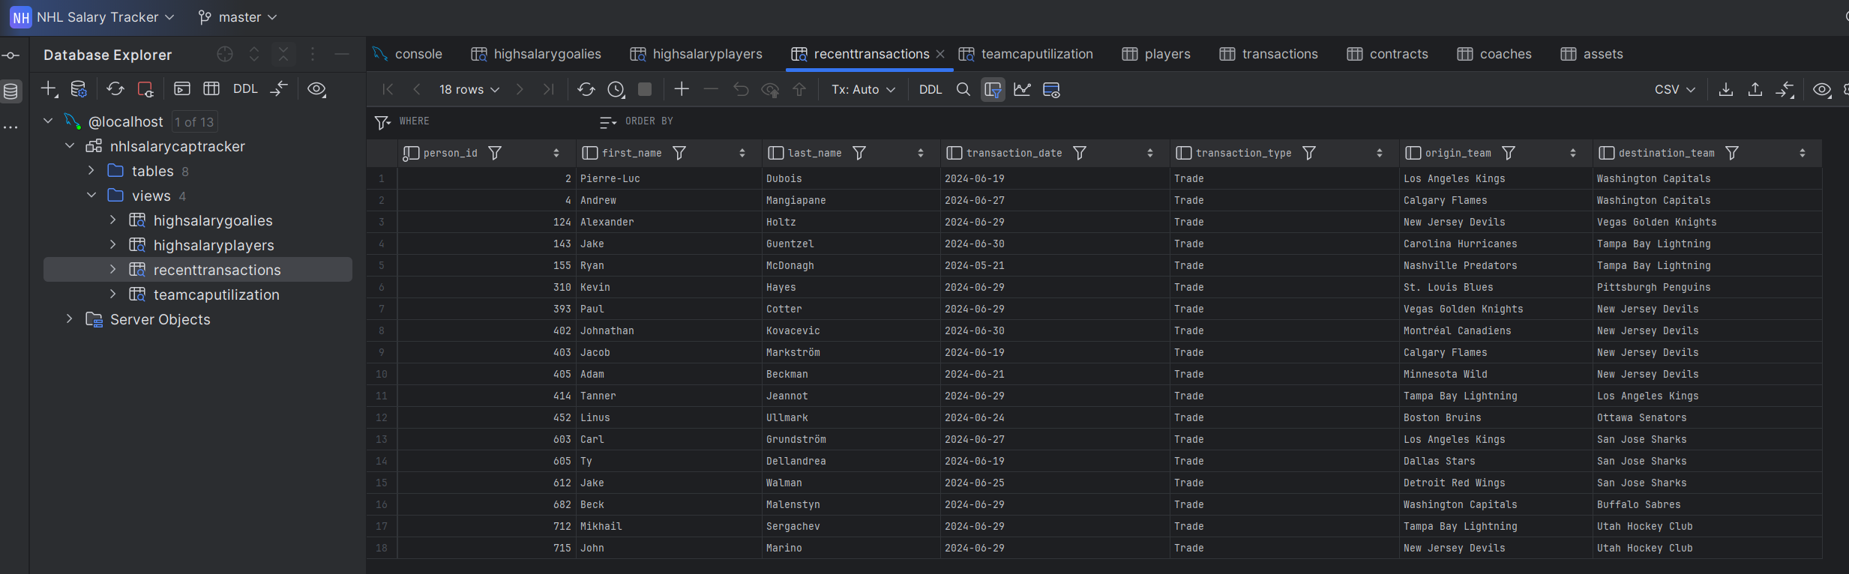

4 – Front End User Interface

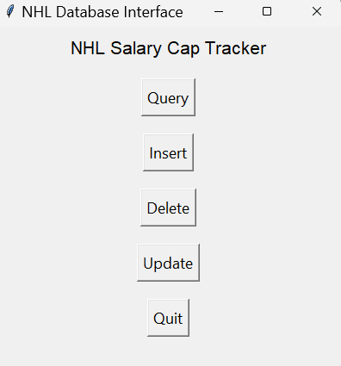 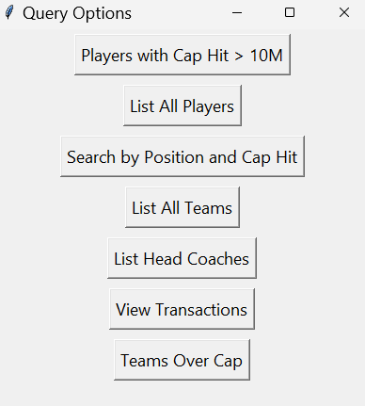

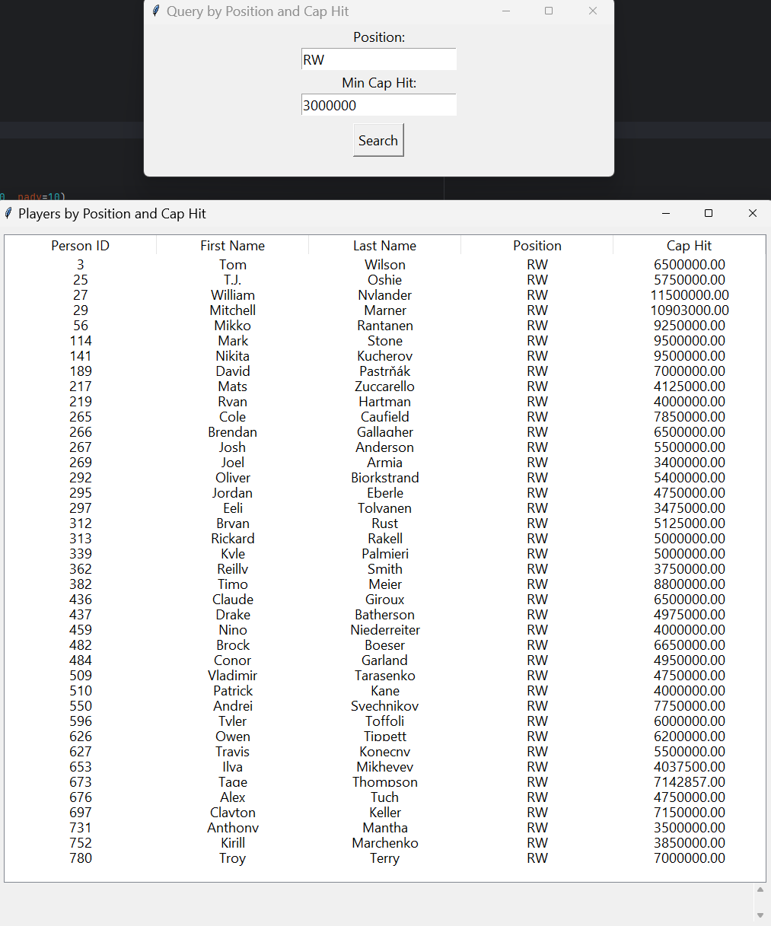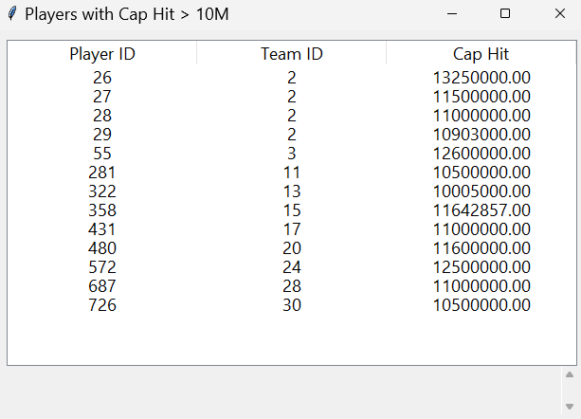

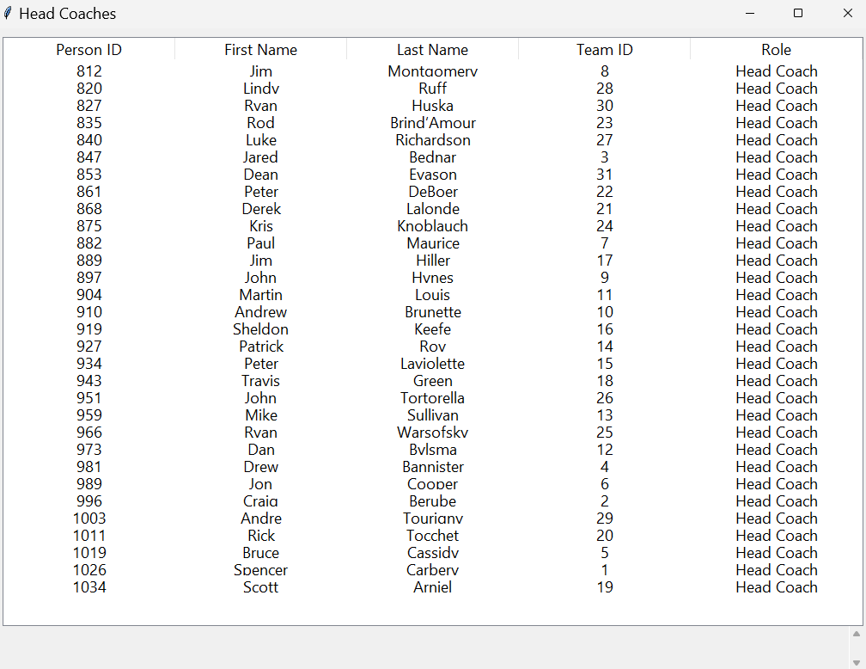

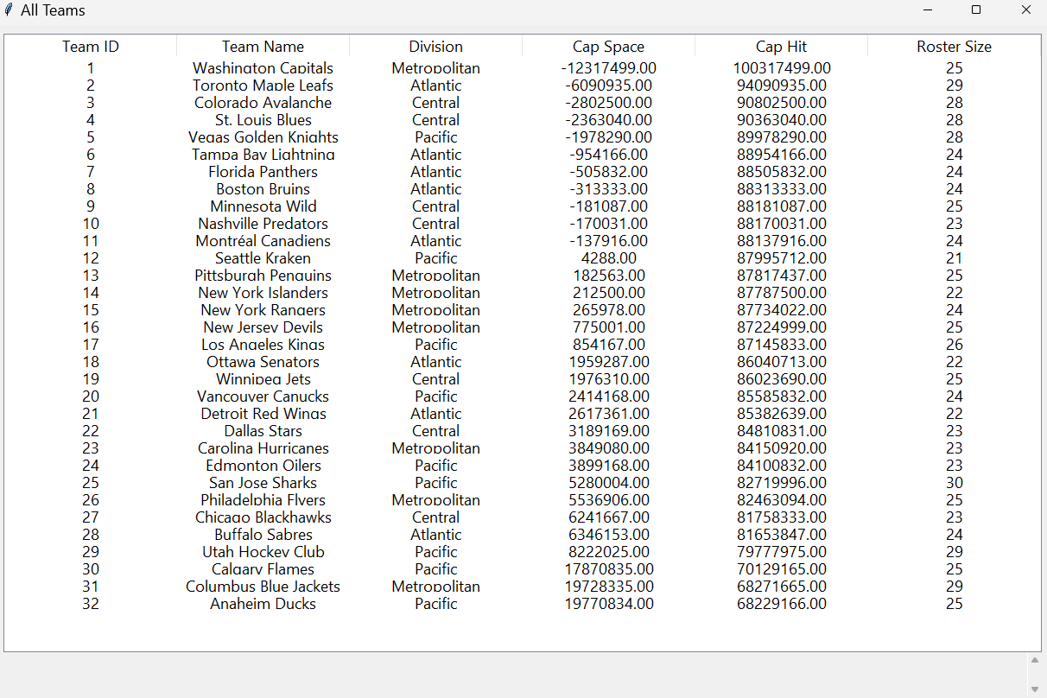

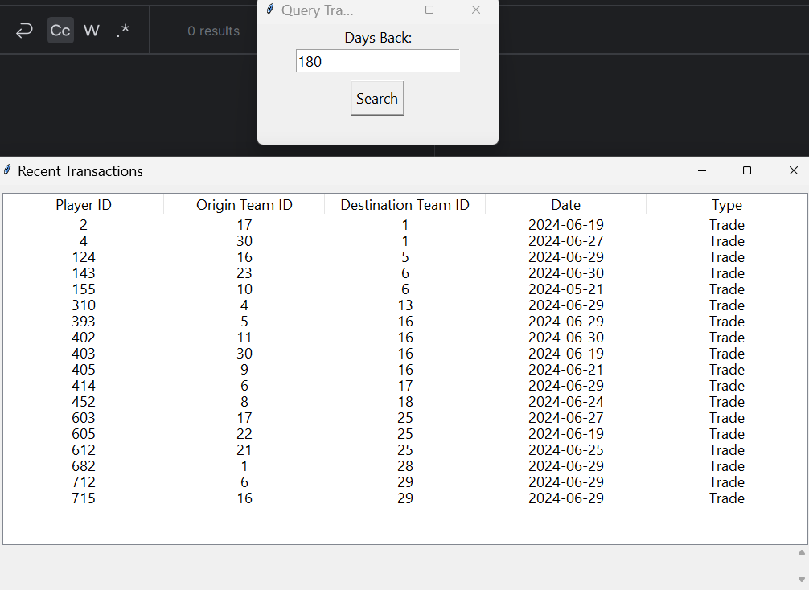

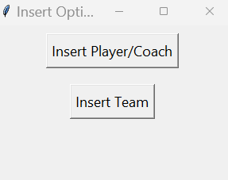 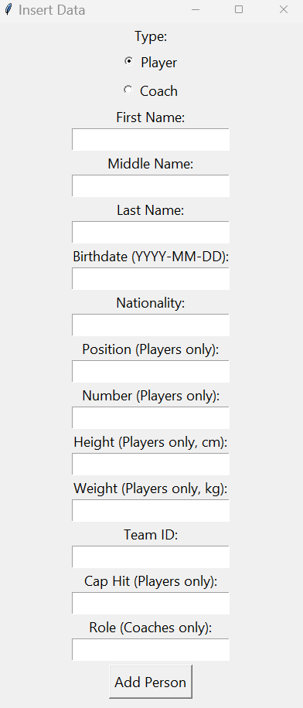 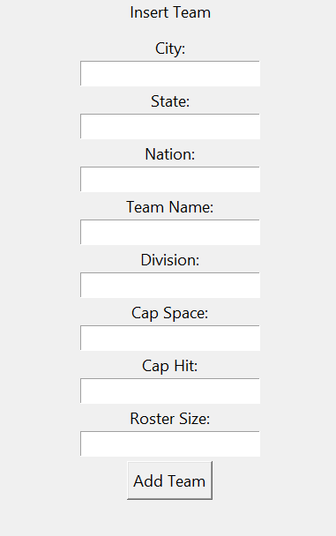

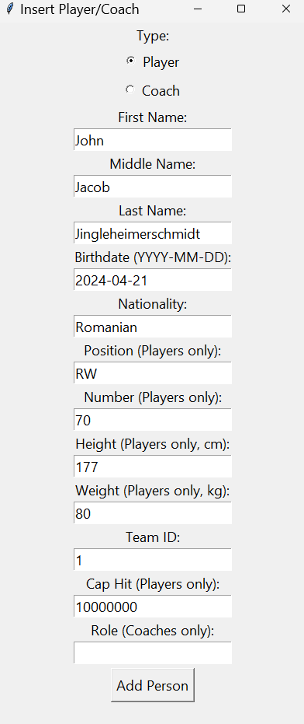 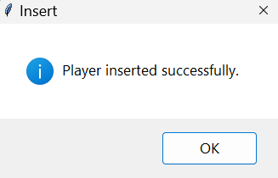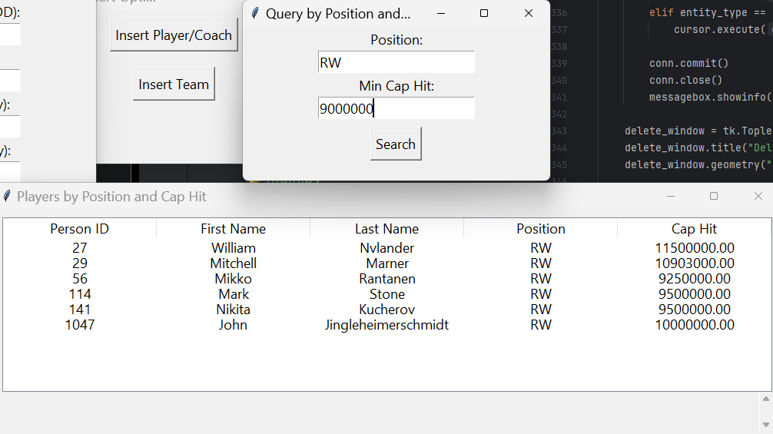

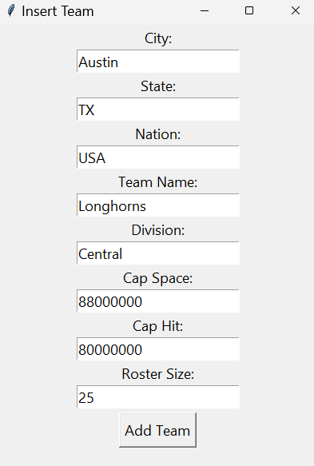 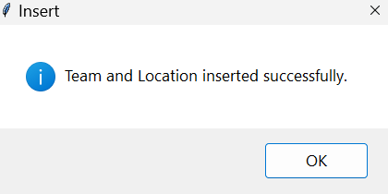

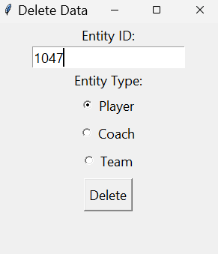 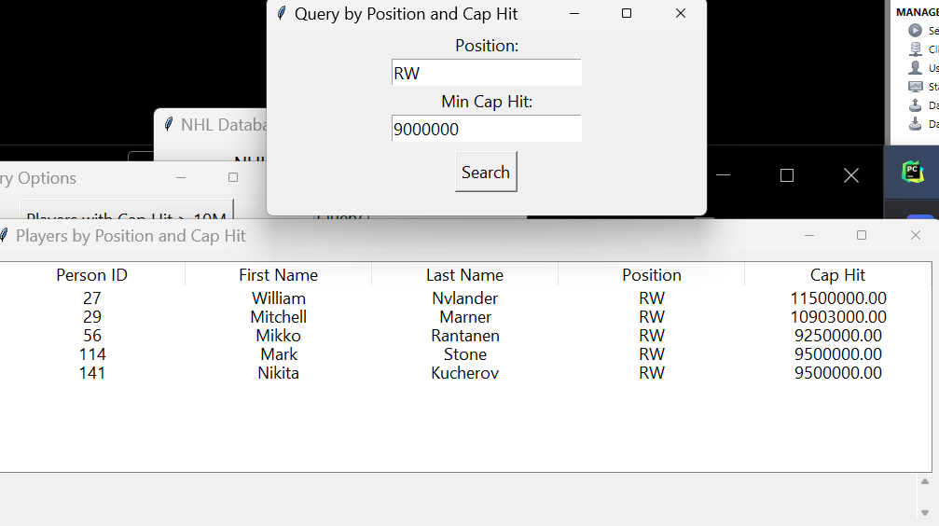

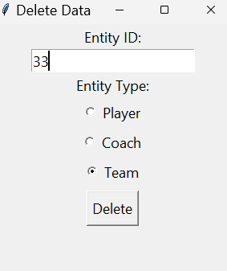 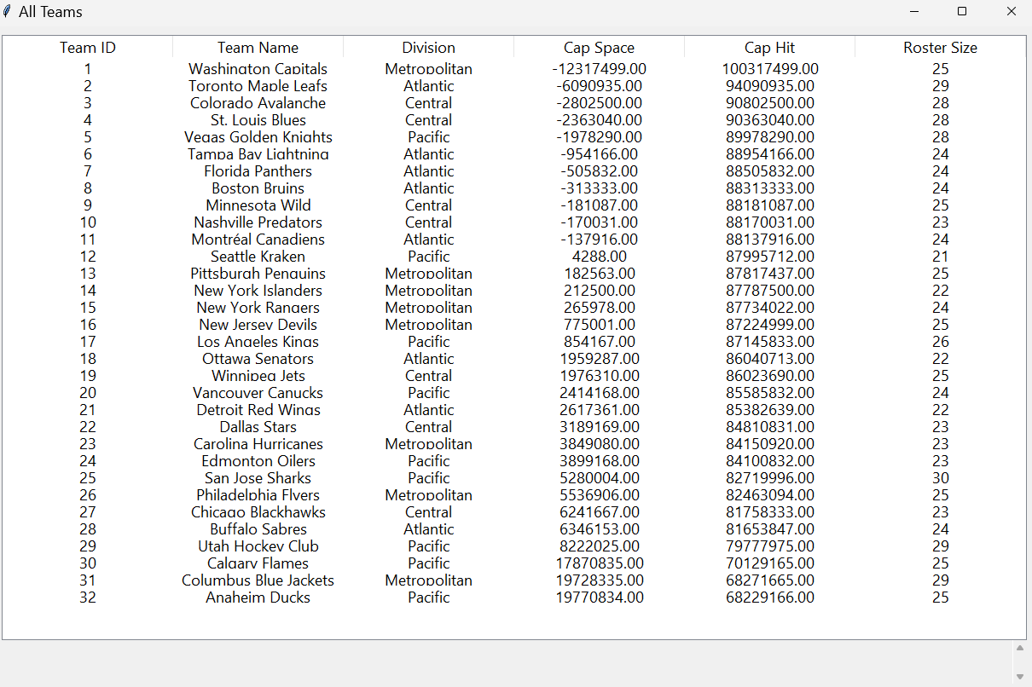

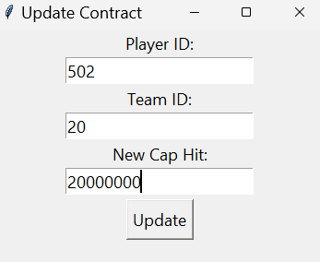 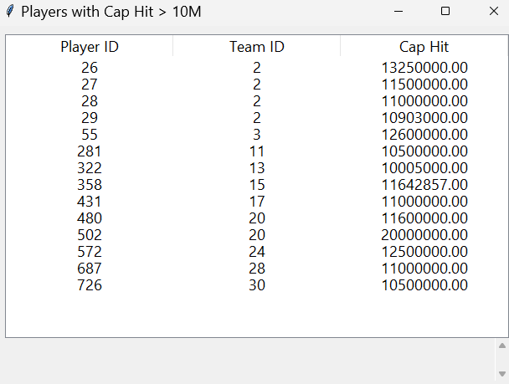

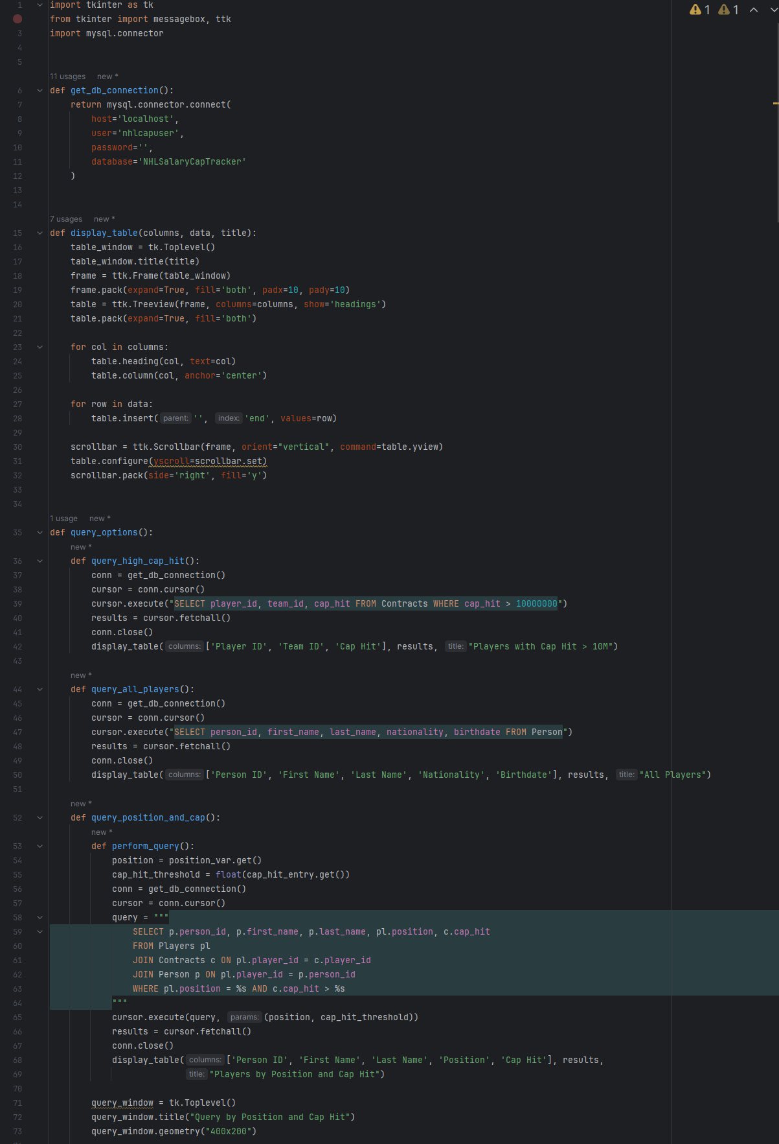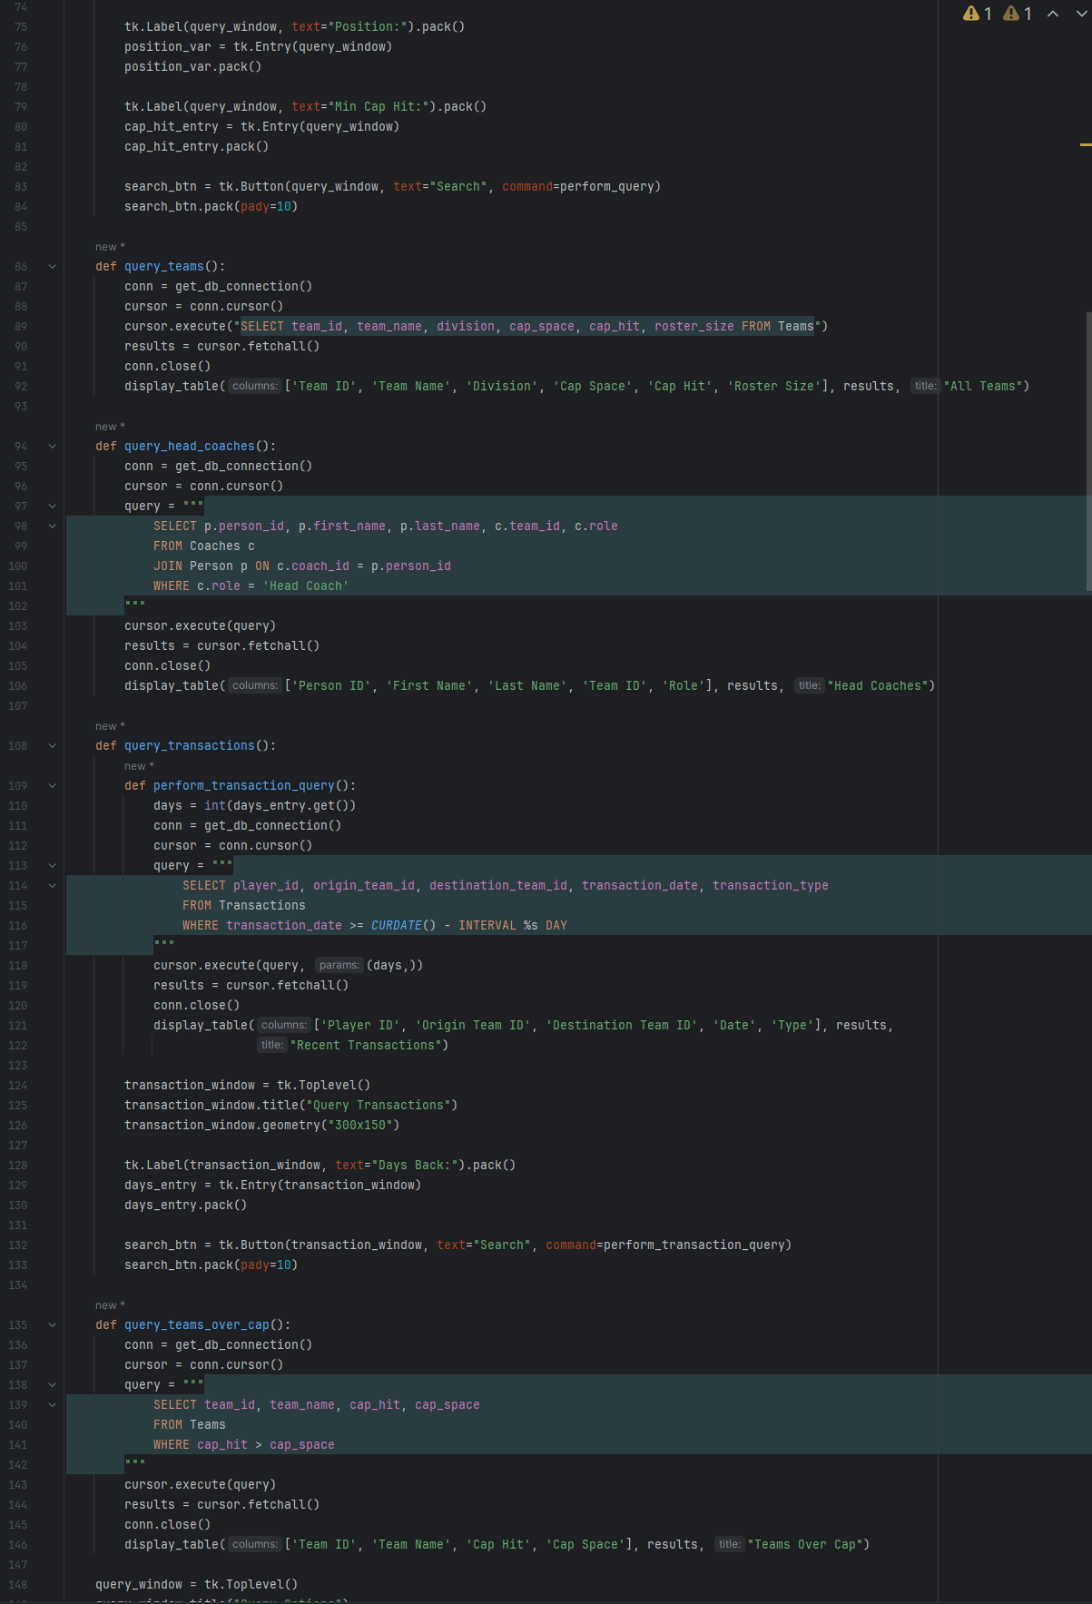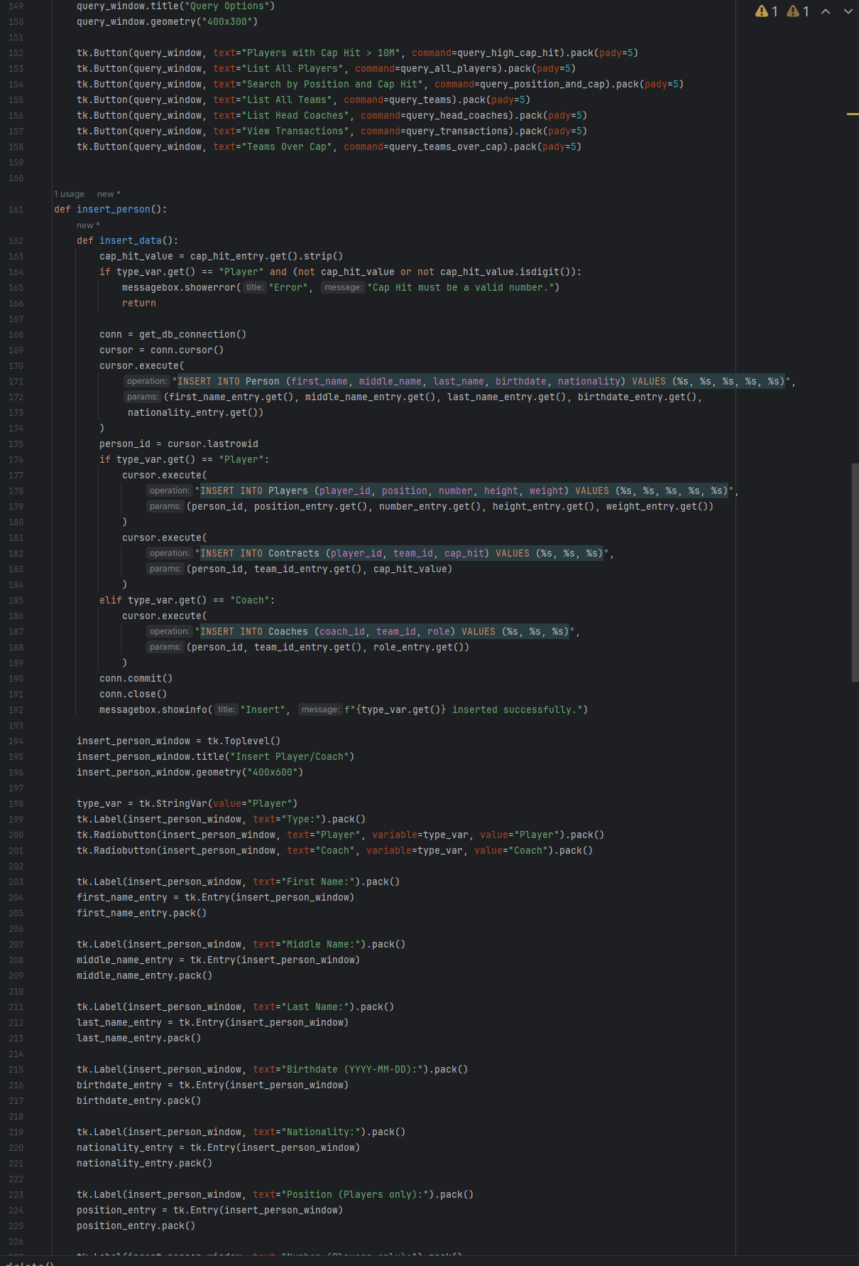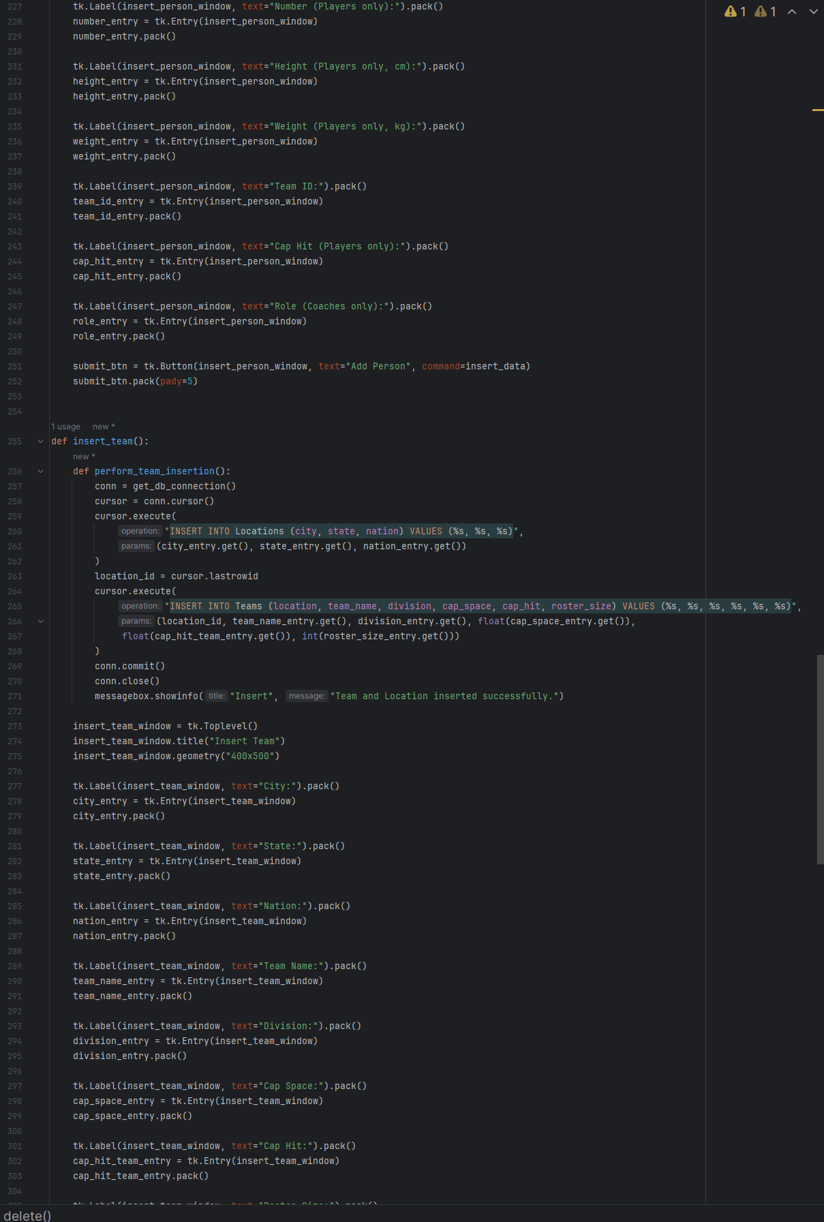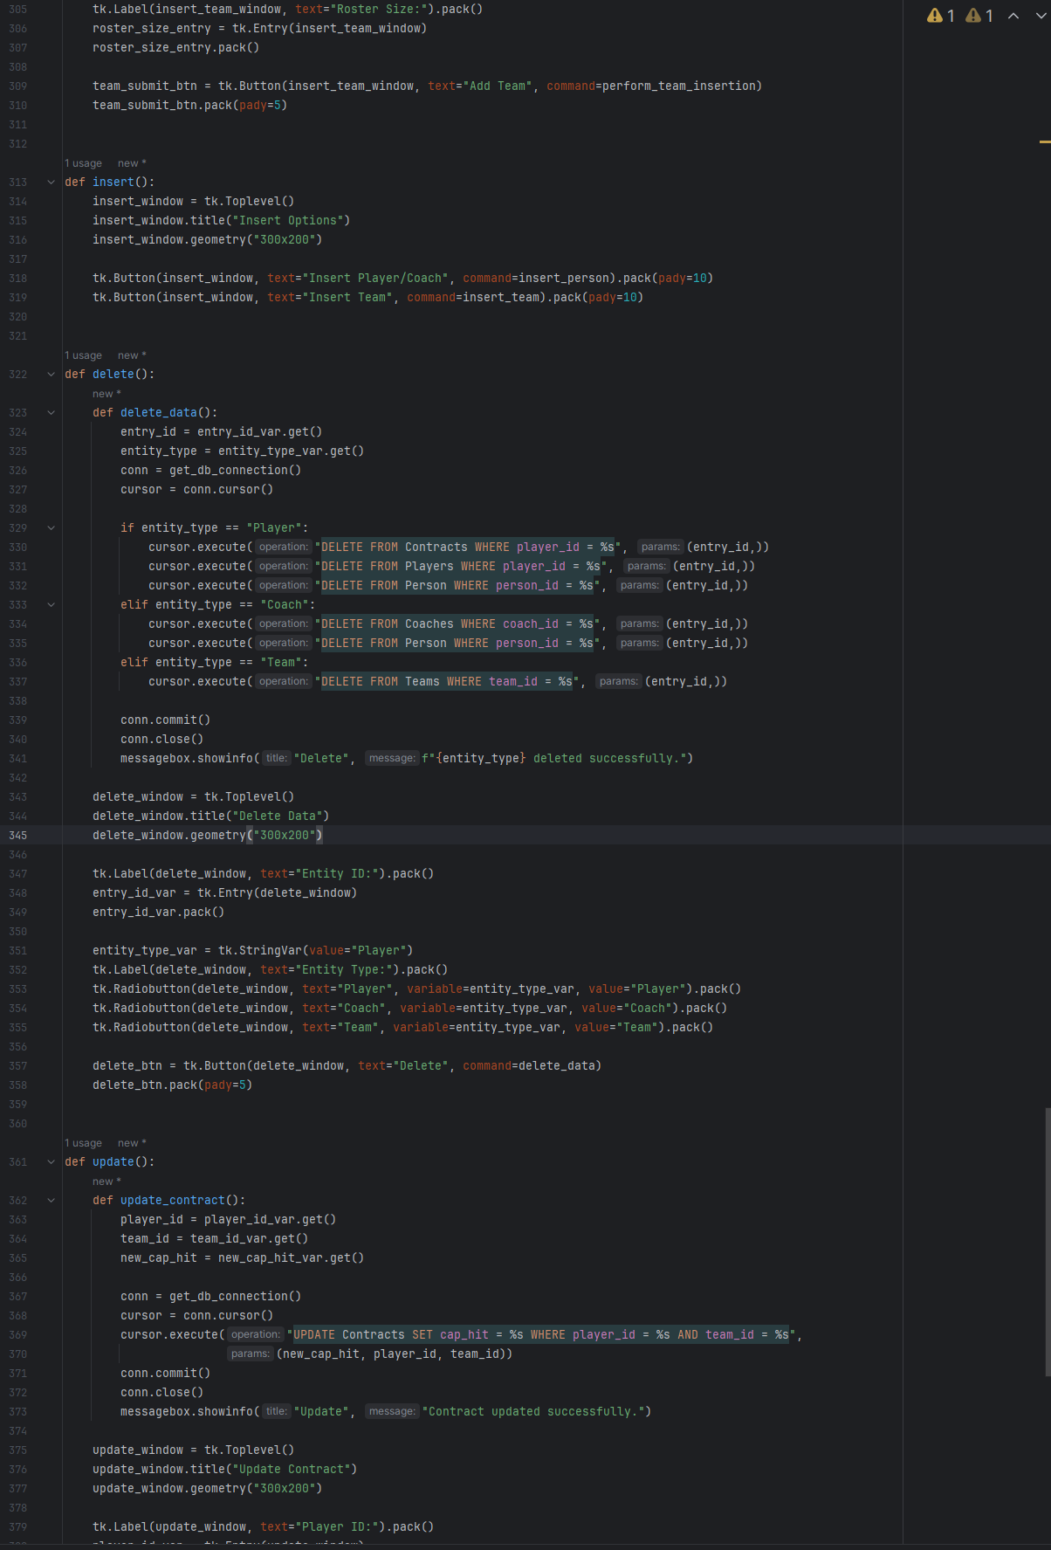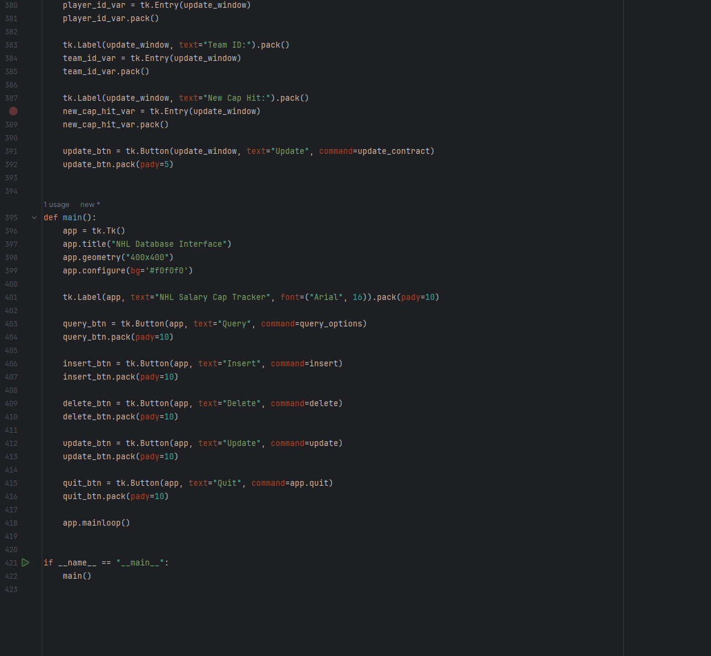

References

[1] H. Brown, “Washington Capitals GM MacLellan Confirms Acquisition Of CapFriendly,” *NoVa Caps*, Jun. 12, 2024. https://novacapsfans.com/2024/06/12/washington-capitals-gm-maclellan-confirms-acquisition-of-capfriendly/ (accessed Oct. 08, 2024).

[2] “PuckPedia - NHL Salary Cap, Player Contracts and Salary Cap Analysis | Puckpedia,” *Puckpedia.com*, Sep. 27, 2024. https://puckpedia.com (accessed Oct. 08, 2024).

[3] “Home - CapSpace,” *Cap-space.com*, 2024. https://cap-space.com (accessed Oct. 08, 2024).

[4] “2023-24 NHL Trade Tracker | NHL.com,” *www.nhl.com*, Jan. 06, 2024. https://www.nhl.com/news/2023-24-nhl-trades-344953916

[5] “NHL Coaches | National Hockey League Coaches’ Association.” https://www.nhlcoaches.com/nhl-coaches/

‌[6] “Hockey Draft Pick Transactions,” *Prosportstransactions.com*, 2024. https://www.prosportstransactions.com/hockey/DraftTrades/Years/index.htm (accessed Oct. 19, 2024).